Print


ATI Proprietary Linux Release Notes

This release note provides information on the latest posting of ATI's Proprietary Linux driver version 8.16 series (IIRC). This release provides improved driver stability and 2D acceleration performance.
The ATI Linux release notes provides information on the following:
- ATI Proprietary Linux Driver Features
- Web Content
- ATI Workstation Product Support
- ATI Mobility™ Product Support
- ATI Desktop Product Family Support
- Operating Systems Distributions Supported
- New Features
- Minimum System Requirements
- System Recommendations
- Issues Resolved
- Known Issues
- ATI Proprietary Linux Driver Installerk
- ATI Customer Care
- Linux Feedback Program

ATI Proprietary Linux Driver Features
The ATI Proprietary Linux driver provides TV Output support for ATI graphics cards that support TV out. The ATI Proprietary Linux driver also allows for the following monitor arrangements:
- Clone Mode (same content on both screens)
- Mirror Mode (same content on both screens, with identical display resolution and refresh rates)
- Big Desktop (one desktop stretched across two screens)
- Dual Head (separate instances of X running on each screen)

Web Content
Currently, this driver is available in rpm format only. Packages are available for XFree86 versions 4.1, 4.2, and 4.3, as well as X.org 6.8. One of these four versions must be installed before installing the ATI Proprietary Linux driver.

 |  |  | Note: | 64 bit driver support for XFree86 version 4.1 and 4.2 are not supported.

 |  |  | Note: | Refer to the minimum system requirements listed below to ensure you have downloaded the correct driver package for your system.

ATI Workstation Product Support
The ATI Proprietary Linux driver is designed to support the following ATI Workstation products:
FireGL™ V7100 | FireGL™ X3
FireGL™ V5100 | FireGL™ X1-128
FireGL™ V5000 | FireGL™ X1-256p
FireGL™ V3200 | FireGL™ 8800
FireGL™ V3100 | FireGL™ 8700
FireGL™ X2-256 | Mobility™ FireGL™ V5000
FireGL™ T2-128 | Mobility™ FireGL™ 9100
FireGL™ Z1-128 | Mobility™ FireGL™ T2
FireGL™ X3-256

ATI Mobility™ Product Support
The ATI Proprietary Linux driver is designed to support the following ATI Mobility™ products:
- Mobility™ Radeon® X700
- Mobility™ Radeon® X600
- Mobility™ Radeon® X300
- Mobility™ Radeon® 9800
- Mobility™ Radeon® 9600
- Mobility™ Radeon® 9550
- Mobility™ Radeon® 9000
- Mobility™ Radeon® 9200
- Radeon® Xpress 200M series

ATI Integrated Product Support
The ATI Proprietary Linux driver is designed to support the following ATI Integrated products:
- Radeon® Xpress 200 series
- Radeon® 9200 IGP
- Mobility™ Radeon® 9100 IGP series
- Radeon® 9100 IGP
- Mobility™ Radeon® 9000 IGP series
- Radeon® 9000 IGP

  
  Caution: | This software driver provides 2D support only for the ATI Radeon® 9100 IGP and ATI Radeon® 9100 PRO IGP.

ATI Desktop Product Family Support
The ATI Proprietary Linux driver is designed to support the following ATI desktop products:
Radeon® X850 series | Radeon® 9200 series
Radeon® X800 series | Radeon® 9000 series
Radeon® X700 series | Radeon® 9700 series
Radeon® X600 series | Radeon® 9550 series
Radeon® X300/X550 series | Radeon® 9500 series
Radeon® 9800 series | Radeon® 9100 series
Radeon® 9600 series | Radeon® 8500 series

 |  |  | Note: | ATI All-In-Wonder™ variants based on the above are also supported. Video capture however is not supported.

Operating Systems Distributions Supported
The latest version of the ATI Proprietary Linux driver is designed to support the following Linux distributions:
- Red Hat Enterprise Linux
- SUSE Linux

 |  |  | Note: | The ATI Proprietary Linux driver should install on a number of other Linux variants as well. Refer to the installation instructions for more information.

New Features
This section provides information on new feature introduced in this release of the ATI proprietary Linux driver. New features include:
- Workstation Performance Improvement
- Improved Display Detection Support
- Linux 2.6.12 Kernel Support
- GCC 4.0 Support
- Driver Package Update

Workstation Performance Improvement
This release of the ATI Proprietary Linux driver provides a noticeable performance increase for all supported ATI Workstation products.

 |  |  | Note: | The exact magnitude of workstation performance benefits will vary depending on the product configuration, clock speeds and available system memory.

Improved Display Detection Support
This release improves automatic detection of display devices when connected to an ATI graphics adapter. This allows for the display device to be configured using its Extended Display Identification Data (EDID) or to manually configured. For more information, refer to /usr/share/doc/fglrx/configure.html once the driver is installed.

Linux 2.6.12 Kernel Support
This release of the ATI Proprietary Linux driver introduces driver compatibly with Linux 2.6.12 kernel.

GCC 4.0 Support
The latest ATI Proprietary Linux driver now provides support for building the driver kernel module on systems with GCC 4.0

Driver Package Update
The Debian and Ubuntu operating systems are now supported by the ATI Installer Package Generator. Updates have occured to the SuSE package generation.

Minimum System Requirements
Before attempting to install the ATI Proprietary Linux driver, the following software must be installed:
- POSIX Shared Memory (/dev/shm) support is required for 3D apps
- glibc version 2.2 or 2.3
- Linux kernel 2.4 or higher
- XOrg 6.7or 6.8; XFree86 version 4.1, 4.2, or 4.3

 |  |  | Note: | If a Linux 2.6.11 or newer kernel was built with CONFIG_AGP enabled, the kernel AGP frontend is required to load the fglrx kernel module. To identify whether your kernel was built with CONFIG_AGP enabled, look for CONFIG_AGP=y in the kernel config file, or if the 'agpgart' module loaded.

System Recommendations
For best performance and ease of use, ATI recommends the following:
- Kernel module build environment - should include the following:
  - Kernel source code: Either the Kernel Source or Kernel Headers packages
- ISSE Support enabled in your Linux Kernel
  - Applies to Intel Pentium III and later CPUs only
  - Enabled by default on version 2.4 and later kernels
- The rpm utility should be installed and configured correctly on your system
- QT version 2.x.x is needed for the ATI Control Panel, but is not mandatory

 |  |  | Note: | The following 32 bit packages must be installed in order for 64 bit drivers to install and work properly:  · XFree86-Mesa-libGL  · libstdc++  · libgcc  · XFree86-libs  · fontconfig  · expat  · freetype  · zlib

 |  |  | Note: | In order to use the fglrx internal AGP support, you have to make sure that the kernel agpgart support is not active, i.e. it is not compiled into the kernel and the kernel modules are not loaded. If the fglrx kernel module detects that the kernel agpgart support is active, it will automatically use that even if its internal AGP support is requested in order to avoid conflicts that can cause problems under some circumstances.

Issues Resolved
This section provides information on issues that have been resolved with the latest release of the ATI Proprietary Linux driver. This includes the following:
- The operating system no longer fails to respond when rendering HDTV or larger video files
- Having two monitors connected to an ATI graphics adapter no longer results in the mouse cursor appearing on both displays simultaneously
- Panning on the secondary display device is now available when using pseudocolor visuals and having clone mode enabled
- The Red Hat Enterprise Linux workstation 4 Update 1 operating system no longer fails to respond during driver load up on systems having four or more gigabytes of system memory
- Overlay support is now available when using a 64 bit operating system
- A slow decrease in available memory (memory leak) for PCIe systems is no longer experienced

Known Issues
The following section provides a brief description of known issues associated with the latest version of ATI Proprietary Linux driver. These issues include:
- TV Display is Corrupt After Switching Resolutions. Topic number 737-1086
- Attempting to resume from system suspension results in the system failing to respond. Topic number 737-218
- Enabling Quad Buffer Stereo results in 2D graphics corruption under XFree86. Topic number 737-219
- Running two X servers simultaneously results in the system failing to respond. Topic number 737-220

PCI GART Support
Users experiencing problems with the AGP GART Module can use the PCI GART module and enable the feature in the driver by making the "BusType" option "PCI" in the Video Card Device section. To do this follow these steps:
- Edit the X Server configuration file (/etc/X11/XF86Config or /etc/X11/xorg.conf
- Navigate to the fglrx device section
- Add the following line: Option "BusType" "PCI"
You have successfully enabled the PCI GART for the ATI Proprietary Linux Driver.

TV Display is Corrupt After Switching Resolutions
This information applies to the following system configurations:
- ATI Proprietary Linux Driver 3.7.1 and later
- TV Out enabled in fglrxconfig
- Big Desktop or Dual Head monitor layout is used
This issue does not occur in Clone Mode or when the TV is the only connected display.
Upon using the resolution keyboard shortcuts (ctrl-alt-+) or (ctrl-alt--) to switch resolution of the XFree86 Desktop, the display will be off center or completely corrupt.
The TV display is not usable in this state and it is not possible to get back to a stable resolution once this has happened. A restart is required.

3D Linux Applications Corrupt or Hang with Force Multi-Sample Visuals Enabled
This information applies to the following system configurations:
- ATI Proprietary Linux Driver 3.7.1 and later
- "force multi-sample visuals" option enabled in fglrxconfig
A 3D window might appear normally, but will corrupt the contents of any other window placed above it.
The 3D display may also appear corrupt. Lines, polygons, and highlights will be visible, but textures will not. The application is not usable in this state and may crash after a few seconds.
This issue does not occur on all systems or monitor configurations. Symptoms may vary between different applications.

X Fails to Load on Systems with Linux Kernel Version 2.6.x
This information applies to the following system configurations:
- Linux kernel version 2.6.x
- Any ATI Linux driver
A blank screen may appear momentarily when X starts to load. The following error message (or similar) may appear on the text console or in /var/log/XFree86.0.log:
(EE) fglrx(0): [agp] unable to acquire AGP, error ""xf86_ENODEV""xf86_ENODEV""
This is not a problem with the display driver.
Version 2.6 kernels require a second kernel module in addition to agpgart, which should be named similar to the manufacturer of your motherboard AGP chipset. This error message should occur if the other agp module is not loaded.
This issue can be worked around as follows:
- First make sure that agpgart is loading properly.
- To find out which AGP controller your motherboard uses, issue the following command: lspci | grep AGP
- To find a list of AGP related kernel modules installed on your machine, issue the following command and look for a module (*.ko file) that suits your AGP Controller: ls /lib/modules/`uname -r`/kernel/drivers/char/agp
- Use the modprobe command (as root) to load the module. For example: On a motherboard using a VIA® AGP Controller, you would load the via-agp.ko using modprobe as follows (notice that the trailing .ko is omitted): modprobe via-agp
Check the modprobe manpage for more information on loading kernel modules.
- To verify that the AGP module is already loaded, run lsmod as root. With the X server running and the connection established, the usage count of this module must be greater than zero.
If you cannot find a suitable agp module for your motherboard, then you may want to upgrade to the latest version of the Linux kernel, or check your motherboard manufacturer's website for more information.

3D Applications Produce Open of Shared Memory Object Failed Error Message
This information applies to the following system configurations:
- ATI Proprietary Linux Driver version 3.14.6 and later
The following may occur when trying to run certain 3D applications:
- 3D image appears corrupt or blank
- Missing textures
- System performance drops sharply
The following error message may also appear numerous verdana:
FGLTexMgr: open of shared memory object failed (Function not implemented) __FGLTexMgrCreateObject: __FGLTexMgrSHMmalloc failed! fglX11AllocateManagedSurface: __FGLTexMgrCreateObject failed!
The display driver requires POSIX Shared Memory to be enabled on the system in order to run these applications correctly. This feature should be enabled by default on most current Linux distributions, but may be disabled intentionally by some system administrators or not included in older distributions.
To enable POSIX Shared Memory on your system, perform the following as root:
- Add the following line to /etc/fstab (if it isn't there already): tmpfs /dev/shm tmpfs defaults 0 0
- Mount shared memory as follows: mount /dev/shm
- Issue the following command to check that it mounted properly: mount | grep "shm"
If the mount was successful, then the following output (or similar) should appear:
tmpfs on /dev/shm type tmpfs (rw)
At this point, POSIX Shared Memory is enabled. Your 3D applications should run properly and the error message above should no longer occur.
If the output from this command is blank, then the mount failed.
If /dev/shm fails to mount, then this feature may not be turned on in your Linux kernel. In this case we recommend upgrading to a more recent Linux kernel, or contacting your Linux Distribution vendor for more information on enabling POSIX Shared Memory.
For further information and general help on driver or software installation, game issues, and more, visit the ATI FAQ website.

ATI Proprietary Linux Driver Installer
ATI's new Proprietary Linux Installer makes installing the ATI Proprietary Linux driver a much simpler and user friendly experience. The new ATI Proprietary Linux Installer provides two modes of installation. The Install Driver option provides a simple driver installation process, and the Generate Distribution Specific Driver Package provides a simple way to generate a package for your distribution.

 |  |  | Note: | ATI recommends that you create a central location for your ATI Proprietary Linux driver downloads.

Install Driver Option
The Install Driver option provides two driver installation options. The Automatic option installs all driver components, and the Custom option allows for the selection of driver components to be installed.

Automatic Driver Installation Option
To install the ATI Proprietary Linux driver using the Automatic option, follow these steps:
- Launch the Terminal Application/Window and navigate to the ATI Proprietary Linux driver download.
- Enter the command ./ati-driver-installer-8.16.20.run to launch the ATI Proprietary Linux driver installer. The ATI Proprietary Linux Driver Setup dialog box is displayed.
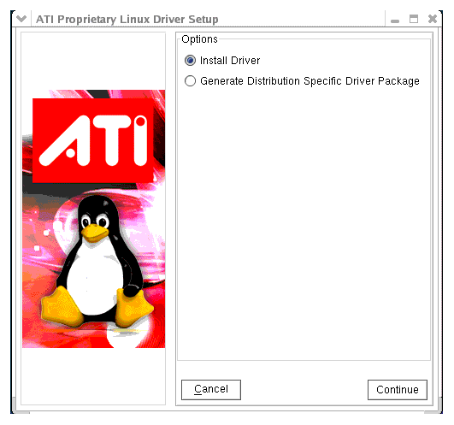

 |  |  | Note: | You must be logged in with super user privileges in order to successfully install the ATI Proprietary Linux driver.

- Select Install Driver and click Continue. The ATI License Agreement is displayed.
- Read the License Agreement and Click I Agree to continue the installation, or Cancel to terminate the installation. The Mode of Installation Dialog Box is displayed.
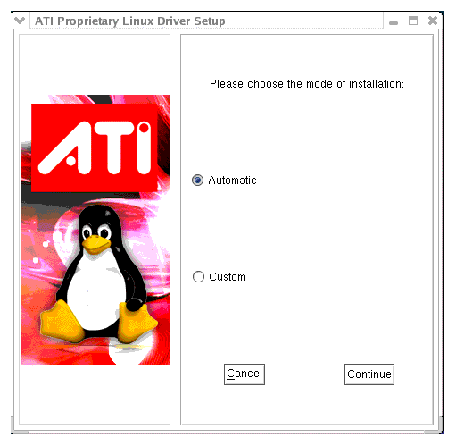
- Select Automatic and click Continue. The ATI Proprietary Linux Driver is installed, and the Installation Complete Dialog box is displayed.
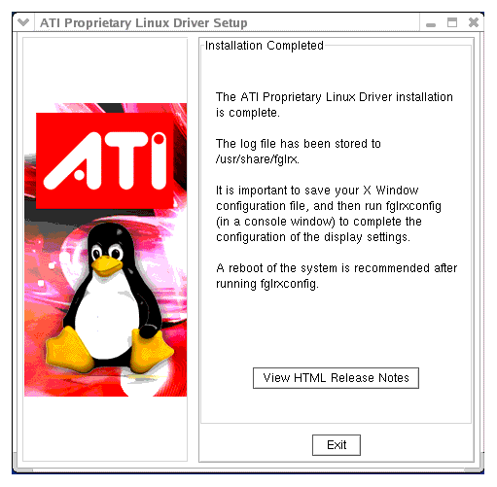
- Click View HTML Release Note for last minute driver information, or Exit to close the ATI Proprietary Linux Driver Installer.
- Launch the Terminal Application/Window and run /usr/X11R6/bin/fglrxconfig to configure the driver.
- Reboot your system.
You have successfully installed the ATI Proprietary Linux Driver.

Custom Driver Installation Option
The Custom option allows for the selection of driver components to be installed. To install the ATI Proprietary Linux Driver using the Custom option, follow these steps:
- Launch the Terminal Application/Window and navigate to the ATI Proprietary Linux driver you have downloaded
- Enter the command ./ati-driver-installer-8.16.20.run to begin the installation.
The ATI Proprietary Linux Driver Setup dialog box is displayed

 |  |  | Note: | You must be logged in with super user privileges in order to successfully install the ATI Proprietary Linux driver.

- Select Install Driver and click Continue. The ATI License Agreement is displayed.
- Read the License Agreement and Click I Agree to continue the installation, or Cancel to terminate the installation. The Mode of Installation Dialog Box is displayed.
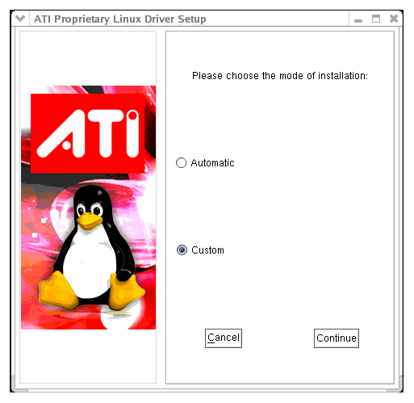
- Select Custom and click Continue. The ATI Proprietary Linux Driver Setup options is displayed.
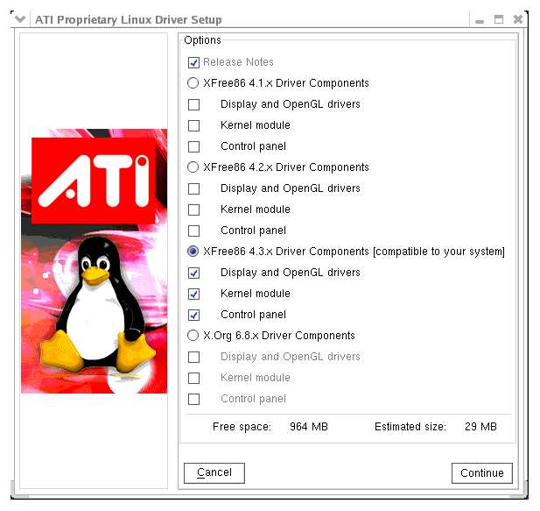
- Select the driver components to be installed and click Continue. The ATI Proprietary Linux Driver is installed, and the Installation Complete Dialog box is displayed.
- Click View HTML Release Note for last minute driver information, or Exit to close the driver installer.
- Launch the Terminal Application/Window and run /usr/X11R6/bin/fglrxconfig to configure the driver.
- Reboot your system.
You have successfully installed the ATI Proprietary Linux Driver.

Generate Distribution Specific Driver Package Option
The Generate Distribution Specific Driver Package option provides a simple way to generate a package specific for your distribution. This option uses the policies set by the operating system vendor and allows for maximum compatibility with the distribution. To install the ATI Proprietary Linux Driver using the Generate Distribution Specific Driver Package option, follow these steps:
- Launch the Terminal Application/Window and navigate to the ATI Proprietary Linux driver download.
- Enter the command ./ati-driver-installer-8.16.20.run to launch the ATI Proprietary Linux driver installer.
The ATI Proprietary Linux Driver Setup dialog box is displayed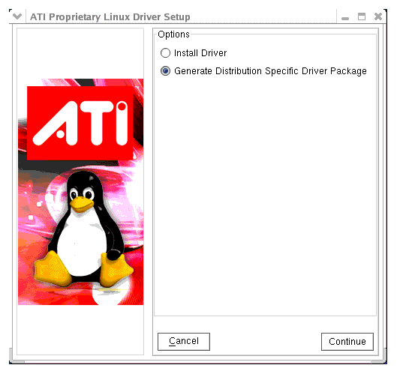

 |  |  | Note: | You must be logged in with super user privileges in order to successfully install the ATI Proprietary Linux driver.

- Select Generate Distribution Specific Driver Package and click Continue. The ATI License Agreement is displayed.
- Read the License Agreement and Click I Agree to continue the installation, or Cancel to terminate the installation. The Package Generation Dialog Box is displayed
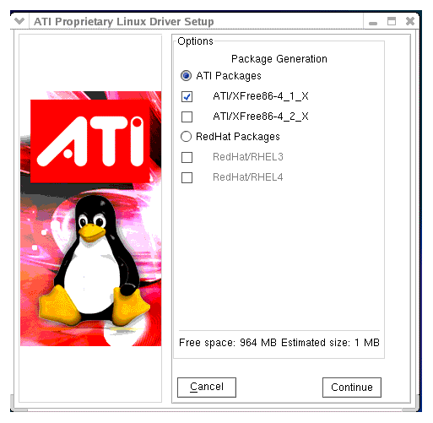
- Select the distribution package to be generated and click Continue. The package generation is started and the Package Generation Completed dialog box is displayed.
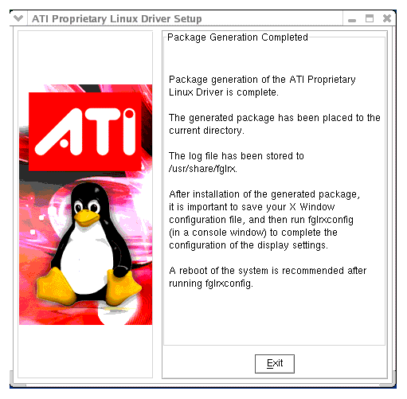
- Click Exit to close the ATI Proprietary Linux Driver Installer.
- You are now ready to install the generated distribution package using the distribution's package management system.
- After installing the generated distribution package, launch the Terminal Application/Window and run fglrxconfig to configure the driver.
- Reboot your system.
You have successfully generated and installed a distribution specific driver package..

ATI Customer Care
The ATI Customer Care website provides accurate and up-to-date product support for optimum usability and performance. Technical issues are categorized and can be personalized to enhance user experience. The new ATI Customer Care Website can be found at: support.ati.com
To view a known or resolved issue, do the following:
- Go to: support.ati.com. The ATI Customer Care web page is displayed.
- In the top left hand pane, click Advanced Search. The Advanced Search pane is displayed.
- Under Search Type: Select the By: ID option.
- Enter the Topic number.
- Click Go.

Linux Feedback Program
The ATI Proprietary Linux driver releases may incorporate suggestions received through the Linux feedback program.
Please refer to https://support.ati.com/ics/support/default.asp?deptID=894&task=knowledge&questionID=1714 to provide us with feedback.

ATI Technologies Inc.
http://www.ati.com
Voice: (905) 882-2600
Fax: (905) 882-2620

