
Modem Communications

An Overview of Analog Dialup Modem Performance, Environments, and Impairments.

Compaq Computer Corporation Communication Products Division

NOTICE

The information in this publication is subject to change without notice.

THE COMPETITIVE INFORMATION CONTAINED IN THIS PUBLICATION IS BASED ON DATA
AVAILABLE FROM PUBLIC SOURCES AT THE TIME OF PUBLICATION. COMPAQ COMPUTER CORPORATION SHALL NOT BE RESPONSIBLE FOR ANY INACCURACIES, ERRORS, OR OMISSIONS IN INFORMATION CONTAINED HEREIN, INCLUDING, BUT NOT LIMITED TO, INFORMATION OBTAINED FROM THIRD PARTY SOURCES, SUCH AS PUBLICATIONS OF OTHER COMPANIES, THE PRESS, OR COMPETITIVE DATA ORGANIZATIONS.

THIS PUBLICATION IS MADE AVAILABLE ON AN “AS IS” BASIS AND COMPAQ SPECIFICALLY DISCLAIMS ALL ASSOCIATED WARRANTIES, WHETHER EXPRESS OR IMPLIED. IN NO EVENT WILL COMPAQ BE LIABLE FOR DIRECT, INDIRECT, SPECIAL, INCIDENTAL, OR CONSEQUENTIAL DAMAGES IN CONNECTION WITH THE USE OF OR RELIANCE ON THE MATERIAL CONTAINED IN THIS PUBLICATION, EVEN IF ADVISED OF THE POSSIBILITY OF SUCH DAMAGES. COMPAQ RESERVES THE RIGHT TO MAKE IMPROVEMENTS OR CHANGES TO THIS PUBLICATION AND THE PRODUCTS AND SERVICES HEREIN DESCRIBED AT ANY TIME, WITHOUT NOTICE OR OBLIGATION.

This publication does not constitute an endorsement of the product or products that were tested. The configuration or configurations tested or described may or may not be the only available solution. This test is not a determination of product quality or correctness, nor does it ensure compliance with any federal, state or local requirements. Compaq does not warrant products other than its own and then, only as strictly stated in Compaq product warranties.

Compaq, Deskpro, Presario, ProLiant, and Prosignia are trademarks registered in the United States Patent and Trademark Office.

Armada, LTE Elite and Netelligent are trademarks of Compaq Computer Corporation.

Other product names mentioned herein may be trademarks and/or registered trademarks of their respective companies.

Microsoft, Windows NT are trademarks and/or registered trademarks of Microsoft Corporation.

x2™ is a trademark of the 3Com Corporation
K56flex™ is a trademark of Lucent Technologies Inc. and Rockwell Semiconductor Systems Inc.

©1998 Compaq Computer Corporation.

Executive Summary 0
Modem Performance 0
Connect Speed 0
Bandwidth and Attenuation 0
Network Modeling 0
SNR 0
Error Correction 0
Network Topology 0
Central Office 0
Copper Loop 0
Premises Wiring 0
Inter-Office Trunking 0
Long Distance and 1-800 numbers 0
PBX Systems 0
Analog Impairments 0
Noise 0
Signal Level 0
Echo 0
Delays 0
Digital Impairments 0
Pads and Attenuation 0
ADPCM 0
Robbed-Bit Signaling 0
PCM (56k) Dependencies and Performance 0
Network Topology for 56K 0
Requirements 0
Connect Speed Explained 0
Compaq Modem Testing 0
Performance testing 0
Interoperability 0
Miscellaneous 0
Glossary 0

Executive Summary
The modem is the one personal computer device that, probably more than any other, is dependent upon an external environment (public switched telephone network, or PSTN) in order to operate. Modems are designed in such a way as to maximize their performance over these conditions – conditions which can vary considerably from one location to the next. Through the use of advanced modulation protocols, error-correction technology, and rigorous hardware design, the modems will make the most of whatever conditions are available.
In the early days of modem technology, the bit rates and technologies in use at the time were less sensitive to line conditions. This is because they did not require as much PSTN bandwidth to operate at full speed as today’s technologies do. As a result, a 2400bps modem or 9600bps modem would pretty much always connect at those speeds. Newer modem technologies, such as V.34 and V.90, utilize the maximum available bandwidth of the telephone systems to achieve the speeds advertised, and require extraordinarily clean lines in order to reach the maximum potential speeds of 33.6Kbps or 56K.
As a result of this, the user of a high-speed modem (33.6Kbps and higher) will not always connect at that speed. When the newer modem technologies were being developed, it was understood that in some locations the telephone network would not always be able to provide the bandwidth and noise characteristics required for the modem to reach the highest speeds. The idea was to fully utilize whatever bandwidth was available, and to give the user a technology that would enable them to connect at the highest possible bit rate for their particular line environment. Depending on line conditions, connect speeds of 24Kbps or 26.4Kbps are not at all uncommon.
This document describes in detail the various elements of the PSTN, and their potential effects on modem communication. Modem communication technology has advanced very rapidly – nearly quadrupling the data rate that was state of the art only a few years ago – and in many respects has advanced beyond the ability of the telco infrastructure to keep up. Given that PSTN line conditions vary from one location to the next, the performance and behavior of today’s modems will vary accordingly.
Modem Performance

Connect Speed
The most readily visible measure of modem performance is the connect speed reported when a call is established. The connect speed reported by the modem when it first establishes a connection is perhaps one of the most widely misunderstood and deceiving behaviors of the modem. The connect speed reported is the speed at which the modems established a connection, and this of course is a fairly straightforward thing to interpret. What is less clear is what happens ‘behind the scenes’, and what the actual throughput of the call might be.
Modems can and often do shift speed during the call, depending on line conditions and how aggressive the modems are when negotiating an initial connect speed. The modems are designed to adjust the speed of the connection as line conditions change, and a modem may report a relatively high connect speed and then shift down to a lower speed during the call. Conversely, a modem may connect at a lower initial rate, and then shift up. Also, V.34 and PCM (pulse-coded modulation) modem connect speeds can be asymmetrical – the transmit and receive connect speeds can be different (and always are in the case of PCM), and most modems only report the connect speed in one direction – typically the receive direction.
It is also important to note that the overall throughput of the connection is dependent not only on the connect speed that is maintained, but also upon whether there are any data errors on the connection which require that data be resent. If a modem tries to force a connect speed higher than what the prevailing line conditions will actually support, errors will be introduced and ultimately lower the effective throughput of the connection, or the call could be dropped due to excessive errors. Because of this, it is sometimes possible to get better throughput with a lower connect speed than would be possible by forcing errors through a call with a higher connect rate on the same line conditions. The aggressiveness of the connect speed, the line conditions, the presence of errors, and the overall throughput are all interrelated, and there are certain tradeoffs involved in establishing a connection that yields the highest data throughput and data integrity.
While outside the scope of this document, there are other conditions that can ultimately affect the throughput of the connection. These would be things such as network traffic and latency (very common with Internet connections), as well as server loading and large amounts of traffic which is often the case with corporate RAS (Remote Access Services) connections.

Bandwidth and Attenuation
Another requirement for optimum modem performance is that there be sufficient bandwidth, or frequency response, available on the phone line. This is typically in the range from 300-3200Hz, but in order to achieve 33.6Kbps, usable bandwidth between 250Hz to ~3700Hz is required. The available bandwidth of the connection is a key factor that the modems use to determine the appropriate connect speed for the call, and insufficient bandwidth will limit connect speeds. The following table illustrates the bandwidth requirements and the expected connect speeds.
Symbol Rate | Carrier Frequency | Bandwidth Requirements | Maximum Bit Rate
2400 | 1600 Hz | 400-2800 Hz | 21600 bps
2400 | 1800 Hz | 600-3000 Hz | 21600 bps
2743 | 1646 Hz | 274-3018 Hz | 26400 bps
2743 | 1829 Hz | 457-3200 Hz | 26400 bps
2800 | 1680 Hz | 280-3080 Hz | 26400 bps
2800 | 1867 Hz | 467-3267 Hz | 26400 bps
3000 | 1800 Hz | 300-3300 Hz | 28800 bps
3000 | 2000 Hz | 500-3500 Hz | 28800 bps
3200 | 1829 Hz | 229-3429 Hz | 31200 bps
3200 | 1920 Hz | 320-3520 Hz | 28800 bps
3429 | 1959 Hz | 244-3674 Hz | 33600 bps

Network Modeling
When the ITU-T V.34 standard was being developed, a need was identified to have a means of modeling the continental U.S. telephone network and to describe a set of line conditions considered to be representative of the network. The ITU-T Study Group 14 working group conducted a survey that included the seven RBOCs (Regional Bell Operating Companies – or Baby Bells), Bellcore, and network equipment vendors, the results of which were combined into a matrix of impairment combinations that form the basis for a model of PSTN line conditions. The model consists of 24 different sets of central-office network impairments, and 7 sets of subscriber loop impairments, with each being assigned a weight, or score, according to their likelihood of occurrence.
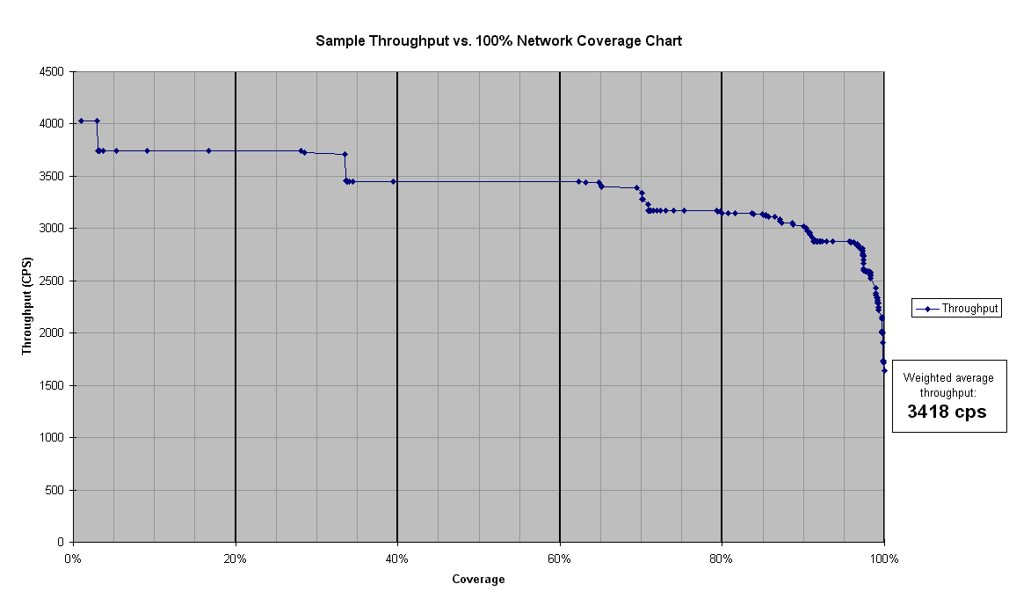
From this model, an industry-standard test method was derived and documented in TIA (Telecommunications Industry Association) bulletin TSB-38. Using this type of testing, it is possible to predict how well a modem may perform over a variety of network conditions, and makes it possible to perform meaningful comparisons between different modem products. The test consists of establishing a modem connection over each of the 168 different line conditions, and then measuring the data throughput as a test file is transmitted from one modem to the other. Here is a sample plot:

In this plot, you can see how the throughput steps down as the line impairments grow worse, and the modems connect at a lower speed and transmit data at a lower rate. By observing the points where the throughput steps down, a percentage of network coverage at a given speed can be inferred. For instance, this plot would indicate that the modem would be capable of connecting at 33.6Kbps on a relatively small percentage of the telephone line conditions present in the PSTN. It should be noted that this model is not a perfect or complete representation of the PSTN, and actual end-user connect speeds will vary depending on their line conditions. These results are interpreted to mean that a given connect speed will be likely over a certain percentage of line conditions taken as a whole – not that a given connect speed will be possible at any particular location.

SNR
SNR is the ratio of signal to noise, and is expressed in decibels. A high SNR value indicates a cleaner and more noise-free line. Modems can operate at very low SNR levels, but in order to reach the maximum possible speed, the phone lines must have a very high SNR – usually 36dBm or better is required for a 33.6Kbps connection. A typical test for modems being developed is to test the SNR performance of the modem via so-called ‘waterfall curves’. This type of testing forces the modem to connect at a fixed speed, and then the SNR is varied from a very noisy to a very clean value, and the performance of the modem is evaluated by measuring the BER, or Bit Error Rate. The SNR level where the BER drops to zero is the SNR level where the modem is said to be able to connect and pass error-free data at that given speed. An example of a waterfall plot is given in the following figure.
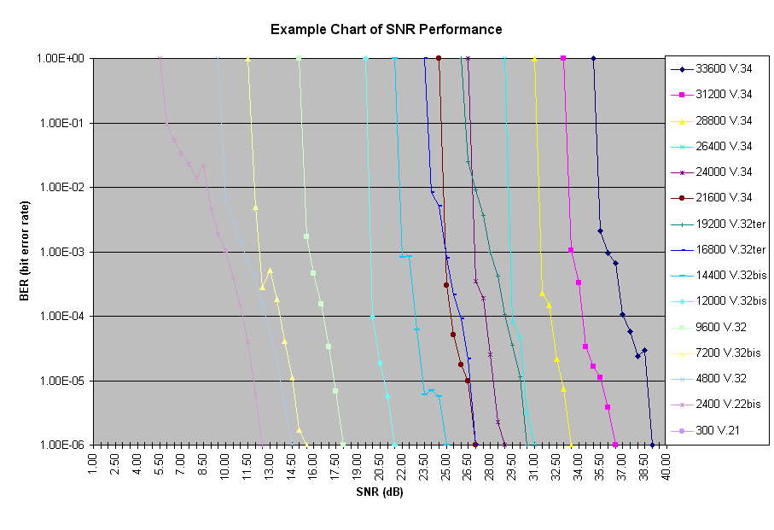

Error Correction
In order to correct for any errors that may occur on the line while the modems are connected, the modems will negotiate an error-correcting protocol. In most applications, the protocol used will be LAPM, although MNP4 may also be negotiated – both protocols are specified in the ITU-T Recommendation V.42. The error-correction performed should be transparent to the user, but over heavily impaired lines, the overall throughput of the modem may decrease as the EC protocol is forced to re-send data blocks to correct the errors. The primary function of error correction is to detect and correct any bit errors that occur between the two modems, so that the integrity of the data is maintained.

Network Topology
In order to better understand how modems are supposed to function during a data call, it is important to understand the basic building blocks of the telephone network and how each piece can affect modem performance. The PSTN is a complex network, consisting of both old and new technology, and is a dynamic environment – enough so that it is even possible to see different performance from one call to the next, depending on network traffic and how the call is routed. The basic components of the PSTN are described in the following sections.

Central Office
The Central Office, or CO, is the telephone company switching location that directly services the customer. Depending upon the size of an area, there may be several – or dozens – of CO locations to serve all of the customers and telephone lines in an area. Central office provisioning has improved considerably in the last several years, enabling such technology and features as Caller ID, voice messaging, ISDN, call forwarding/call return, and other such features. Unfortunately, there are still a number of CO facilities that utilize older technology, and which may prevent a modem from operating at its peak performance. One example would be the facilities that are still using an analog switch – this can introduce impairments for normal analog calls, and would make a PCM connection impossible.

Copper Loop
The copper loop, or subscriber loop, is the run of wire between the telco CO and the customer location. In its simplest form, this is nothing more than 22-guage wire from end to end. More complex installations will use some combination of copper wire and digital subscriber loop concentrators, or SLCs, to serve a large number of customers. The copper loop is the network component that is most vulnerable to degradation. It is subject to physical damage due to being cut or otherwise disturbed, environmental issues due to exposure, moisture, or other interference, and degradation due to corrosion and insulation breakdown. The copper loop may also contain loading coils or other devices if the length from the CO to the customer site is longer than normal – generally 12,000 cable feet or greater.

Premises Wiring
This, of course, is the final link in the chain – the inside wiring of the house, business, or other facility. The premises wiring is the only part of the network topology that can be accessed or affected by the end user. Some considerations to keep in mind are:
- Device loading – multiple devices on the same line as the modem can affect performance. This would include such things as multiple extension phones, Caller ID boxes, answering machines, satellite dish receivers, and so forth. In extreme cases, these devices could introduce a sufficient load on the circuit that the modem may not operate properly.
- Cross-talk – this can be a problem when the premises is wired for two phone lines that are being carried over the same wiring in adjacent pairs. Cross-talk is the condition where you can hear interference (or in extreme cases, actual conversation) coming from one phone line while using another. This is usually caused by poorly shielded cabling somewhere in the premises wiring, and can make it very difficult for a modem to connect at the appropriate speed.
- Poor connections and corrosion – this can be a problem in older houses or facilities where the telephone lines are old, the connections could be loose or corroded, or wiring exposed due to deterioration of the insulation. It is also common to find corrosion in telephone network interfaces that are exposed to the elements.
- Interference – this can be caused by running the phone wiring parallel to electrical wiring, fluorescent light fixtures, and other potential sources of interference.

Inter-Office Trunking
Inter-office trunking is the part of the network that connects the CO facilities to each other, as well as to other network systems and facilities. This is typically done over digital fiber-optic links which are capable of carrying enormous amounts of data.

Long Distance and 1-800 numbers
Long distance and 1-800 connections pose a potential impairment to the modem due to the routing of the call and the number of facilities through which the call must pass in order to reach its destination. This is especially true of international calls or other such connections which may pass through a satellite relay. 1-800 numbers may also use a scheme known as ‘Least-Cost Routing’, which may route the call through a more indirect path.

PBX Systems
PBX (Private Branch Exchange) systems can introduce their own set of problems for modem communications. One important consideration is whether the available line at a particular location is digital or analog – modems are generally not designed to operate over digital PBX lines, and in some cases can be damaged by connecting to a digital line. While analog lines can be safely used for modem communications, the quality of the connection will vary according to the PBX system used and how it is connected to the PSTN. Many PBX installations are not digitally integrated into the PSTN (line-side terminated instead of trunk-side), which can introduce impairments.
It’s also important to note that some PBX systems use non-standard call-progress signals (dial tone, ring frequency and cadence, etc.), which can cause problems for modem operation. On the client side of the PBX system, things like dial tone and ring cadences cannot be taken for granted; these systems can and often do behave in a way that is quite unlike the PSTN that modems are designed to operate on.
Analog Impairments

Noise
Noise is quite simply the presence of any interference or unwanted signal on the line. This can sometimes be heard as pops, clicks, static, or other noise when using a normal telephone on the line. The presence of such noise will degrade modem performance.

Signal Level
This is the level, expressed in decibels referenced to 1 milliwatt (dBm), at which the modem is transmitting to the network (transmit level), as well as the perceived loudness of the remote signal (receive level). Of these, the receive level is often the most variable and potentially harmful to modem performance. If the receive signal level is too low, the modem will be more adversely affected by any noise present on the line, and in extreme cases the level may be so low that the modem cannot properly decode (or ‘hear’) the signal from the remote modem. Conversely, if the receive level is too high, or too loud, the analog front-end of the modem may become saturated (driven into clipping) or non-linear, resulting in poor signal quality. A typical receive level would be somewhere around –22 to –26dBm, with an upper limit of approximately –18dBm and lower limit of approximately –35dBm.

Echo
Echo levels are described in terms of near-end (listener) and far-end (talker) echo levels. This is the reflection of the signal from the hybrid balances in the network, and must be cancelled out in order for the modems to work. On a normal voice call, the telephone network will utilize its own echo cancellers so that the echoes are not distracting to normal voice conversation. On a modem call, the modems will set up their own echo cancellers and do not utilize the ones on the network.
The network echo cancellers are turned off by the modems by sending a 2100Hz tone of approximately 1s duration to the network. After this, the modems set up, or ‘train’, their own echo cancellers. This is done so that each modem will be able to cancel out the reflection of its own signal, so that the only thing it hears is what the remote modem is transmitting.

Delays
A large amount of end-to-end delay in the telephone network can cause problems for modem data transmission. Large delays are typically encountered on international calls or other calls which are relayed via satellite. This introduces a delay of up to 200ms (sometimes greater), which makes it difficult for the modems to properly train and adjust the echo cancellers, among other things.
Digital Impairments

Pads and Attenuation
Pads are commonly used to equalize the volume levels between different lines, so that the volume of the voice call is consistent from end-to-end and at an acceptable level. With a digital pad, the digital data is manipulated to adjust the volume. With analog pads, the digital data is converted to analog where the volume is adjusted and then converted back to digital.

ADPCM
ADPCM (adaptive differential pulse coded modulation) is a digital speech compression technique that is used to reduce the transmitted bit rate in digital carrier systems for voiceband signals. ADPCM allows the network provider to accommodate more voiceband channels on a digital carrier facility than would be present without it, while still maintaining signal and perceptual quality in the connection. While ADPCM algorithms have no apparent effect on the quality of a voice call, they have widely differing impact on data modem performance. There are several different ADPCM algorithms, and a description of these can be found ITU-T Recommendations G.721 and G.726.

Robbed-Bit Signaling
Robbed bit signaling (RBS) is a form of in-band signaling which uses the least significant bit from every 6th and 12th frame of the PCM channel. When this bit is ‘robbed,’ the signal effectively becomes a 7 bit quantizer for that sample. Since the signal was originally an 8-bit signal, the resulting output effectively appears as the original signal and a low level impulse hit. The use of robbed bit signaling is being phased out by the increased use of common channel signaling in the network.
PCM (56k) Dependencies and Performance
Due to improvements in the PSTN network, and the increasing number of service providers that are digitally connected to the network, it became possible to develop a technology that would extend the possible data rates of a modem call beyond 33.6K bps. The technology for doing so is referred to as PCM (pulse-coded modulation), and is fundamentally different from the technology used to achieve data rates up to 33.6K bps.
Current PCM technology allows data rates up to 56Kbps in the receive direction, and up to 33.6Kbps in the transmit direction. Since the host-end modem must be digitally connected to the network, it is not possible for PCM to operate between two end-user installations.

Network Topology for 56K
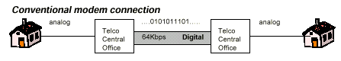
When considering the PSTN topology and its implications for modem performance, it’s important to discuss the special case over which PCM (56K) modems are designed to operate. With normal analog modem communications, the network is assumed to consist of primarily analog components.
With PCM modem technology, the PSTN network is treated as a completely digital network with one analog impairment – that being the end user local loop. PCM technology became practical as more and more service providers and telcos upgraded their facilities to digital equipment. Now, it is common for an online service provider or ISP to have a fully digital connection to the PSTN.
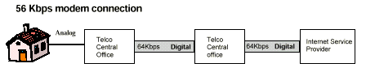

Requirements
In order for PCM modem technology to work at a customer location, certain criteria must be met. For one thing, there can only be one D/A conversion in the complete circuit depicted above – this means that if the customer is on an analog switch in the CO, or if their loop circuit contains non-integrated (line-side terminated) SLCs, they won’t be able to achieve a 56K connection. Certain types of padding may also cause problems for 56K connections.
Another important consideration is whether the modems on the provider end support the same 56K protocol – although a draft standard (V.90) is in place, most modems currently on the market will support either K56flex™ (Rockwell/Lucent) or x2™ (3Com/U.S. Robotics). These protocols are not interoperable, and the next highest commonly support speed would be V.34. As V.90 modems become more widely deployed, the interoperability issues should improve.

Connect Speed Explained
One final note on 56K technology is that at the current time, FCC limitations on transmit power prevent the modems from being able to actually connect at 56K. FCC Part 68 regulation limit the transmit power to the network to –10dBm; in order for current PCM technologies to reach 56Kbps, the required transmit power is approximately –8dBm. Another potential limitation is whether or not the provider end is connected with a T1 connection or ISDN PRI – a T1 connection normally requires bit-robbing to be used for signaling, whereas an ISDN PRI connection uses a separate channel for signaling and does not employ RBS. The presence of RBS can degrade the connect speed of a PCM connection.
As is the case with the other modems technologies, 56K modems will adjust their connect speed to fully utilize whatever line conditions are presented – meaning that the user will not always see a 56K connect. Connect speeds between 40K and 48K bps are fairly common, and higher rates will be dependent on line conditions.
Compaq Modem Testing
With all of the above in mind, it quickly becomes obvious how important it is to perform rigorous testing of any modem product to ensure peak performance regardless of where or how it’s used. At Compaq, the modems are tested thoroughly and are held to the highest performance standards. Each modem is subjected to a battery of tests that are intended to fully exercise each functional area of the modem. The following list is a brief overview of the testing each modem must pass – the full detail of which would comprise a fairly large document by itself and is only summarized here. It is also important to note that new tests are regularly being added to keep pace with advancements in modem functionality and performance.

Performance testing
- Throughput vs. Network Model
This is the network model testing described earlier in this document. This testing is performed according to the procedures specified in TIA TSB-38. This testing is quite exhaustive, and a modem may undergo hundreds of hours of testing from the early design phase to final production.
- SNR testing
This testing is used primarily in the design phase of the modem to ensure that the performance of the analog front-end is fully optimized. All applicable connect speeds and modulation protocols are tested.
- Fall-forward/Fall-back
This test ensures that the modem properly adjusts its connect speed to match the line environment, and that it does so at the correct time. During this test, the line conditions are varied from very clean to very poor, and back again, and the throughput is measured at each step.
- Connect Reliability
This test measures the ability of the modem to reliably and consistently connect and pass data over a variety of line conditions. This test is performed over the 7 EIA loops and over a null loop.

Interoperability
- Data Interoperability
This testing verifies that the Compaq modem is able to successfully connect with a broad variety of 3rd party modem products – including both client-end modems and host-end modem racks, concentrators an other type of high-density RAS equipment. This type of testing helps to ensure maximum compatibility with other modem products in the field. All of the applicable modulation, error correction, and data compression protocols are tested.
- Fax Interoperability
This test verifies that the Compaq modem will be able to negotiate and send/receive faxes from a broad range of stand-alone fax machines and other fax modem products. The test is performed in an automated environment that can emulate over 75 different fax devices, and ensure compliance with the T-30 fax protocol set.

Miscellaneous
In addition to the testing above, the Compaq modem products are tested in a variety of other ways. These would include –
- Speakerphone and Telephony testing, if applicable
- Compatibility with 3rd party communications applications
- Special PSTN features (Caller ID, Distinctive Ringing), if applicable
- Training robustness
- Regulatory compliance (FCC Part 68)
- RF/EMI testing
- Cellular data testing, if applicable
- AT Command set functions and features testing

Glossary
ADPCM – Adaptive differential pulse-coded modulation. Used to compress the data in voice calls to increase switch capacity.
Baud – this is defined as the rate of state transitions, or symbol rate, on the phone line. This unit is used as a base rate upon which the modems encode multiple bits per baud, which yields the final BPS data rate of the modem. For instance, a modem that transmits data at 14,400bps is using a 2400 baud carrier and is encoding 6 bits per baud (via trellis coding) for 14,400bps. In the old days of modem technology, baud and bps meant pretty much the same thing – that is no longer true of today’s high-speed modems, and the terms should not be used interchangeably.
Bps – Bits Per Second. This is the unit of measurement used when describing data rate of a modem.
CO – Central Office. This is the telco facility that directly provides telephone service to the customer.
ITU-T – International Telecommunications Union. This is the international standard-setting body that publishes the V.xx Recommendations for modem communications.
K56flex™ – proprietary PCM protocol developed jointly by Rockwell and Lucent. Not interoperable with x2™ or V.90.
LAPM – Link Access Procedures for Modems. This is the primary error-correction protocol specified in ITU-T Recommendation V.42.
Loop – copper network or circuit between the customer and the CO.
MNP2-4 – error correction protocol developed by Microcom, which is specified as an alternate error-correction protocol under V.42.
PCM – Pulse-coded modulation.
PSTN – Public Switched Telephone Network, alternately referred to as POTS (Plain Old Telephone System).
RBOC – Regional Bell Operating Company (Baby Bell)
RBS – Robbed-bit signaling. This uses certain bits from the digital data stream to perform call control and switching.
SLC – subscriber loop concentrator. This is a device used on the loop circuit to aggregate a large number of phone lines into a single connection back to the central office.
SNR – Signal-to-Noise ratio
V.34 – ITU-T standard modulation protocol for speeds up to 33.6Kbps.
V.42 – ITU-T standard for the negotiation of an error-correcting link.
V.90 – ITU-T draft standard modulation protocol for speeds up to 56,000bps.
x2™ - proprietary PCM protocol developed by U.S. Robotics (now 3Com)

