September 2000
Prepared By:
Compaq Computer Corporation
Contents
Introduction to Display Technologies 3
Why CRT Refresh Rates Are Important 5
Role of Dot Pitch in Picture Quality 6
Selecting an Appropriate Monitor Resolution 6
Screen Size and Ergonomics 7
Summary Conclusion 7

Compaq Professional Series Monitors:

Key Technologies
A number of key technologies make the new Compaq Professional Series naturally flat CRTs the best in the industry. Featuring Mitsubishi’s Diamondtron Natural Flat (NF) technology, the 17-inch P710, 19-inch P910, and 22-inch P1210 offer crisp, clear displays and pixel-perfect presentation for a variety of power users.
This paper provides a closer look at the Professional Series’ distinguishing cutting-edge technology features, which include:
- Flat aperture grille CRTs
- High CRT refresh rates
- Dot pitch
- Resolution
- Screen size

Notice

The information in this publication is subject to change without notice.
Compaq Computer Corporation shall not be liable for technical or editorial errors or omissions contained herein, nor for incidental or consequential damages resulting from the furnishing, performance, or use of this material.
This publication does not constitute an endorsement of the product or products that were tested. The configuration or configurations tested or described may or may not be the only available solution. This test is not a determination of product quality or correctness, nor does it ensure compliance with any federal, state, or local requirements. Compaq does not warrant products other than its own, strictly as stated in Compaq product warranties.

Compaq and the names of Compaq products referenced herein are either trademarks and/or service marks or registered trademarks and/or service marks of Compaq.

Other product and company names mentioned herein may be trademarks and/or service marks of their respective owners.

©2000 Compaq Computer Corporation. All rights reserved. Printed in the U.S.A.

Compaq Professional Series Monitors: Key Technologies

First Edition (September 2000)

Introduction to Display Technologies
The cathode ray tube (CRT) is the oldest form of computer display technology, having enjoyed widespread use since the mid-1970s. The CRT uses a glass surface coated with a phosphorescent substance that glows when illuminated by an electron beam.

Color CRTs
In a color CRT, three separate electron beams (cathode rays) are produced at the back of the monitor and scanned side to side, line by line, across the internal face of the tube, exciting the phosphor coating on the glass. The amount of current from the electron gun determines the brightness of the color dots in any given area. As the beam scans rapidly across the screen, it excites each phosphor dot for only a brief period of time, after which the light output of each phosphor dot starts to diminish.
Color CRT technology uses small areas of phosphor that emit red, green, and blue color rays but also makes them small enough and close enough together that they are not seen as individual colors. The phosphor is applied to the inside of the tube surface either in small dots or vertical stripes, and to make sure that each beam strikes only the correct corresponding phosphor dots, a perforated metal plate, called a shadow mask, is fitted inside the tube a short distance away from the phosphor coating.

Aperture Grille CRTs
Aperture grille CRTs use wires as a mask. The wires are stretched vertically in a frame, and the beams pass between the wires, as shown below.

Conventional CRTs deliver crisp, bright images, but also present some geometric distortion on the horizontal and vertical planes and increased glare from ambient lighting because of curvature along the face of the monitor.

Diamondtron Technology
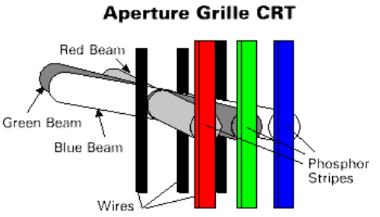
In 1993, Mitsubishi introduced an aperture grille tube CRT with the brand name Diamondtron that uses a three-gun/three-beam system. This technology, currently available in Compaq Professional Series monitors, offers a greater area of phosphor and less area of mask to block the beam, so more of the beam energy is converted into visible light, creating more brightness and color saturation.

Flat Screens
The latest developments in the CRT arena have involved “flattening” the CRT screen to overcome the drawbacks of traditionally curved monitors. The ideal flat screen monitor offers a level of performance comparable to “reading off a sheet of paper.” The key to this effect is the design of the glass envelope that forms the front surface of the CRT. Developed to create a flat image rather than a perfectly flat surface, this glass incorporates a slight and precisely calculated curve in the outer radius of the tube that compensates both for how the human eye perceives the image coming from the tube, as well as for the refraction of light. This also reduces the ambient light reflection and glare, making the image much easier to view.
In monitors that have perfectly flat glass, the image appears bowed because light refracts off the surface. This phenomenon is often referred to as the “concave” or “convex” look and is a by-product of CRTs that are mechanically designed to be completely flat.
In creating the flat aperture grille CRT, the actual design was reconceived. Using special design considerations and improved manufacturing processes, vibration and wrinkle effects were addressed and minimized, assuring sharp, crisp images throughout the entire viewing area.
Flat aperture grille Diamondtron CRT monitors also use a new electron gun designed to compensate for the difference in the distance from the electron gun to the perimeter and the center of the CRT surface. This new gun and lens technology ensures that the beam spot size remains constant (and circular) regardless of the beam’s location with respect to the active phosphor area of the CRT. In addition, a newly developed high-voltage electrode improves focus and reduces overall power consumption.
The flat aperture grille also incorporates a new type of deflection yoke that corrects for top-to-bottom pincushion distortion by using an enlarged deflection area, which has been increased by about 15 mm (when compared with conventional CRTs). The distribution of the deflection magnetic field has been designed mainly for correcting distortion. The new deflection yoke ensures stricter convergence specifications for greater accuracy and improved convergence performance, and simplifies the convergence adjustment process on the manufacturing line and by the end user.

Why CRT Refresh Rates Are Important
Refresh rates are important in evaluating CRTs because they help determine the quality of the display image. “Refresh rate” refers to the speed at which the CRT’s electron beam scans the entire screen, causing it to glow more brightly. This speed is measured in Hertz (Hz), which indicates the number of times the beam scans the screen per second. For example, a 75Hz refresh rate means the beam scans the entire screen 75 times per second.
To create each new screen refresh, the electron beam scans the screen from left to right and top to bottom. The horizontal scan rate (measured in kHz) is the time it takes to scan each row of pixels. The vertical scan rate (refresh rate) is the time it takes to scan the entire screen. If the refresh rate is too slow, it causes a common problem called “flicker,” which can result in user fatigue and eyestrain. A higher horizontal scan rate (frequency) allows you to run a given frequency at a higher vertical frequency and minimizes image flicker.
A higher refresh rate results in a picture that appears more solid, does not flicker, and is easier on the user. The determination of an optimal refresh rate varies per user and depends primarily on what the individual sees on the screen and how the monitor is used. Some users do not notice flicker at 70Hz, but others do. According to user studies, 70 Hz is the point at which most users stop seeing flicker, and it is also the best starting point when trying to eliminate flicker for a particular user.
A maximum refresh rate specification indicates the maximum capabilities of the monitor, but maximum capabilities are not usually required except when using niche applications such as those that involve 3D imagery. For the specific refresh rates of Professional Series monitors, refer to the product overview or product brief for each model.

Role of Dot Pitch in Picture Quality
Dot pitch is regarded as one of the defining specifications of CRT monitors and is often viewed as the most important factor in picture quality. “Dot pitch” is defined as the distance between the nearest phosphor dots of the same color. Aperture grille pitch is the distance between the stripes of phosphor on a monitor’s tube – the closer the stripes, the sharper the focus and image. The increase in the phosphor area results in a brighter image and improved contrast over conventional shadow mask CRTs. Consequently, more color shows through the grille, providing crisper images, more clarity in fine details, and improved brightness and contrast.
The figures below show how pitch is measured differently in shadow mask and aperture grille CRTs.
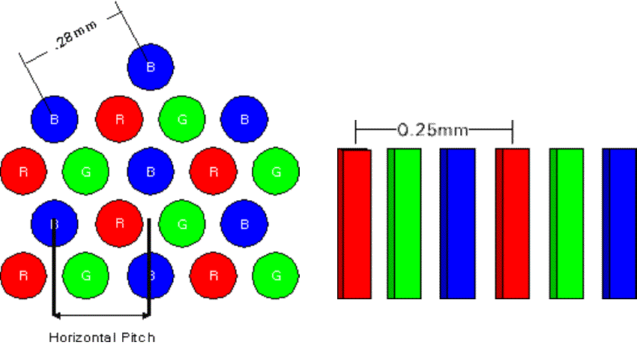
In aperture grille CRTs, the pitch is measured either on the phosphor (stripe pitch) or is measured on the wire, when it is defined as the grille pitch.

Selecting an Appropriate Monitor Resolution
For optimal display presentation, it is important to choose the appropriate resolution settings for each size monitor. For example, upgrading from a 17-inch to a 19-inch or 22-inch monitor, but staying at 800 x 600 resolution, will only result in a larger version of the same screen image, whereas changing to a 1024 x 768 resolution will enable more information detail to fill the larger screen area. At the other extreme, setting the resolution too high will result in icons and text becoming too small and hard to read.
Monitor specifications often refer to “maximum resolution” and “recommended resolution.” Though many monitors are able to display an image when the resolution setting is higher than the recommended operating resolution, it is important to choose the appropriate dot pitch for the desired resolution. If the relationship between the two is not correct, a loss of image quality will occur.
CRTs easily adjust to new resolutions by varying the size and number of pixels. This allows a CRT to fill the screen with a resolution of 800 x 600, 1024 x 768, or even 1280 x 1024. For high resolutions, the video system displays smaller pixels; for low resolutions, the pixels are larger.
The following table summarizes the relationship between screen size and recommended resolutions.

CRT | Viewable | Screen | Recommended Resolution
Screen Size | Image Size | Aspect Ratio | Minimum | Maximum
17-inch | 15.5 to 16 inches | 4:3 | 800 x 600 | 1280 x 1024
19-inch | 17.5-to 18 inches | 4:3 | 1024 x 768 | 1280 x 1024
21-inch | 19 to 20 inches | 4:3 | 1024 x 768 | 1600 x 1200

Screen Size and Ergonomics
The general rule with CRTs is that the bigger the monitor, the more information is viewable at any one time. A 17-inch display is a good choice for general-purpose business use, whereas 19-inch or especially 21-inch (or 22-inch in the case of the P1210) monitors are essential for design work – such as DTP and CAD/CAM – or for working with very large spreadsheets.
Recent studies conducted by Compaq Computer Corporation shed some light on the specific productivity gains to be realized when upgrading between monitor sizes. The study compared 15-inch, 17-inch, 19-inch, and 21-inch monitors within three vertical markets to determine user performance and preference differences.
Preference surveys revealed that users significantly preferred 19-inch and 21-inch monitors over the 15-inch and 17-inch monitors, with users ranking the 19-inch as the most preferred monitor, followed by the 21-inch, 17-inch, and 15-inch monitors, respectively.
Sixty-five percent of users stated that bulkiness and space constraints were reasons why they ranked the 19-inch monitor above the 21-inch monitor. The study also found that 19-inch and 21-inch monitors provide users with 16 percent and 22 percent productivity gains over 17-inch and 15-inch monitors in certain tasks.

Summary Conclusion
The award-winning Professional Series monitors from Compaq are the most technologically advanced CRT monitors on the market today, offering precision, glare-free imaging technology along with expansive viewing areas. A variety of key technology features are responsible for the Professional Series’ market leadership. They include:
- Flat aperture grille CRTs
- High CRT refresh rates
- Dot pitch
- Resolution
- Screen size
For more detailed information about the Professional Series line of monitors, please refer to the product overview or product brief for each specific model.

