Microsoft WWH and hp ProLiant essentials
abstract:
This guide provides information for deploying the Microsoft® Solution for Windows® Web Hosting (WWH) on ProLiant platforms from the new HP using both HP ProLiant Essentials and Microsoft automated deployment tools. A typical customer reference configuration for Windows Web Hosting is also provided.
This information is intended to help service providers and enterprises design, configure and deploy Web hosting solutions using the prescriptive architecture for Microsoft Windows Web Hosting and ProLiant Essentials tools with ProLiant servers, the #1 platform for Windows web servers (IDC Workload Study).

contents
introduction 3
customer environment 4
scope and purpose of this solution guide 4
ProLiant server overview 6
typical customer configuration for Windows Web Hosting using ProLiant BL servers 12
required infrastructure for remote management 13
comparison of software deployment technologies 14
comparison of RDP and APF 16
typical RDP and APF customer usage scenarios 19
software deployment stages 20
coexistence of APF and RDP - the best of both worlds 22
benefits of using automated deployment tools in WWH configurations 23
summary 24
appendix – references 25

notice

Microsoft® and Windows® are U.S. registered trademarks of Microsoft Corporation

The information in this document is subject to change without notice.

September 2002
178D-0902A-WWEN

introduction
With the explosive growth of the Internet in recent years, Service Providers are required to continually add and enhance service offerings and support for their customers. During the upbeat era of Internet exuberance, launching a managed hosting environment was an easy win. Today, the challenges are different. Managed Hosting is dependent on being able to handle rapidly changing and unpredictable requirements both efficiently and cost effectively. Web hosting, one of the most prevalent of services, requires both a secure and scalable environment for either shared or dedicated scenarios.
Research shows that web serving is projected to grow 15% annually. The growth is driven by the small- and medium-sized business (SMB) market as more of these ventures require a web presence. This provides new sources of revenue for service providers with the opportunity to up-sell and command more revenue per customer. Moreover, IDC recently found that 44% of U.S. corporations are hosting their sites with third parties.
In order to make this technology more accessible and as part of the Frontline Partnership Program, HP and Microsoft have developed a solution that delivers reliable, scalable, and manageable Windows web hosting solutions on industry-standard platforms, complete with innovative tools and world-class support.
The architecture of this solution is described within the Prescriptive Architecture Guide (PAG) for Windows Web Hosting, which is part of the complete Microsoft Solution for Windows Web Hosting. This document can be obtained directly from Microsoft via their Microsoft Customer Services group. The homepage for the Microsoft Solution for Windows Web Hosting can be found at:
http://www.microsoft.com/serviceproviders/windowswebhosting/default.asp
Information technology has become an imperative to meeting business objectives in a web-enabled, global marketplace. Organizations are faced with economic pressures, complex integration issues, scarce resources, and fluctuating demand. HP is investing in technologies for an HP Adaptive Infrastructure that enables customers to maximize their existing IT investments while adapting easily to the changes necessary to remain competitive.
At the heart of the blueprint for the Adaptive Infrastructure are four categories of technologies:
- Virtual Presence and Control
- Automated System Provisioning
- Intelligent Fault Resilience
- Dynamic Resource Scaling
HP considers these categories vital in making IT more adaptive, efficient and responsive to your needs. These technologies range from embedded technologies that are part of every ProLiant server and StorageWorks product from the new HP to software and tools that focus on improving your operational processes to support your business objectives. HP is developing the tools, building the platforms, and initiating partnerships with other industry leaders to bring a truly Adaptive Infrastructure into being.
For more information on Adaptive Infrastructure, refer to the following web site: http://www.compaq.com/ai.

customer environment
With a need to meet increasingly complex customer requirements, today’s service providers (SPs) require a solution-oriented approach comprised of integrated components. They need to maintain a highly available, secure environment, while being capable of scaling their business to add additional revenue opportunities and operate efficiently in the dynamic world of web hosting. Web hosting today is a very competitive business with keen price sensitivity. Furthermore, web sites are becoming more complex. Thus, SPs need to manage costs, seek ways to maximize resources, and delegate the administration of simple web hosting services. Microsoft’s focus on Solution Offerings is a tangible way to meet these requirements. To these offerings, SPs can add ProLiant industry-standard platforms and newly enhanced management tools. With this combination, SPs benefit through:
- Increased Average Revenue per user
- Reduced administration costs in a Windows environment
- Ease of scalability for web hosting offerings
- High Availability and Security for maximum performance
- Leading industry-standard platform and worldwide support
Thus, deploying the Microsoft Solution for Windows Web Hosting, running on ProLiant servers and utilizing ProLiant Essentials management tools is a complete offering enabling xSPs to manage and grow web hosting services smoothly and cost-effectively.
This paper contains information about the ProLiant BL10e and ProLiant DL360 G2 server models. These are the typical ProLiant systems recommended for a Windows Web Hosting deployment.

scope and purpose of this solution guide
This guide details recommended practices for HP Rapid Deployment Pack (RDP) and Microsoft Automated Purposing Framework (APF) for use on, and deployment of, ProLiant systems for the purpose of implementing a Microsoft Solution for Windows Web Hosting (WWH). This guide also provides the necessary requirements for a typical customer hosting Windows based sites, a summary of the RDP and APF tools, and a recommended way that they can be used together. It also recommends the ProLiant systems for WWH.

steps to successful web hosting
A service provider needs to complete a series of steps to prepare systems for customer use. These steps are listed below:
- Ensure that the required IT infrastructure needed for system deployment is available
- Acquire additional systems for deployment
- Configure network for these systems
- Configure storage for these systems
- Configure software for these systems
- Provision customers into environment
- Manage and monitor the health of the system

deploying Windows Web Hosting servers
Figure 1 illustrates the difference between manually installing the software on a number of servers versus automating this task via the deployment tools (RDP and APF) highlighted in this paper. The time savings is quite evident.
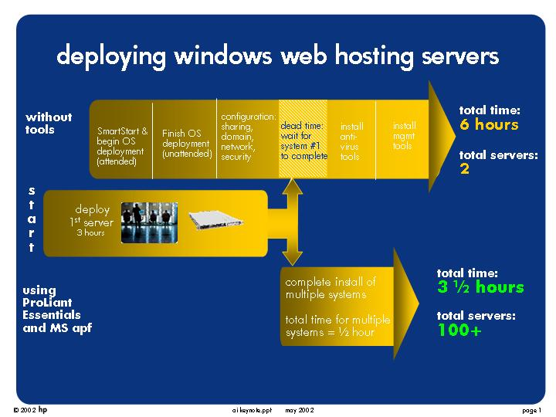
Figure 1: Time savings for deploying Windows Web Hosting servers using automated deployment tools

ProLiant server overview
The ProLiant line of high density servers offers the best platforms on which to host Windows Web Hosting (WWH). This section highlights the ProLiant BL10e and the ProLiant DL360 G2 high-density server lines, which are highly recommended for WWH deployments. These systems are ideally suited for WWH. Both the ProLiant BL and DL server lines provide:
- Scalability
A server farm can be scaled out to distribute risk and load while minimizing the impact on users.
- Performance
ProLiant servers provide the performance necessary to support the most demanding business-critical and line-of-business applications.
- Rapid server deployment and redeployment
Rapid deployment capability allows the organization to save valuable time by quickly deploying a solution, then quickly and dynamically responding to changing business needs. It is used with both the ProLiant BL and DL lines.
For the ProLiant BL10e server line, it takes only seconds to install the servers and power supplies once the rack infrastructure is in place. This allows dynamic scaling – without powering down the system. RDP allows the administrator to pre-configure each server bay before installing server blades. After installation, server blades configure automatically, assuming the role assigned by the administrator. RDP also provides rip-and-replace capability. When a failed server blade is replaced, the new server blade automatically assumes the role assigned to the original server blade.
- Anytime, anywhere access
The remote connectivity delivered by the HP Integrated Administrator (iA) and HP Integrated Lights-Out (iLO) allows anytime, anywhere access to the server farm for remote management.
- Reduced total cost of ownership
ProLiant servers can further reduce Total Cost of Ownership (TCO) in the following ways:
- Supports extremely high density, which reduces real estate costs
- Reducing cabling complexity - This reduction was accomplished by placing all the connections for the server blades on the backplane of the enclosure. All the connections are made as soon as a server blade is plugged into this backplane.

ProLiant BL10e server overview
Businesses are deploying more and more servers in edge-of-the-network applications such as web serving, media streaming, load balancing, caching, and firewall protection. Adding additional servers, however, increases operating costs, consumes more power and space, and increases the complexity of system administration. Existing resources to manage this new complexity may become inadequate.
HP has developed the ProLiant BL line of modular server blades specifically to address the needs of space-constrained enterprises and service providers for increased server density, rapid deployment and provisioning, and remote manageability. The ProLiant BL line is optimized for use with ProLiant Essentials Rapid Deployment Pack for automatic, high-volume server deployments or redeployments. The ProLiant BL10e servers are the highest density servers on the market today.

ProLiant BL10e system components
The modular ProLiant BL e-Class system is comprised of the following components:
- ProLiant BL e-Class server blades
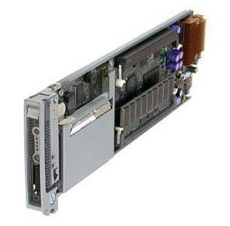 | The ProLiant BL10e is a high-performance, single-processor server blade.
- ProLiant BL e-Class server blade enclosure
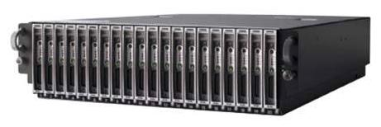 | Up to twenty ProLiant BL10e server blades can be housed in each 3U server blade enclosure. Server blades blind-mate into the enclosure’s backplane for power and data connections The enclosure houses dual hot-plug redundant power supplies for the ProLiant BL e-Class system infrastructure. The power supplies run on either 120V or 220V.
- ProLiant BL e-Class server blade interconnect trays
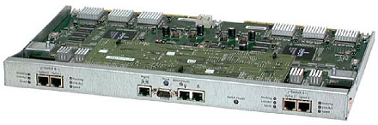 | There are three different interconnect trays that can be purchased for the ProLiant BL10e enclosure. These are:  - C-GbE Interconnect Switch with Integrated Administrator (iA) (with four 10/100/1000T Gigabit Ethernet uplinks)  - RJ-45 Patch Panel with iA (with 40 RJ-45 uplinks)  - RJ-21 Patch Panel with iA (with four RJ-21 uplinks)  To the left, the C-GbE Interconnect Switch with iA is shown.

ProLiant BL10e benefits
Table 1 summarizes the benefits of a ProLiant BL e-Class system.
Table 1. Benefits of a ProLiant BL e-Class system
Benefit | Description
Processor power | Server blades include either a single 700 or 800 MHz Pentium III processor and a 100 MHz system bus.
Reliability | Server blades have the proven reliability that is essential for business-critical applications. The following features are supported:  Two NICs per server that can be teamed to provide redundancy  Redundant AC power supplies
Scalability | A system scales out to twenty ProLiant BL10e server blades per enclosure, 280 per 42U rack
Manageability | Server blades can improve productivity, uptime and deployment time. Capabilities include:  Plugging in new servers or power supplies in seconds for dynamic scaling without powering down the system  Relieving cable congestion – the C-GbE interconnect switch option can reduce network cabling requirements to a single cable for every twenty blades  Improving serviceability – the modular design makes upgrades and service easy  Integrating with the existing environment – components fit into HP, telco and some third-party racks, and mix with traditional servers and storage
Total cost of ownership | Server blades can significantly reduce IT costs and resource requirements. Benefits include:  Reducing the IT headcount through remote management, innovative features, and ease of deployment  Saving valuable floor space through increased density – up to 280 blades in a 42U rack – without sacrificing high-availability features  Taking seconds to snap in new server blades and power supplies  Offering headless management – no keyboard, video or mouse  Requiring fewer network and power cables
ProLiant Essentials Rapid Deployment Pack | In addition to the ProLiant BL10e server itself, the ProLiant Essentials Rapid Deployment Pack (RDP) adds the following capabilities:  Pre-configuring each enclosure bay so that, when plugged in, the appropriate operating system and applications are automatically deployed to the new blade.  Enabling quick deployment or redeployment of server blades – use multicasting to configure 2 to 100 server blades in 30 minutes  Using rip-and-replace technology to replace a defective blade with a new blade that automatically assumes the role of the defective blade

features
A ProLiant BL10e server blade offers the features listed in Table 2.
Table 2. Key Features of a ProLiant BL10e server blade
Feature | Description
Processor | One Pentium III 700 or 800 MHz Processor with 512KB level-2 cache
Memory | Two DIMM slots – up to 1GB total
Disk | One Ultra ATA 30 or 40 GB internal hard drive
Network connectivity | Two general-purpose 10/100 Ethernet connections
LED display | LEDs on the front of the blade provide information on unit identification, health, NIC status, disk drive activity, and power
Headless | Virtual keyboard, video, and mouse available through iA
PXE capability | Embedded Preboot Execution Environment (PXE) capability, allowing the server blade to boot from the network – particularly useful in an RDP environment (described below)
Integrated Administrator | The iA feature allows the administrator to access and control the server blade from any location on the network, regardless of the state of the blade’s operating system or hardware. iA provides a virtual power button, keyboard, video, and mouse.
Related HP software tools
HP Insight Manager 7 | Insight Manager 7 brings together in one location all performance, management and fault information relating to the IT environment, allowing the administrator to monitor and manage groups of server blades from a standard web browser.  In addition, Insight Manager 7 includes a Blade Server Visual Locator tool that offers a graphical representation of server blades, server blade enclosures and shared infrastructure.
ProLiant Essentials Rapid Deployment Pack (RDP) | Optional RDP software allows the administrator to deploy and redeploy server blades, rapidly and automatically. High-volume server deployments are now possible within minutes rather than hours or days.  RDP also allows the administrator to assign a role to each bay in a server blade enclosure. When a new server blade is plugged in to a particular bay, the pre-assigned software is automatically deployed to the blade; if the blade is replaced, the new blade automatically receives the pre-assigned software, taking over the role of the replaced blade.

ProLiant DL360 G2 server overview
The ProLiant DL line of high-density servers is ideally suited for multi-server deployments. Like the BL line, they are rackable systems that address the needs of space-constrained enterprises and service providers for increased server density, rapid deployment and provisioning, and remote manageability.
The ProLiant DL line is optimized for use with ProLiant Essentials Rapid Deployment Pack for automatic, high-volume server deployments or redeployments.

ProLiant DL360 G2 system
- ProLiant DL360 G2 servers
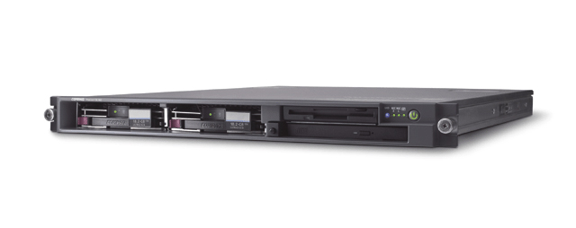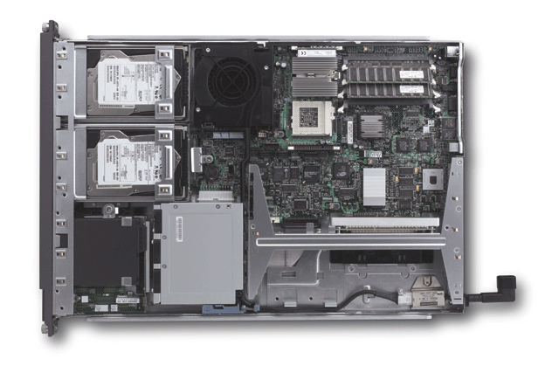 | The ProLiant DL360 G2, is a second generation, high-performance, dual processor server. Having a height of 1U, up to 42 ProLiant DL360 G2 servers can be housed in each 42U rack.

The ProLiant DL systems are optimized for use with HP 10000 Series racks but fit into other HP racks, telco racks or third-party racks.

benefits
Table 3 summarizes the benefits of a ProLiant DL360 G2 system.
Table 3. Benefits of a ProLiant DL360 G2 system
Benefit | Description
Processor power | ProLiant DL360 G2 servers include up to two 1.4GHz Pentium III processors with 512KB level-2 cache.
Reliability | ProLiant DL360 G2 servers have the proven reliability that is essential for business-critical applications. The following features are supported:  Two hot-plug SCSI hard drive bays  Two NICs per server that can be teamed to provide redundancy
Total cost of ownership | ProLiant DL360 G2 servers can significantly reduce IT costs and resource requirements. Benefits include:  Reducing the IT headcount through remote management, innovative features, and ease of deployment  Saving valuable floor space through increased density – up to 42 servers in a 42U rack – without sacrificing high-availability features  Offering headless management via iLO – no keyboard, video or mouse needed
ProLiant Essentials Rapid Deployment Pack (RDP) | In addition to the ProLiant DL360 G2 server itself, the ProLiant Essentials Rapid Deployment Pack (RDP) adds the following capabilities:  Enabling quick deployment or redeployment of servers – use multicasting to configure multiple servers simultaneously.

features
A ProLiant DL360 G2 server offers the features listed in Table 4.
Table 4. Key Features of a ProLiant DL360 G2 server
Feature | Description
Processor | Up to two Pentium III 1.4 GHz processors with 512KB level-2 cache
Memory | Four DIMM slots – up to 4GB
Disk | Two universal hot-plug SCSI disk bays, supporting up to 144GB using two 72GB drives
Fault tolerance | Embedded Smart Array 5i controller with RAID1 or RAID0, supporting Wide Ultra3 technology and offering an optional battery-backed write cache
Network connectivity | Two general-purpose 10/100/1000T Gigabit Ethernet connections, One additional connection dedicated to Integrated Lights-Out (iLO)
Headless | Virtual keyboard, video, mouse and media drive available through iLO
PXE capability | Embedded Preboot Execution Environment (PXE) capability, allowing the server to boot from the network – particularly useful in an RDP environment (described below)
ProLiant Essentials iLO Advanced Pack | The ProLiant Essentials iLO Advanced Pack allows the administrator to access and control the server from any location on the network, regardless of the state of the server’s operating system or hardware. iLO provides a virtual power button capability, keyboard, video, mouse and media drive.
Related HP software tools
Insight Manager 7 | Insight Manager 7 brings together in one location all performance, management and fault information relating to the IT environment, allowing the administrator to monitor and manage groups of servers from a standard web browser.
ProLiant Essentials Rapid Deployment Pack (RDP) | Optional RDP software allows the administrator to deploy and redeploy servers, rapidly and automatically. High-volume server deployments are now possible within minutes rather than hours or days.

typical customer configuration for Windows Web Hosting using ProLiant BL servers
This section describes a typical customer configuration for Windows Web Hosting using ProLiant BL10e servers. In this scenario, as illustrated in Figure 2, a service provider uses ProLiant BL10e servers to meet the needs of a customer’s web hosting requirements utilizing the prescriptive architecture for the Microsoft Solution for Windows Web Hosting. Note that ProLiant DL360 G2 servers could be used within this same configuration in place of the ProLiant BL10e servers.
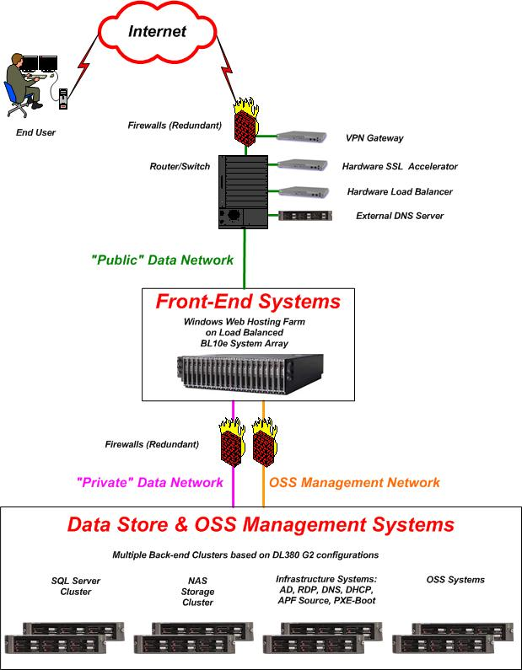
Figure 2: Typical Customer Reference Configuration for Windows Web Hosting

required infrastructure for remote management
This section describes the required infrastructure to remotely manage and deploy ProLiant BL or DL servers. There are many variations on what the installation environment can look like. Listed below are some common environment characteristics.
- All source servers, used as a basis for replicating and configuring additional target servers, need some form of a bootable media to initiate the installation on the source server. Possible media options are: diskette, CD-ROM, PXE-enabled NIC, and hard disk. The bootable media source almost always initiates a 16-bit DOS command shell environment.
- All source servers will need a local hard disk, or at least a controller that presents a disk to the BIOS as if it were local and bootable. The OS installation will only install to a local hard disk.
- All source servers will have access to a build source that contains the necessary files to successfully install the operating system and applications. It is recommended that the build source be accessible via some locally attached storage device.
- All servers need to be connected to a network. The installation process itself may not use the network, but, when complete, a network interface is usually configured.
Depending on the installation method, some additional environment features are required.
If a network-based unattended script is used, then a dynamic host configuration protocol (DHCP) server and a build-source file server are needed. It is not recommended to use hard-coded IP addresses.
PXE-based installations (Remote Installation Services (RIS), Altiris, Symantec Ghost, PowerQuest Drive Image Pro, etc.) generally require a DHCP, a Boot Information Negotiation Layer (BINL), and a Trivial File Transfer Protocol (TFTP) server. Windows 2000 RIS provides all of these on the same computer. However, integration of other PXE server products with Windows 2000 DHCP usually requires placement of the PXE server on a separate computer.
Figure 2 above illustrates a typical customer reference Windows Web Hosting deployment using ProLiant BL series servers, with all the necessary infrastructure servers required to dynamically and remotely manage these servers.
In this environment, the source server can:
- Obtain a dynamic IP address for the initial boot environment
- Boot from a diskette, PXE server, or CD-ROM
- Access the build source locally.
When adding target servers into this environment, it is a recommended goal that the target servers are exactly the same hardware-wise. Reducing the number of differences in target servers will reduce the complexity of the build. The more consistent the hardware, the easier it will be to duplicate the software and to replace a component when a failure occurs.

comparison of software deployment technologies
There are two fundamental types of software deployment. These are: imaging and scripting. This section describes these two technologies. Note that neither imaging nor scripting is best in all situations. Both technologies have their advantages and disadvantages.

imaging
In this section, the advantages and disadvantages of software deployment using imaging are discussed. Imaging is the technique of copying the entire operating system (snap-shot) and any applications from a source system for later deployment on other target systems. The speed of this type of deployment mainly depends on the speed and utilization of the network connecting the target and source systems, and the time required for multiple reboots of each of the target servers. During the deployment, each target server needs to reboot a number of times.
For mass deployments of servers, imaging is the preferred method of software deployment.
Some of the advantages of imaging include:
- Reproducibility – All the target systems end up being exact clones of each other. Elapsed time to deploy is much less than scripting.
- Multicast deployment is possible (many servers deployed at the same time).
- Operator time to deploy is minimized.
Some of the disadvantages of imaging include:
- After imaging is complete, scripts need to be run to modify the OS for proper deployment. These scripts, in their most simple state, would modify the computer name, SID, and IP address to be unique.
- In general, multicasting works best if the source and target systems have exactly the same hardware configuration. This is not always the case.
- Imaging is not as flexible as scripting.
- Some applications cannot be imaged. They have to be scripted.

scripting
In this section, the advantages and disadvantages of software deployment using scripting are discussed. Scripting is the technique of deploying the entire operating system and any applications via automated command line scripts. These scripts automatically answer the questions posed to an operator during a normal installation process. By hard-coding these answers within a script, the process is automated and reproducible.
Some of the advantages of scripting include:
- Reproducibility – All the target systems end up being exact clones of each other.
- Scripting is sometimes the only game in town. Some applications cannot be imaged. An example of one of these “non-imageable” applications is Microsoft Exchange. Microsoft Exchange has to be installed within the Active Directory environment in which it will reside.
- Scripting is more flexible. While scripting can produce exact clones, it also supports conditional logic so that a server can be tweaked for a particular custom setup.
- Any software deployment can be done with scripts.
- Target systems can be radically different.
- It is easier to modify scripts than it is to modify images.
Some of the disadvantages of scripting include:
- Scripting is unicast, meaning the deployment is single streamed. Given one deployment server, only one target server can be deployed at a time. Because of this, network bottlenecks could be incurred where large numbers of servers are being deployed.
- Scripting takes longer to deploy to one server.
- Scripting takes much longer to deploy a group of servers (no multicast is available).

summary of imaging versus scripting
In summary, the areas where you would use imaging versus scripting are listed below:
- Imaging
  - When little customization is needed to the system.
  - When a short time window is important for target server purposing or repurposing (such as a 3am - 5am maintenance window in a production data center).
  - When hardware is highly standardized such that Windows Plug and Play can automatically sort out hardware configuration differences.
  - When Multicast can be used.
- Scripting
  - When customization is needed. Scripting is more flexible than imaging. Imaging is not by itself flexible and requires scripting to complete certain complex tasks (such as installing Microsoft Exchange).
  - When hardware or software configurations are less standardized.

comparison of RDP and APF
In this section, two software deployment tools are discussed. These are the ProLiant Essentials Rapid Deployment Pack (RDP) and Microsoft Consulting Services’ Automated Purposing Framework (APF).

ProLiant Essentials Rapid Deployment Pack
The ProLiant Essentials Rapid Deployment Pack is an integrated HP and Altiris solution that automates the process of deploying and provisioning server software, enabling companies to quickly and easily adapt to changing business demands.
Server deployment can be a time-consuming task, especially if you need to deploy hundreds of servers quickly and reliably. The Rapid Deployment Pack is a server deployment product that facilitates the installation, configuration, and deployment of high-volumes of servers, via a GUI-based console, using either scripting or imaging technology. Server configuration time is reduced, making it possible to scale server deployments to high volumes in rapid fashion.
The ProLiant Essentials Rapid Deployment Pack integrates two powerful products: Altiris eXpress Deployment Server and the HP SmartStart Scripting Toolkit. This deployment solution is a fast, easy, point-and-click solution for deploying servers using imaging or scripting and maintaining server software images, all from a management console. The management console's graphical user interface provides an intuitive drag-and-drop of events, such as scripts and images, to deploy the operating systems and applications. Deploying a server is as easy as dragging and dropping predefined images or scripts onto one or hundreds of target servers.
Especially designed for the new ProLiant BL servers, the ProLiant Essentials Rapid Deployment Pack has advanced features that can detect and display server blades based on their physical rack, enclosure, and bay location. You can set the deployment console to automatically install pre-defined configurations on newly installed server blades.
The RDP tool uses imaging and scripting to deploy software. Listed below are some of the key features of RDP.
- Automated system provisioning provides the underlying foundation for the other three key technologies of an Adaptive Infrastructure.
- Provides a fast, easy, drag-and-drop solution for deploying standard server configurations and software builds in an automated fashion from a remote console.
- Includes the SmartStart Scripting Toolkit, providing an easy way to automate generation of standard server hardware configuration scripts.
- Provides instant out of the box functionality for the entire line of ProLiant ML, ProLiant DL and the new ProLiant BL servers.
- Provides advanced optimizations for the new ProLiant BL servers.
- Utilizes multicast and imaging technology allowing simultaneous deployments of multiple servers.
- Optional deployment services provide planning, design, implementation and support services. For example, the HP Insight Manager suite helps simplify deployment and redeployment thus making ProLiant servers manageable right from the start, ensuring continuous operations and improving efficiency as the customer’s environment changes and grows.
- RDP contains a PXE boot server.
For more information on ProLiant Essentials Rapid Deployment Pack, please see http://www.compaq.com/products/servers/management/rapiddeploy.html
A screen shot of the RDP management console is shown in Figure 3.
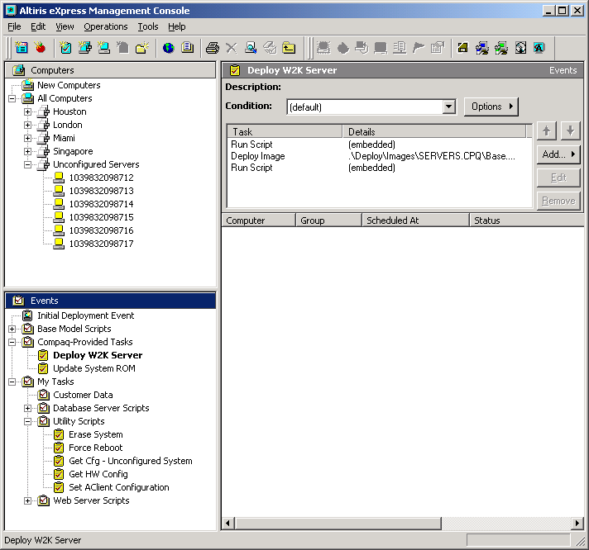
Figure 3: Sample RDP/Altiris Deployment Server Management Console Window

Microsoft Automated Purposing Framework
The Microsoft Automated Purposing Framework (APF) is a collection of scripts and utilities that enable a service provider to consistently and reliably install the Windows operating system and applications on one or more target computers. It is called a framework because it has a structured core processing architecture, which implements the primary stages of a computer installation.
The APF tool uses scripting to deploy software. It can only deploy on one server at a time (unicast) and does not support PXE booting. It can leverage either Windows unattended installation methods or imaging tools to transport a prepared image to the target server, using either the multicast or unicast methods provided by the image tool of choice. APF requires a boot diskette, which can be delivered manually or virtually.
Listed below are some of the key features of APF:
- Flexible. The APF integrates with all of the supported operating system installation techniques (unattended answer files, SysPrep, RIS).
- Extensible. APF supports different hardware vendors’ utilities for configuring the computer. The Framework also makes it easy to add new post-OS installation and configuration scripts for the applications.
- Scalable. Because the Framework hooks into existing Windows installation techniques, it can be used to configure thousands of computers.
- Reliable. The Framework uses standard built-in Windows scripting to reduce or eliminate human intervention and improve repeatability.
- Consistent interface specification. The APF uses a consistent set of manifest files to configure a target computer. This consistency enables external provisioning systems to easily front-end the process.
- Reduction in complexity. The computer installation and configuration process is abstracted to a handful of core scripts and there are only a few Windows answer file settings that need to be known to make it work. APF provides a highly reusable library of scripts that themselves create and leverage answer files that the applications need.
- Logging and error handling. Each step of the process is logged and any detected failures cause the process to stop for inspection. In many cases, after the failure is repaired, the process can be restarted from the point of failure.
Note that Microsoft APF does not know or do anything about external network devices or Storage Area Network (SAN) management systems other then the server HBA. Its scope is the server.

typical RDP and APF customer usage scenarios
This section categorizes some of the customer usage scenarios faced by a service provider, and how RDP and APF can be used to resolve these problems.
- Large data center server deployment - Sheer number and complexity dominate this need, and RDP and APF both address that need. Additionally, time pressures to deliver new customer servers by a deadline make building a machine reliably very important from a QA and customer satisfaction viewpoint and important for service level agreement (SLA) goal achievement. Moreover, use of automated tools enables, over time, less skilled operators to perform these tasks. All the preceding contribute to better total cost of ownership (TCO) or servers/administrators ratio.
- Small web farm - RDP and APF enable quicker deployment of small web farms. For example, they enable a consultant to appear on site ready to build and configure servers per customer expectations. The consultant uses the RDP and APF toolsets and walks out in half the time it used to take performing this manually. The consultant can share the reduced cost of the engagement with his customer.
- Complex configuration by a small IT staff – RDP and APF are primarily used to enable a repeatable process for complicated tasks. These may be low volume but challenging to perform correctly. Of great value is the "Bus Test" rule. (If the IT person who built the server gets hit by a bus, can someone else rebuild it later, or build a new one as an expansion of a site or a new branch office?)
- Branch Office server deployments - The goal is to reduce the cost of supporting branch office expansion and updates by reducing the number of trips required by IT staff to a remote location. It is possible, for example, to drop ship a bare server to a remote location (saving shipping and staff handling expense, time en-route, and exposure to loss or damage) and have local staff plug the new box in and, if necessary, feed it a diskette or bootable CD-ROM. They may answer a few upfront questions that launch the build process. The process can have notification built-in, so that the IT staff can track the build process and know when the box is ready for any final configuration changes done by hand, using terminal services or an equivalent remote-access method. Reducing travel expenses and time away from the office for essential personnel saves money and time.
- Lab test preparation - The goal is to automate the baseline configuration for a lab test environment of any number of servers. Repeatability is paramount. Time saved equals more test cases run and/or shorter product cycles. Better quality should also result. Staff expertise can be directed to the application under test, and not in troubleshooting the underlying configuration.
- Classroom prep - Imaging tools (RDP) are king in this application. In some locations, imaging alone is not enough. For example, the training room empties at 5pm Friday night, and the equipment must be turned around by Monday at 8am. If unique parameters are needed, such as IP addresses, several domain controllers, or DNS, classroom preparation is labor intensive without scripting tools (APF). Many workshop offerings require many small domains to be built, all of which are unique.

software deployment stages

initial requirements
As mentioned in the section titled Required Infrastructure for Remote Management some components in the infrastructure need to be in place before a customer can deploy a Windows Web Hosting (WWH) environment utilizing either RDP or APF. This paper, for the most part, assumes that these requirements are met within the IT infrastructure into which the deployment will be made. In summary, a WWH deployment environment expects:
- PXE Server on the same subnet as the servers to be deployed
- DHCP Server on the same subnet as the servers to be deployed
- Image/binary sources available on the same subnet as the servers to be deployed.
For more details on these initial requirements, please reference the Microsoft Solution for Windows Web Hosting: Implementation & Deployment guide, which is part of the Microsoft WWH Prescriptive Architecture Guide.
Also, in order to perform a mass deployment of multiple servers, it is recommended that the scripting technology within RDP be used to create the first server. Once the first server is built, it is recommended that the imaging technology, also within RDP, be used to perform the mass deployment.

stage 1) first server build
Imaging technology is the preferred method to deploy software to multiple servers. In order to use imaging technology, however, a “first server image” has to be created. Although both RDP and APF can be used to create the first server using their respective scripting technology, it is recommended that the scripting tools within RDP be used to create the first server. Once this first server is built, an image can be created that can be deployed to the 2nd through n^{th} server using imaging technology in RDP.
Note that with the ProLiant BL line of computers, RDP is all but mandatory to perform this initial build. The only other way to provision a ProLiant BL server is manually through the use of the Diagnostic Adapter that is supplied with the ProLiant BL servers when purchased.

stage 2) pre-operating system deployment
As part of the pre-OS deployment, the BIOS NVRAM on each of the computers must be configured. Typically, the BIOS must be "tuned" to support the specific OS that is being deployed. The BIOS must also detect the hardware installed and configure itself to support the hardware.
The end-result of configuring the hardware is a BIOS that is optimized for the OS you are installing and a disk drive that is available for the installation of the OS.
HP provides a CD-ROM-based server configuration utility for its servers called SmartStart. While the specific instructions for individual server models differ, each has you boot from the CD-ROM and answer questions to enable you to configure the BIOS. If you have a RAID controller, the utility detects this and gives you a tool to configure the controller and disks.
Scripting the hardware configuration can greatly reduce the computer preparation time. Currently, HP provides DOS-based utilities that enable you to script the configuration of hp hardware (SmartStart Scripting Toolkit). RDP takes advantage of these utilities allowing a fully integrated installation process.

stage 3) operating system deployment
As described earlier, there are several methods of installing the operating system. It is recommended that RDP be used to deploy the OS.
RDP has a PXE-based install method that requires the NIC in the target server to be PXE enabled so that a MS-DOS boot image file can be downloaded from the PXE server.
Once this MS-DOS boot image file is downloaded, the system boots to MS-DOS and copies the “first server build” image created in stage 1 to a local drive on the target server. The system then reboots. At that point, it is an exact clone of the source server.

stage 4) post-operating system deployment
Purposing a computer for service involves configuring the computer and installing applications. It is recommended that APF be used for this stage when complex post-OS installations need to occur.
Configuring the computer basically means adding operating system components and tuning the OS for its intended purpose.
When an application is installed, features are added that make the computer more useful for its intended purpose. If installing several products manually, this stage can take several hours. The more this stage can be scripted, the faster a computer can be put into service.
Another problem with manual installations that is eliminated by scripting is human error. If someone installs several computers a day, it is very easy to make mistakes. Scripting this process dramatically improves the reliability and repeatability of this process.
APF enables integration of scripted application installations and is the principal reason why it was designed and built. Developing an application installation script is outside the scope of this document, but scripts already exist for many applications.
After this stage is complete, the computer is ready for service.

coexistence of APF and RDP - the best of both worlds
As noted above, both imaging and scripting have their advantages and disadvantages. Although RDP and APF could be used completely by themselves to deploy software, there are advantages to simultaneously using both RDP and APF. This section describes a recommended method in which RDP and APF could be used together.

RDP calling APF in post operating system deployment method
In this method, RDP calls APF. This is the recommended way of utilizing these two software deployment tools together. A summary of the four stages of this deployment scenario is listed in Table 5. In this method, RDP is used in the pre-OS and OS stages and APF is used in the final post-OS stage.

Table 5: RDP Calling APF in Post OS Deployment
Stage 1 – First Server Build | Stage 2 – Pre OS | Stage 3 – OS | Stage 4 – Post OS
Uses RDP | Uses RDP | Uses RDP | Uses APF
Creation of OS image to be used in stage 2 | HP Remote Insight Lights-Out Edition (RILOE) or equivalent (iLO or iA) turns on server. SmartStart used to configure storage. Server then PXE boots from Altiris server and starts downloading OS image. | Image deployment of base OS with RunOnce Registry value set to run APF on first reboot. | Installation of “non-imageable” applications” and OS tweaks

benefits of using automated deployment tools in WWH configurations
The following list summarizes the benefits and savings from using these products and how they impact customer businesses:
- Direct saving in data center labor costs (based on Microsoft’s estimates)
- Initial Deployments: 90% reduction in time
- Software Maintenance: 4X improvement in maintenance window
- Shift in required skills to less costly labor
- Ability to quickly adapt to changing business demands and security issues
- Faster Upgrades
- Faster Content Refresh
- Faster Virus elimination
- Faster implementation of security fixes
- Faster Server Redeployment
- Modify Server Roles to meet changing business demands (re-provisioning)

summary
This guide provides information for deploying Windows Web Hosting solutions on ProLiant platforms using both ProLiant Essentials and Microsoft automated deployment tools. The combination of RDP and Microsoft APF radically simplifies and reduces the time required to deploy server software.
HP is investing in technologies for an Adaptive Infrastructure that enables customers to maximize their existing IT investments while adapting easily to the changes necessary to remain competitive.
At the heart of the blueprint for the Adaptive Infrastructure are four categories of technologies:
- Virtual Presence and Control
- Automated System Provisioning
- Intelligent Fault Resilience
- Dynamic Resource Scaling
HP considers these categories vital in making IT more adaptive, efficient and responsive to your needs.
In each of these technology areas, HP has already established hardware and software solutions that provide the first-generation architectures in an Adaptive Infrastructure. As advances are made, HP will bring these innovations into product lines to further enhance the infrastructure. The net effect of the Adaptive Infrastructure will be an IT organization that can adapt quickly to changing business conditions, conserve and efficiently use valuable IT resources, and provide the highest level of customer service.

appendix – references
This appendix lists the references for this solution guide:
- Microsoft PAG: Microsoft has created a number of “Prescriptive Architecture Guides” or “PAGs”. There is a PAG for the “Microsoft Solution for Windows Web Hosting.” It contains the following sub-guides:
  - Architecture & Design
  - Implementation & Deployment
  - Operations
  - Migration
  - Tests and Benchmarks
  - Appendices
Please refer to the “Implementation & Deployment” guide for more details on items mentioned in this guide. Please refer to other sub-guides in the PAG for a broader picture of their WWH solution.
- Automated Purposing Framework Operations Guide, October 4, 2001
- Table A-1 lists several HP and Microsoft guides providing more detail in many of the areas covered in this guide
Table A-1: References
Adaptive Infrastructure | http://www.compaq.com/ai
Remote Insight Lights-Out Edition (RILOE) II | http://www.compaq.com/manage/riloe2.html
Integrated Lights-Out Advanced Pack (iLO) | http://www.compaq.com/manage/iloadv-description.html
Integrated Administrator (iA) | http://www.compaq.com/products/servers/proliant-bl/e-class/integrated-admin.html
ProLiant Essentials Rapid Deployment Pack | http://www.compaq.com/products/servers/management/rapiddeploy.html
SmartStart Scripting Toolkit | http://www.compaq.com/manage/toolkit.html
ProLiant Essentials | http://www.compaq.com/products/servers/proliantessentials/index.html
HP Windows Web Hosting site | http://www.compaq.com/solutions/showroom/microsoft-wwh.html
Microsoft Windows Web Hosting site | http://www.microsoft.com/serviceproviders/windowswebhosting/default.asp

http://www.compaq.com/products/servers/technology/ai/index.html

