F5 BIG-IP server blade on hp ProLiant servers
abstract: This paper shows how HP ProLiant BL10e server blades, loaded with F5 BIG-IP Blade Controller software, can provide load balancing and traffic management to server blades in multiple server blade enclosures. This paper explores how the Interconnect Switches in each server blade enclosure need to be configured, as well as the configuration of the BIG-IP Blade Controller. This paper was jointly written by HP and F5 Networks.

contents
introduction 3
overview of the solution 3
solution overview diagram 6
benefits 7
configuration guidelines and best practices 9
interconnect switch configuration 9
BIG-IP Blade Controller configuration 13
server blade configuration 14
summary 14
appendix a: additional information 15

notice

Technical information in this document is subject to change without notice.

Microsoft and Windows are U.S. registered trademarks of Microsoft Corporation.

© 2002 Hewlett-Packard Development Company, L.P.

november 2002
5981-4730en

introduction
The HP ProLiant BL e-Class server blades are the first power-efficient, ultra-dense server blades engineered for the enterprise. The ProLiant e-Class server blade enclosure provides redundant hot-plug power and redundant hot-plug cooling to all installed ProLiant BL10e server blades. Included with each ProLiant BL e-Class server blade enclosure is the HP Integrated Administrator for remote, out-of-band management. e-Class server blades are ideal for static web hosting and single function application servers.
With the release of ProLiant BL p-Class servers, higher performance applications can be run on server blades. With dual CPUs, integrated RAID, and other performance features, p-Class server blades are ideal for high performance applications such as streaming media, dynamic web hosting, and terminal serving.
F5 Networks’ BIG-IP Blade Controller is the essential component for providing high availability, scalability, security and performance for server blades and applications. The BIG-IP Blade Controller is available as a software option for BL10e blades. BIG-IP Blade Controller increases high availability by performing application health monitoring, increases scalability by allowing customers to easily add additional server blades for an application, and increases performance by dynamically load balancing traffic between multiple server blades.
This solution guide shows how ProLiant BL10e server blades, loaded with BIG-IP Blade Controller software, can provide load balancing and traffic management to server blades in multiple server blade enclosures. This paper explores how the Interconnect Switches in each server blade enclosure need to be configured, as well as the configuration of the BIG-IP Blade Controller.

overview of the solution
BIG-IP Blade Controller is not dependent on the operating system or hardware platform of the servers to which it sends load balancing requests. In addition, the servers may be located anywhere on the network, as long as load balanced traffic to and from the servers passes through the BIG-IP Blade Controller. For these reasons, BIG-IP Blade Controller software running on e-Class server blades can provide load balancing and traffic management functions for server blades in the same server blade enclosure, and for other e-Class or p-Class server blade enclosures.
Having this capability gives customers the ability to consolidate BIG-IP’s load balancing and high availability features into e-Class server blade enclosures – with each BIG-IP Blade Controller providing services to multiple server blades. Each e-Class enclosure can house twenty (20) server blades. Therefore, one e-Class enclosure could have ten (10) redundant pairs of BIG-IP Blade Controllers, with each pair dedicated to certain applications. The Interconnect Switch in the enclosure provides high-speed connectivity to the rest of the network.
By following this model, customers have the ability to dedicate BIG-IP resources to specific applications, servers, or departments without sacrificing valuable rack space and other infrastructure resources. With an e-Class server blade enclosure in place, additional blades can be added easily and provisioned with BIG-IP Blade Controller software. In addition, BIG-IP Blade Controller’s licensing model allows customers to purchase licenses for additional servers as needed
BIG-IP Blade Controller can provide load balancing and traffic management for many different applications, including the following:
- Web-enabled applications
- Citrix MetaFrame XP
- Microsoft® Windows® Terminal Servers
- Outlook Web Access
- Web cache servers
- Firewalls
- VPN servers
BIG-IP Blade Controller can perform a variety of functions related to load balancing and traffic managements, including the items outlined in Table 1.
Table 1. BIG-IP Controller Load Balancing Functions
“Observed” mode dynamic load balancing | BIG-IP load balances traffic to the server with the most capacity and fastest response time
Extended Content Verification (ECV) | BIG-IP checks the availability of a server by performing an HTTP request for specified content
Connection mirroring | With two BIG-IP Blade Controllers in a redundant pair, BIG-IP mirrors connection information so that connections will not be lost if a failover occurs
HTTP cookie-based persistence | BIG-IP can maintain session integrity by using HTTP cookies to send clients to the correct server
“Rules” for Layer 7 load balancing | BIG-IP can evaluate Layer 7 information, such as the type of content being requested, to make intelligent load balancing decisions
BIG-IP Blade Controller is available as a software option for ProLiant BL10e server blades. Installing BIG-IP Blade Controller makes the server blade into a “dedicated” load balancing server – no additional software can be installed on the server blade. Customers must purchase, from F5 Networks, the BIG-IP Blade Controller software, then purchase licenses for the servers they want to provide load balancing and traffic management for. These server licenses are available in increments of one or ten. In addition, custom site license agreements can be made for large BIG-IP Blade Controller installations.
The number of servers BIG-IP can load balance depends greatly on the type of application, and its processing and bandwidth requirements. Typically, BIG-IP Blade Controller is used for load balancing anywhere from 2 to 20 server blades. For configurations requiring greater network throughput, F5 Networks’ IP Server Appliances or IP Application Switches would be a better choice.

solution overview diagram
In this solution, BIG-IP is providing load balancing and traffic management for eight (8) web servers, serving static web content. Each p-Class enclosure houses four (4) web servers. While web hosting is the sample application used here, most of this configuration is generic enough to be applied to a variety of applications.
Figure 1 illustrates the BIG-IP Blade Controller environment for this solution. BIG-IP Blade Controller is running on two server blades in the BL e-Class enclosure. The uplinks from switch module A on the e-Class enclosure are connected to the two enterprise access switches, utilizing Spanning Tree Protocol for redundancy. The uplinks from switch module B on the e-Class enclosure are connected to each of the p-Class enclosures. On the two p-Class enclosures, switch 1 has one uplink connected to the e-Class enclosure, and one uplink connected to an enterprise access switch. Switch 2 has one uplink connected to an enterprise access switch.
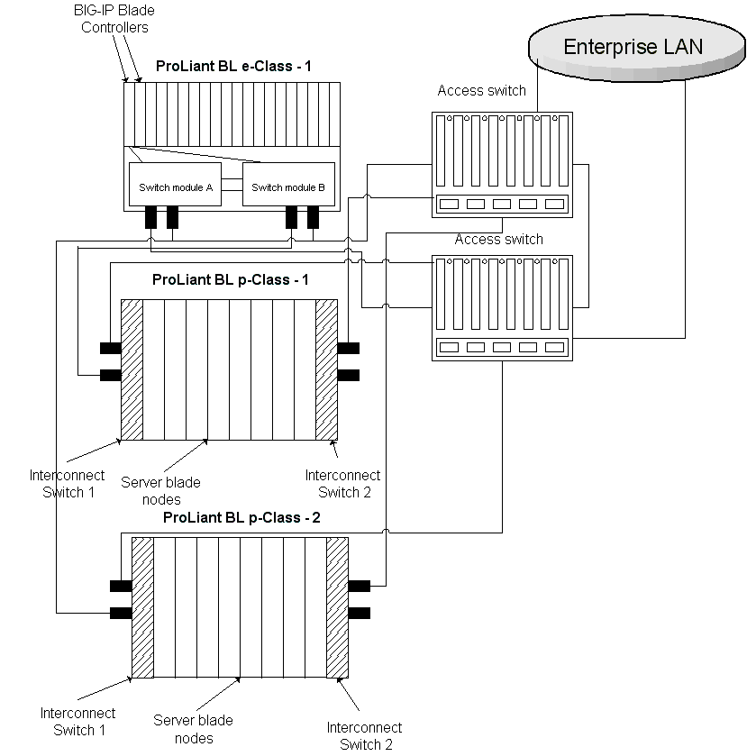
Figure 1. BIG-IP Blade Control Environment

benefits
This Solution provides the following benefits:
- High availability
- BIG-IP Blade Controller monitors the applications running on server blades
- BIG-IP is deployed in a redundant pair
- Multiple switch interconnects and Spanning Tree provide link redundancy
- Scalability
- Easily add additional server blades or additional server blade enclosures to BIG-IP’s load balancing pools as needed
- Add additional BIG-IP Blade Controllers for new applications as needed
- Security
- BIG-IP “hides” the server blade farm from the enterprise network by using a private IP subnet and network address translation
- Performance
- BIG-IP Blade Controller provides intelligent load balancing based on server blade capacity and performance

configuration guidelines and best practices
This section details the configurations needed to implement this server blade infrastructure.

interconnect switch configuration
In this configuration, the server blade enclosures use the C-GbE Interconnect Switches. The C-GbE Interconnect Switch offers an embedded web-based Management interface (HTML) that allows users to manage each C-GbE Interconnect Switch from anywhere on the network through a standard browser. The C-GbE Interconnect Switch is an optional integrated switch card that is available for both the e-Class and p-Class ProLiant servers. Using the C-GbE Interconnect Switch option allows administrators to reduce the cabling needs and complexity of the server blade environment.

e-Class interconnect switch configuration
The e-Class Interconnect Switch architecture in this solution is redundant, with two independent switch modules (named Switch Module A and Switch Module B) that are cross-connected internally (See Figure 2 for Interconnect Switch Architecture Diagram below). Each ProLiant BL10e server blade has two NICs. NIC1 is managed by Interconnect Switch A and NIC2 is managed by Interconnect Switch B. Each switch module provides 10/100/1000 Gigabit Layer 2 switching technology.

interconnect switch architecture diagram
Figure 2: Interconnect Switch Diagram

spanning tree protocol (stp) configuration

The Spanning Tree Protocol (STP) is used to provide redundant links between switches. When multiple links to the same switch are detected, STP chooses one link as primary. Duplicate links are put into a standby state. If the primary link fails, a standby link will be activated.
To support the configuration in this Solution, Spanning Tree should be globally enabled on each switch module of each e-Class C-GbE Interconnect Switch. The Spanning Tree settings are accessible through the web-based management interface. Figure 3 shows how the STP Port settings window allows you to configure Spanning Tree Protocol functions for individual ports.
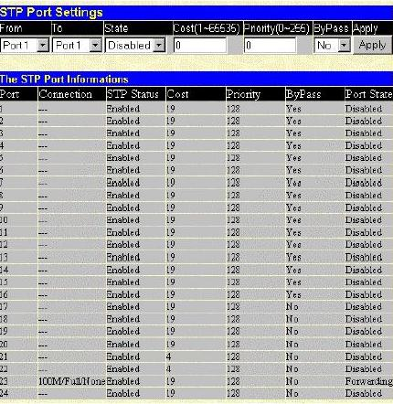
Figure 3: STP Port Settings

virtual local area network (vlan) configuration

VLANs allow for greater security and control over network traffic. For this Solution, two VLANs need to be used. By default, all ports on each switch module are assigned to a VLAN called DEFAULT_VLAN, with VLAN ID 1. The following changes need to be made:
- e-Class server blade enclosure 1, Switch Module A
- Create a VLAN called EXTERNAL – use a VLAN ID that is appropriate for your network
- Add ports 1 and 2 as Egress members of VLAN External, Untagged
- e-Class server blade enclosure 1, Switch Module B
- Leave all ports in the VLAN DEFAULT_VLAN
- Leave all ports in the VLAN DEFAULT_VLAN
Figure 4 shows how the 802.1Q Static VLANs window allows you to create or delete entries to the 802.1Q Static VLAN table. Figure 5 shows how the 802.1Q Static VLAN Setup window allows you to change several parameters on each VLAN ID (VID).

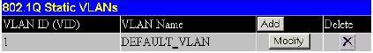
Figure 4: 802.1Q Static VLAN

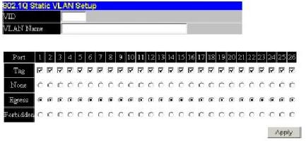
Figure 5: Static VLAN setup
Refer to the following link for additional information on the ProLiant e-Class C-GbE Interconnect Switch:
ProLiant BL e-Class C-GbE Interconnect Switch

p-Class interconnect switch configuration
The p-Class Interconnect Switch architecture is redundant, with two independent Interconnect Switches that are cross-connected internally. Each p-Class server blade has four NICs. NIC1 is managed by Interconnect Switch A and NIC2 is managed by Interconnect Switch B. NIC3 is assigned to HP iLO and NIC4 available for any purpose. Each switch module provides 10/100/1000 Gigabit Layer 2 switching technology

spanning tree protocol (stp) configuration
The Spanning Tree Protocol (STP) is used to provide redundant links between switches. When multiple links to the same switch are detected, STP chooses one link as primary. Duplicate links are put into a standby state. If the primary link fails, a standby link will be activated.
To support the configuration in this Solution, Spanning Tree should be globally enabled on each Interconnect Switch.

virtual local area network (vlan) configuration
VLANs allow for greater security and control over network traffic. By default, all ports on each switch module are assigned to a VLAN called DEFAULT_VLAN, with VLAN ID 1. For the p-Class server blade enclosures, all ports on each interconnect switch can be left in the VLAN DEFAULT_VLAN

BIG-IP Blade Controller configuration
In this configuration, BIG-IP Blade Controller is configured as a redundant pair, running on server blades 1 and 2 in the ProLiant e-Class server blade enclosure 1. The following configurations are necessary to support this Solution:

vlan Configuration
Like a switch, BIG-IP Blade Controller is configured with VLANs that its NICs are assigned to. The following VLANs will be used:
- EXTERNAL, containing interface 1.1 on each BIG-IP Blade Controller. Configure this VLAN as Untagged.
- DEFAULT_VLAN, containing interface 1.2 on each BIG-IP Blade Controller. Configure this VLAN as Untagged.

ip subnets used
This Solution uses two IP subnets. One subnet is used for inbound traffic to BIG-IP and communication with the enterprise network, and a private (RFC 1918) subnet is used for the server blades running applications. This setup has the following advantages:
- A minimal number of IP addresses that are routable on the enterprise network are needed
- BIG-IP “hides” the server blade subnet from the rest of the network, increasing security
BIG-IP’s EXTERNAL VLAN will use IP addresses routable in the enterprise network for Virtual Servers, Self IP Addresses, and any other needed configurations
BIG-IP’s DEFAULT_VLAN will use a private IP subnet for communication with the server blades running applications

secure network address translation (snat) automap
BIG-IP Blade Controller has a special feature call SNAT Automap. This allows BIG-IP to perform network address translation on packets sent from server blade nodes to resources that are external to BIG-IP. This feature is necessary in order to “hide” the internal IP addresses used by the server blades from the enterprise network, while still allowing those server blades to access other network resources.

create a snat automap for the vlan default_vlan
To add a SNAT using the automapping feature, the following procedures must be completed:
- 1. Enable the SNAT automap attribute on any self IP addresses
- Add the SNAT, specifying the Automap feature

virtual servers
Virtual Servers are created on BIG-IP for each application that will be load balanced by BIG-IP. This allows the client of the application to access one virtual address, while many physical servers are used for the application behind BIG-IP.

create virtual servers on the external vlan for each application that is being load balanced
To create a virtual server, the following procedures must be completed:
- Create a pool containing the servers to be load balanced
- Create a virtual server using the IP address designated for the application, and specifying the pool of servers

server blade configuration
Each server blade in the p-Class server blade enclosures can be used to service traffic to BIG-IP Virtual Servers. These server blades should have the following configuration:
- Each server blade should have an IP address on the private IP subnet used
- Each server blade’s IP configuration should have BIG-IP’s shared self-IP address on the DEFAULT_VLAN as its default gateway IP address

summary
This Solution Guide shows how ProLiant BL10e server blades, loaded with BIG-IP Blade Controller software, can provide load balancing and traffic management to server blades in multiple server blade enclosures. This paper explores how the Interconnect Switches in each server blade enclosure need to be configured, as well as the configuration of the BIG-IP Blade Controller.

appendix a: additional information
Table A-1: References
HP Adaptive Infrastructure | http://www.hp.com/solutions/ai
ProLiant BL Servers | http://h18004.www1.hp.com/products/servers/platforms/index-bl.html
ProLiant BL e-Class | http://h18000.www1.hp.com/products/servers/proliant-bl/e-class/index.html
ProLiant BL p-Class | http://h18000.www1.hp.com/products/servers/proliant-bl/p-class/index.html
Integrated Administrator (iA) | http://h18000.www1.hp.com/products/servers/proliant-bl/e-class/integrated-admin.html
F5 BIG-IP Blade Controller | http://www.f5.com/f5products/bigip/BladeController

Integrated Lights-Out (iLO) Advanced ships standard on every ProLiant BL p-Class server blade

