h[
.
.
.
.
.
.
.
.
.
.
.
.
.
.
.
.
.
.
.
.
.
.
.
.
.
.
.
.
.
.
.
.
.
.
.
.
.
.
.
.
.
.
.
.
.
.
.
.
.
.
.
.
.
.
.
.
.
.
.
.
.
.
.
.
.
.
.
.
.
.
.
.
.
.
.
.
.
.
.
.
.
.
.
.
.
.
.
.
.
.
.
.
.
.
.
.
.
.
.
.
.
.
.
.
.
.
.
.
.
.
.
.
.
.
.
.
.
.
.
.
.
.
.
.
.
.
.
.
.
.
.
.
.
.
.
.
.
.
.
.
.
.
.
.
.
.
.
.
.
.
.
.
.
.
.
.
.
.
.
.



Dec 1999
Prepared by
Micky Balladelli
Senior Consultant
Compaq Services
Applied Microsoft Technologies Group
Compaq Computer Corporation
Understanding Active Directory Replication
One of the most important features of Windows 2000 is the Active Directory, an extensible and programmable Directory Service integrated with the Operating System.
New Active Directory enabled applications are able to store objects and configuration data in the directory and have this information replicated to servers throughout the enterprise, using the standard replication mechanisms and topology established by Windows 2000. The first of these applications is the next major functionality release of Microsoft Exchange Server, codenamed “Platinum.” Platinum stores information about messaging users, routing topologies, administration, and servers in the Active Directory. Successful deployments of Windows 2000 and its applications require administrators and system designers to understand Active Directory replication.
This paper provides a technical drill-down of the replication features implemented for the Active Directory in Windows 2000 and reviews some of the design options and features that should be considered during deployment projects..

Notice

.
.
.
.
.
.
.
.
.
.
.
.
.
.
.
.
.
.
.
.
.
.
.
.
.
.
.
.
.
.
.
.
.
.
.
.
.
.
.
.
.
.
.
.
.
.
.
.
.
.
.
.
.
.
.
.
.
.
.
.
.
.
.
.
.
.
.
.
.
.
.
.
.
.
.
.
.
.
.
.
.
.
.
.
.
.
.
.
.
.
.
.
.
.
.
.
.
.
.
.
.
.
.
.
.
.
.
.
.
.
.
.
.
.
.
.
.
.
.
.
.
.
.
.
.
.
.
.
.
.
.
.
.
.
.
.
.
.
.
.
.
.
.
.
.
.
.
.
.
.
.
.
.
.
.
.
.
.
.
.
.

The information in this publication is subject to change without notice.

Compaq Computer Corporation shall not be liable for technical or editorial errors or omissions contained herein, nor for incidental or consequential damages resulting from the furnishing, performance, or use of this material.
This publication does not constitute an endorsement of the product or products that were tested. The configuration or configurations tested or described may or may not be the only available solution. This test is not a determination of product quality or correctness, nor does it ensure compliance with any federal, state or local requirements. Compaq does not warrant products other than its own strictly as stated in Compaq product warranties.
Product names mentioned herein may be trademarks and/or registered trademarks of their respective companies.
Compaq, Contura, Deskpro, Fastart, Compaq Insight Manager, LTE, PageMarq, Systempro, Systempro/LT, ProLiant, TwinTray, LicensePaq, QVision, SLT, ProLinea, SmartStart, NetFlex, DirectPlus, QuickFind, RemotePaq, BackPaq, TechPaq, SpeedPaq, QuickBack, PaqFax, registered United States Patent and Trademark Office.
Aero, Concerto, QuickChoice, ProSignia, Systempro/XL, Net1, SilentCool, LTE Elite, Presario, SmartStation, MiniStation, Vocalyst, PageMate, SoftPaq, FirstPaq, SolutionPaq, EasyPoint, EZ Help, MaxLight, MultiLock, QuickBlank, QuickLock, TriFlex Architecture and UltraView, CompaqCare and the Innovate logo, are trademarks and/or service marks of Compaq Computer Corporation.
Other product names mentioned herein may be trademarks and/or registered trademarks of their respective companies.
©1999,2000 Compaq Computer Corporation. Printed in the U.S.A.
Microsoft, Windows, Windows NT, Windows NT Advanced Server, SQL Server for Windows NT are trademarks and/or registered trademarks of Microsoft Corporation.

December 1999
2nd Draft.
Feedback may be addressed directly to micky.balladelli@compaq.com.

Thanks to Tony Redmond for his invaluable support in reviewing this white paper.
Thanks also to Dung Hoang Khac for spending so many hours in airport lounges with the support of napkins to explore, share and help me understand the implications of this technology.
Also many thanks to Andreas Luther, from Microsoft, for the many late night discussions spent reviewing the Windows 2000 Academy materials, which were the base for this white paper.

Table of contents
Introduction 5
Replication Basics 5
What is Replication? 5
Domain Controllers 6
Replication Operations 7
Update Types 7
Naming Contexts 8
Update Sequence Number 9
The Replication Process 10
Creation of an object 10
Replication to a second DC 11
Object Manipulation on the second DC 11
Replication back to DC1 12
Understanding Propagation Dampening 13
High-Watermark Vector table 13
Up-to-Dateness Vector Table 14
How replication activity is triggered and dampened 14
Step 1: The creation of a user and replication to immediate partners 15
Step 2: Replication to the second level partners 17
Step 3: Multiple Replication partners 18
Step 4: Propagation dampening 19
Sites 20
Replication transports 21
Intra-site vs Inter-site replication 21
Replication Topologies 22
Knowledge Consistency Checker 22
Connection objects 23
Intra-Site Replication Topology Generation 24
Rings of Replication 24
Global Catalog Replication 29
Site Topology 31
Fundamentals of Site Topology Design 31
Site Links 32
Bridgehead server 35
Site Links implementation 37
Site Link Bridges 38
Creating replication topologies 39
Network Topologies and Site Design 40
Hub and Spoke Topology 40
Ring Topology 41
Mesh Topology 42
Replication challenges 42
Urgent Replication 42
Password uniqueness 42
Collisions 43
SMTP Replication Process 43
RPC versus SMTP Replication 45
Conclusion 46
Appendix - Registry Settings 46
Replication Priority 46
Replication Packet Size 46
Replication Latency 47
Replication TCP/IP Port number 47
Logging when KCC is running 47

Introduction
This white paper reviews various aspects of Active Directory replication. We will introduce the terminology used to describe the replication technology used in Windows 2000 and explain how data is replicated between Windows 2000 servers. We will also look at how replication topologies are generated within a Windows 2000 site and between sites. Finally, we will review some possible designs for a replication topology and provide recommendations.
Replication in Windows 2000 is changed drastically from previous versions of Windows NT. For Windows NT, replication was a simple matter of copying information from the Primary Domain Controller (PDC) system to the other computers in a domain that act as Backup Domain Controllers (BDCs). Windows 2000 uses a multi-master, store and forward replication mechanism to allow changes to be made at any controller within an organization and have those changes successfully copied to all other domain controllers. Replication is the mechanism that ensures that data is copied in a robust and reliable manner so that domain controllers are updated in the most efficient and controlled way, no matter how distributed the organization.
One of the design goals of Windows 2000 is to accommodate the requirements of large enterprises. Windows NT replication was too simple to be able to match the scalability issues that are addressed in Windows 2000. The extensibility of the Active Directory and the number of objects it can support far surpass the capabilities of the single master replication model used in previous versions of Windows NT. A new replication strategy with the ability to sustain a large number of objects in an environment where domains are grouped together to form a global namespace had to be defined.
In this paper we assume that the reader is already familiar with the basic concepts introduced in Windows 2000. To get acquainted with those concepts, you are encouraged to read Active Directory – A technical overview white paper, which can be obtained from http://www.compaq.com/activeanswers.
Replication Basics
What is Replication?
Windows 2000 domain controllers (DC) hold a replica of all of the objects belonging to their domain and have full read/write access to these objects. Administrators can perform management operations using any DC in a domain. These operations affect the state or the value of an object and must therefore be replicated to the other DCs. Replication is the process of propagating object updates between DCs.
The goal of replication is to allow all controllers to receive updates and to maintain their copies of the Active Directory database in a consistent state. Replication is not triggered immediately as an object has been modified as this could trigger a flood of replication operations if the directory is ever being manipulated by programs that insert or update many records in a short period of time, such as directory synchronization procedures. Instead, replication is triggered after a period of time, gathering all changes and providing them to other controllers in collections. Therefore, in normal operation the Active Directory on any controller can be regarded as always being in a state of loose consistency as replication changes may be on the way from other controllers. Eventually the changes arrive and DCs synchronize with each other. However, when performing a management operation an administrator does not know if another user or another administrator is performing the same operation on another DC. This could lead to a replication collision that must be resolved. We will see how these collisions are resolved in a later section.
Domain Controllers
Windows NT 4.0 uses a single-master replication model. This means that operations can only be performed on the Primary Domain Controller (PDC) as it was the only DC with read/write access to the database. Operations performed on the PDC are then replicated to Backup Domain Controllers (BDC). BDCs maintain a read-only copy of the database and are designed to provide a replica of the domain information closer to the users. This allows faster authentication because users are not required to connect to distant DCs over a potentially, slow link.
In Windows NT 4.0, the replication granularity is coarse. If a user or an administrator modified a password, the entire user object with all its attributes has to be replicated to all BDCs in the domain. In other words, NT 4.0 uses object-level replication. The replication topology is simple and consists of linking the PDC to all the BDCs in the same domain.
In a Windows 2000 infrastructure every Domain Controller (DC) maintains a copy of the Active Directory database with full read/write access to all of the objects belonging to the domain. This implies that if an operation is performed on one of the DCs, it must then be replicated to all other DCs in the domain. If domains are linked together to form a forest, some of the data from each domain must be replicated to the other domains to form a collective view of the forest. Windows 2000 introduces a multi-master replication model to support copying of data within the domain and indeed, between domains. At the same time, Active Directory replication is optimized because only the data that is actually changed is replicated. In other words, if a user updates their password, then only the updated password is replicated to other controllers instead of the complete object. Active Directory uses attribute-level replication.
Domain Controllers are responsible for initiating and performing replication operations. Each DC serves as a replication partner for other DCs. Replication is always performed between DCs. Member servers do not play a role in the replication process (they don’t hold Active Directory information).
Internally DCs reference other DCs or replication partners using Globally Unique Identifiers (GUID). GUIDs are unique numbers that can be used to identify objects. They were introduced by Microsoft’s COM to uniquely identify Application Interfaces. GUIDs are by definition unique. This implies that they generated using an algorithm that ensures their uniqueness even if they are generated at the same time on the same system.
There are two GUIDs used internally by Windows 2000 to reference a DC:
- Server GUID. Replication partners use this GUID to reference a specific DC. The GUID for each DC is saved in the DNS database and is used by replication partners to locate available DCs.
- Database GUID. Initially, this GUID is the same as the Server GUID and is used to identify the database during replication calls. In the event of a restore, this GUID is changed to allow other DCs to realize that the database was restored and therefore the state of the DC was changed.
GUIDs are more reliable than names because their values remain constant even if systems are renamed. This ensures a rename safe environment. In other words, an object can be moved from one part of the Active Directory to another without requiring the object to be deleted and then recreated in its new location.

Replication Operations
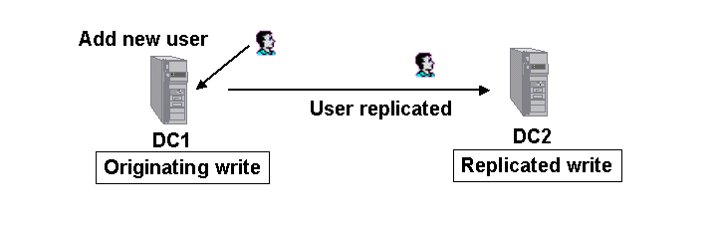
A number of operations trigger replication between DCs. Depending on permissions, an Administrator or a user performs these operations on objects stored in the Active Directory.
Figure 1: Originated Write versus Replicated Write.
The operations that trigger replication are the following:
- Object Creation - the creation of a new object in the database, for example a new user.
- Attribute Modification - the modification of an object attribute, for example a user changes his/her password.
- Object Move - moving an object from one container to another. Organizational units are special containers to help organize objects within the Active Directory and often use the same names as departments within a company. For example, “Sales” or “Marketing.” A move from the “Sales” organizational unit (OU) to the “Marketing” OU is an example of an object move that might happen as a result of reorganization within a company. Object moves operations are very similar to Attribute Modification, in that an object move implies the modification of an attribute, the distinguished name of the object.
- Object Deletion - This operation deletes objects from the database. This operation doesn’t actually delete the object immediately but transforms it into a tombstone.
A tombstone is a state of the object, or a flag meaning that the object has been deleted and it is no longer accessible. If for example one creates a large number of objects in the database, and then deletes them, the database doesn’t shrink. This is because all objects in the database have been transformed into tombstones. Tombstones have the size of the original objects. The role of tombstones is to replicate throughout the domain the fact that an object has been deleted. Tombstones have a default lifetime of 60 days. After 60 days, the object is really removed from the database. However amending the following attribute in the Active Directory can change the lifetime of a tombstone:
cn=DirectoryServices,cn=WindowsNT,cn=Services,cn=Configuration,
dc=DomainName with the name tombstonelifetime.
Update Types
When performing Write operations there is a distinction based on whether the operation was performed locally on a DC or whether the operation was performed on a remote DC and replicated locally. As shown in Figure 1, the two update types are:
- The Originating Write is an operation that was originally performed on the same system. The Originating Write is one of the four operations (add, modify, move, delete) performed on a DC. It’s called Originating Write because this operation originated on the current DC. For example if we create a user on the current DC, we are performing an Originating Write.
- The Replicated Write is an operation that was performed on another system and was replicated locally. A Replicated Write is a database modification issued from an operation that originated from another DC and was replicated to the current DC. For example if we create a user on DC1 and the operation gets replicated to DC2, we refer to the modification of the DC2 database as a Replicated Write.
Naming Contexts
A Naming Context (NC) is a tree of objects stored in the Active Directory. There are three NCs:
- Configuration NC - contains all the objects that represent the structure of the Active Directory in terms of domains, DCs, sites, and other configuration type objects.
- Schema NC - contains all the classes and attributes that define the objects and their attributes that are stored in the Active Directory.
- Domain NC - contains all the other objects of the Active Directory: the users, the groups, the OUs, the computers, etc.
Domains act as partitions for the Active Directory, but they are not the boundary of replication. Naming Contexts define the boundary of replication and define the replication scope. The boundary of replication indicates how far management operations performed on DCs are replicated to other DCs in the same domain or to other DCs in the forest. In other words, naming contexts define how far Active Directory changes are replicated in an organization.
Naming contexts are a new concept introduced in Windows 2000. The scope of replication within a Windows NT domain is only domain-wide and therefore this concept did not exist.
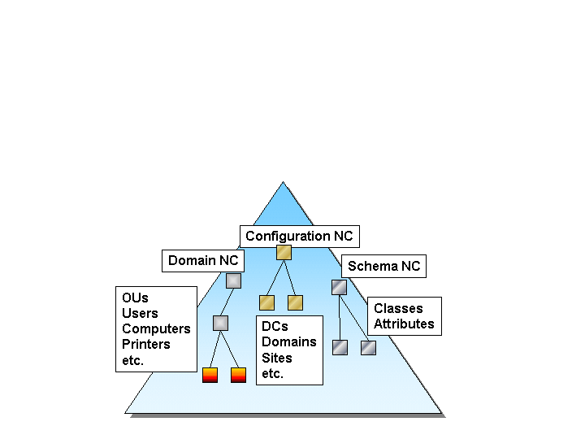
There are two scopes of replication for NCs: forest-wide and domain-wide.
Figure 2: Naming Contexts
The Configuration and Schema are unique in the entire forest and form a unit in the forest. This means that their NCs must be replicated to all the DCs in every domain composing the forest. The Configuration NC and Schema NC are therefore said to have a forest wide scope
Domain objects are replicated only within the domain to which they currently belong, The Domain NC has a domain wide scope. In other words, information stored in a domain is confined to a NC and is replicated in the domain itself. There is one exception to this rule. When the Domain NC is replicated to a GC, its scope becomes forest wide. This is because GCs are available in multiple domains and therefore a Domain NCs needs the forest-wide scope to reach them. We will see later how the replication topologies will allow a Domain NC to reach GCs in other domains.
Naming Contexts contain all the objects of the Active Directory and are obviously held in the Active Directory. The characteristic of objects in the Active Directory is that they have always a parent. Objects are contained in other objects such as organizational units, computers, and domains. The parents of these top-level objects are the naming contexts. Some naming contexts are a child of other naming contexts. This is the case of the schema NC that is a child of the configuration NC. The parent of child domains is their parent domain. This means that the child domain NC is a child of the parent domain NC. The parent of the top-level naming contexts is the RootDSE. The RootDSE is a virtual container. It contains all the objects in the domain. It’s the only object in the entire Active Directory that doesn’t have a parent object. The RootDSE object doesn’t get replicated and doesn’t hold any space. It is simply a virtual parent for the top-level NCs stored in the Active Directory. The RootDSE could be viewed as the summit of the Active Directory and is often used by applications to discover the naming contexts available at a particular Domain Controller.
Update Sequence Number
DCs maintain a sequence number to keep track of the operations that have been performed on objects stored in the Active Directory. This number is called the Update Sequence Number (USN).
The USN is a number associated with an operation performed on a DC. Every time an operation is performed the sequence number is increased by one and updated within the object. The operation may succeed or may fail. However the USN number remains updated. This is due to the LSASS process (the name of the process that is executing the Active Directory), which is multi-threaded, and multiple threads may perform operations affecting the database concurrently. Each operation requires a distinct USN. USNs are increased and assigned atomically to every committed operation. This transaction ensures that the USN can uniquely reference an operation.
USNs are 64 bit numbers that begin at 1 and increase sequentially, which allows a USN to reach a 20-digit number before the capacity of 64 bits overflows. If such an overflow condition occurred the replication process will request all changes since USN 1 from the other DCs in the domain and cause a replication storm. While it is theoretically possible to overflow a USN, in practical terms this is unlikely as a Windows 2000 infrastructure would need to be operational for centuries to accumulate enough object changes to reach such a large number. Every DC maintains its own USN independently from other DCs in the domain. This means that USNs change on each DC regardless of the USNs of other DCs.
So far it might appear that an object carries a single USN that is used to track changes to the object. However, two different USNs are maintained for every object in the Active Directory. The first USN is called usnCreated, and its value is set when the object is first created. The second USN is called usnChanged, and this value is updated each time the object is changed. Every attribute for each object also carries two USN numbers. One is associated with the operation when the attribute is changed. The second USN number is associated with the originating write operation performed on the originating DC. Attributes carry USN numbers because Windows 2000 supports attribute level replication. Without attribute USNs, it would be impossible to track attribute-level replication operations across a distributed infrastructure.
The Replication Process
In this section we will look closely at the role of USNs and originating writes versus replicated writes in the replication process.
Creation of an object
We have a DC in a domain named DC1. Let’s assume that a number of operations have been performed on the DC and the current USN number is 110.
We create a user. The creation operation is automatically allocated the next USN number in sequence. That is, 111. Note that the create operation may fail, however the USN number will nevertheless remain associated with this operation. The following operation will be allocated the USN number 112.
If we look at the table in the Active Directory database on DC1after the create operation is performed we can see that:
- The usnCreated and usnChanged attributes for the new object have been assigned the same USN because the user has just been created.
- Various attributes (we assume that only four have been filled: Name, Address, Phone and Password) have received a value.
- Each attribute has the current USN (111) associated to it.
- The version is set to one, because this is a new user and we have set the values for each attribute once. The version number will be used to resolve a conflict. We will see this in a later section.
- The current timestamp is saved. Timestamps are also used to resolve replication conflicts.
- The originating write DC GUID is saved. We have created the user on DC1. So DC1 is the originating DC and its GUID is saved in the table. The originating USN, in this case 111, is also saved in the table.

Attribute | Value | USN | Version | Time-  Stamp | Originating  DC GUID | Originating  USN
Name | Joe | 111 | 1 | TS | DC1 GUID | 111
Address | Compaq  Valbonne | 111 | 1 | TS | DC1 GUID | 111
Phone | +33 4 92 95 1111 | 111 | 1 | TS | DC1 GUID | 111
Password | ******** | 111 | 1 | TS | DC1 GUID | 111

Replication to a second DC
Now let’s replicate this user to a second DC named DC2. DC2 is a replica of DC1, that is, they are both DCs of the same domain. DC2 has its own USN sequence that happens to be at 520. This means that there have been 520 operations on DC2, either originating writes, or replicated writes. When the replication operation occurs to add the new user object the USN value goes up to 521.
If we look at the table on DC2 after the object is replicated we can see that:
- This is a new object creation therefore the object USNs, usnCreated and usnChanged, received the value of the current USN for the DC, or 521.
- The values for the object’s attributes have been replicated.
- The USN value associated with the replication operation (521) is saved for each attribute.
- The time of the replication operation is saved in the timestamp column
- The originating write DB GUID and originating write USN are saved. This operation was originally performed on DC1; therefore, it’s the DC1 GUID and USN number that are saved.

Attribute | Value | USN | Version | Time-  Stamp | Originating  DC GUID | Originating  USN
Name | Joe | 521 | 1 | TS | DC1 GUID | 111
Address | Compaq  Valbonne | 521 | 1 | TS | DC1 GUID | 111
Phone | +33 4 92 95 1111 | 521 | 1 | TS | DC1 GUID | 111
Password | ******** | 521 | 1 | TS | DC1 GUID | 111
Object Manipulation on the second DC
We now modify one of the attributes for this user: the address.
For this operation, the USN value on DC2 goes from 521 to 522. The user’s address is modified. When the operation is performed, we can see in the table for this user that:
- The usnChanged is updated with the USN value associated with the operation
- The Address value has been changed.
- The USN for the operation (522) is saved for the Address attribute.
- The version number went up by one. We will see how version numbers are useful later.
- The timestamp for the operation is saved.
- This operation was originally performed on DC2, which means that this is an originating write. The GUID for the DC2 database and the originating USN (522) are saved

Attribute | Value | USN | Version | Time-  Stamp | Originating  DC GUID | Originating  USN
Name | Joe | 521 | 1 | TS | DC1 GUID | 111
Address | Compaq  Sophia Antipolis | 522 | 2 | TS | DC2 GUID | 522
Phone | +33 4 92 95 1111 | 521 | 1 | TS | DC1 GUID | 111
Password | ******** | 521 | 1 | TS | DC1 GUID | 111
Replication back to DC1
Given that we are in a multi-master replication model, the operations performed on DC2 must replicate to DC1 to keep all replicas consistent and equal. When the data is replicated:
The USN on DC1 goes from 111 to 112. If we look at the table for the user on DC1 we can see that:
- The usnChanged property has been updated with the USN for the operation, 112. Note that usnCreated property is not modified.
- The value for the Address attribute has been replicated.
- The USN for the operation is saved at the attribute level.
- The version number is increased to 2.
- The timestamp for the operation has been saved.
- This operation was originally performed on DC2. Therefore, this is a replicated write. The DC GUID and USN (522) of the originating DC are saved.

Attribute | Value | USN | Version | Time-  Stamp | Originating  DC GUID | Originating  USN
Name | Joe | 111 | 1 | TS | DC1 GUID | 111
Address | Compaq  Sophia Antipolis | 112 | 2 | TS | DC2 GUID | 522
Phone | +33 4 92 95 1111 | 111 | 1 | TS | DC1 GUID | 111
Password | ******** | 111 | 1 | TS | DC1 GUID | 111
Making a distinction between originating writes and replicated writes and saving USN numbers at the attribute level is very important because:
- Given that Active Directory replication is performed at the attribute level we need to distinguish between object creation, which affect all attributes, and attribute modifications. This allows the value of the attribute to be replicated instead of the entire object.
- Originating USNs are used for propagation dampening, or the ability to detect that a DC has already been updated. We will discuss this mechanism in more detail later in this paper.
Understanding Propagation Dampening
Propagation dampening is the ability to detect that a replication operation has already happened at a replication partner. The goal of propagation dampening is to avoid replicating the same information twice to the same DC.
This is a very important feature of Active Directory replication and is key in a multi-master replication environment where DCs may have multiple replication partners, which may use different paths to replicate data back to the target DC. The first replication instruction to arrive at the target DC will update the Active Directory, so it’s important to detect that all DCs know that the replication operation has already happened to reduce the amount of traffic and cut unnecessary duplicate operations.
To understand propagation dampening and how replications are triggered, we need to look at the roles of two tables maintained by the Active Directory: the High-Watermark vector table and the Up-to-dateness vector table.
High-Watermark Vector table
The high-water mark vector is a table stored on every DC. It contains the list of all the replication partners and their highest known USN values. The high-water mark vector is used to detect changes performed at other DCs that are replication partners. The table also allows a DC to determine and request only those changes that haven’t been replicated yet. For example, in a domain with two DCs (DC1 and DC2), the two systems are replication partners. DC1 stores the highest USN from DC2 in its High-watermark vector table. Let’s assume that this USN is set to 100. On DC2, the USN is currently at 120. This means that 20 operations are outstanding and need to be replicated to DC1. Without this table, DC2 would have no choice but replicate all operations. That would be an enormous waste of bandwidth and time.
Replication partners exchange their highest known USN numbers through notification messages. If no update has occurred within one hour, replication partners will notify each other with their highest USN. This is done in case a DC has been offline and has just restored a connection to its replication partners and has missed a number of notifications.
For example, let’s assume that we have a domain with 4 domain controllers DC1, DC2, DC3 and DC4. Each DC has two replication partners forming a ring. If we look at Figure 3 and examine the High-watermark vector table for DC4, we can see data for its two replication partners, including the highest known USN number for each. If DC4 ever detects that the number held in the table is smaller than the actual number on the partner DC, then DC4 knows that it is not be up to date and needs to initiate a replication cycle to request data from its partner.
Up-to-Dateness Vector Table
In an enterprise Windows 2000 network, there may be a large number of DCs. Replication may follow multiple paths, in turn incurring the risk that attempts might be made to update an object multiple times on the same DC.
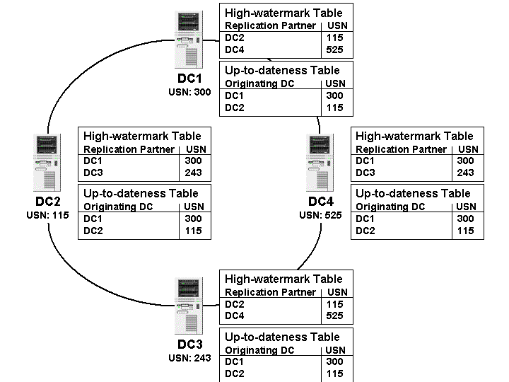
In order to avoid unnecessary replication, the Active Directory uses a table of up-to-dateness vectors also called the state vector table. This table contains the list of replication partners and the highest originating write USN on each partner. Each DC has its own up-to-date vector table, which is sent to the replication partners to filter out unwanted data that is up-to-date. The replication partner matches the USN in the up-to-date vector table with its high-water mark vector table to identify which attributes need to be updated. This operation implements replication dampening since all DCs know which replication partners are up to date and can avoid unnecessary replication.
Figure 3: High-watermark vector table and Up-to-dateness vector table
If we use the previous example of a domain containing 4 domain controllers to illustrate the up-to-dateness vector table and we assume that DC1 and DC2 were the only two DCs on which an originating write was performed, then the GUIDs of these two DCs will be stored in the up-to-dateness vector table of DC4, as shown in Figure 3. In a synchronized environment, the up-to-dateness vector table is the same on all DCs.
How replication activity is triggered and dampened

It’s important to understand how the High-Watermark vector table and Up-to-dateness vector table are used to trigger and dampen replication. DCs may have two or more replication partners. This means that operations may potentially be replicated multiple times by the various DCs that want to replicate the same data with a common replication partner. In order to prevent this, Active Directory replication supports dampening. Replication dampening is used to detect that replication has already occurred at a DC and is a key feature in a multi-master replication model. Without this feature, given the replication topologies generated by the DCs, data would flow from DC to DC several times and network traffic would increase enormously, and precious CPU cycles would wasted to process the data in the replication messages.
To illustrate how the High-Watermark vector table and Up-to-dateness vector table are used during replication, we will go through the process of replicating data within our sample domain and review the roles of each DC. Once gain, we have four DCs in a domain, DC1, DC2, DC3 and DC4. The High-watermark vector table on each DC tells us which controllers are its replication partners. Referring back to Figure 3, we see that every DC has its two adjacent DCs as its replication partners. The data in the table also tells us whether each DC is fully synchronized with its replication partners. For example if we look at the High-watermark vector table of DC4, we can see that it has DC1 and DC3 as replication partners and that it is currently synchronized. This is because the USN numbers stored in the table are the same as the current USN numbers on DC1 and DC3.
When DCs are fully synchronized the Up-to-dateness vector table is the same on every DC. If we look at DC4, its up-to-dateness vector table shows that DC1 and DC2 have performed originating writes, that is, administrators or users performed tasks on those DCs that trigger replication. Let’s now examine what happens when a new user object is created on DC2.
Step 1: The creation of a user and replication to immediate partners
We create a user on DC2. The USN number on DC2 associated with this operation is 116, an increment of 1 from the previous USN (115).
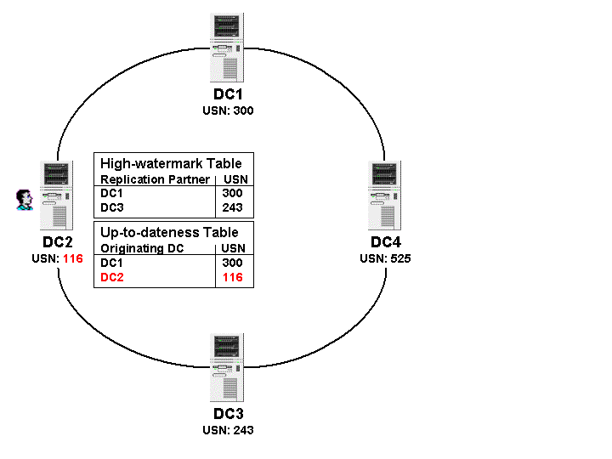
After a period of time (discussed later in this paper), DC2 notifies its replication partners that a change has occurred and sends its own highest USN number. The replication partners for DC2 are DC1 and DC3. These DCs will check the high-watermark table for the highest USN number they have for DC2 and realize that a change has occurred. The two DCs will trigger a replication cycle and request (pull) the information from DC2. Let’s start with the operations performed by the first controller, DC1.
Figure 4: Creating the user on DC2
To request an update, DC1 sends the following information to DC2:
- Each replication operation is associated with a particular naming context (NC), so DC1 must specify which NC it wants. In this case we are replicating a created user, which belongs to the Domain NC.
- The highest known USN value for this NC - This allows DC2 to determine what changes must be replicated. DC1 tells DC2 that its highest known USN is 115, so DC2 is able to determine that it must provide data for USN 116.
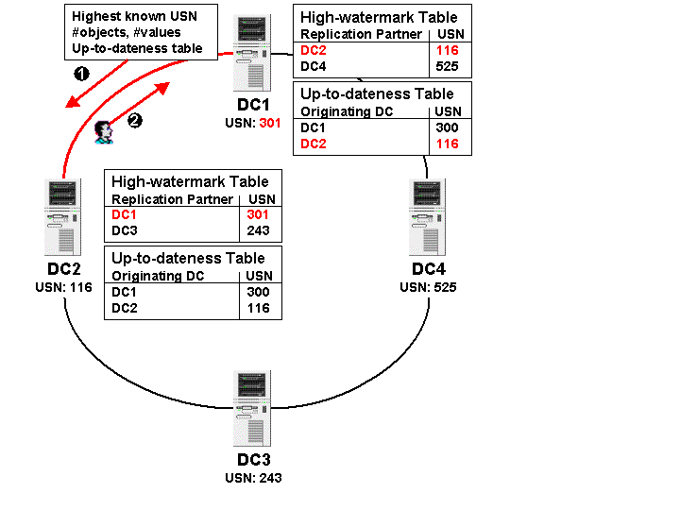
- The number of replicated objects and their values. By default, this value is set to 100, but it can be changed in the registry and is dependent on the memory size of the system. The goal here is to avoid congesting the network and swamping the replication partners with changes. So replication is performed using chunks of 100 objects. 100 objects are transferred and then some time is allowed to process the values. After a period of time another 100 objects are sent.
- The Up-to-dateness vector table. This allows DC2 to know which originating write operations have already been replicated to DC1. The role of this table will become clearer later.
With this information, DC2 knows exactly which operation must be replicated. The data is provided from DC2 to DC1 and the new user object is created in the Active Directory on DC1, forcing the USN to increase from 300 to 301 on DC1, as shown in Figure 5. .
Figure 5: Replicating the user object to DC1

Step 2: Replication to the second level partners
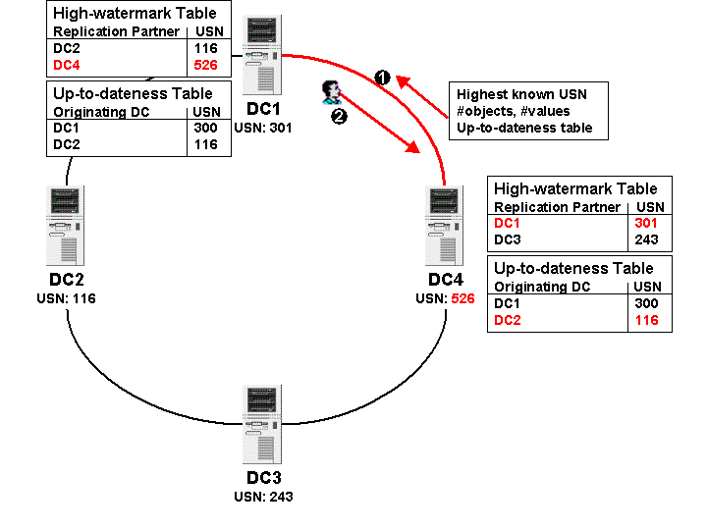
DC1 has two replication partners, DC2, from which it replicated the user, and DC4. It’s now the turn of DC1 to notify DC4 that information has to be replicated. DC1 notifies DC4 that its USN number has been increased.
Figure 6: Replicating the user to DC4

When DC4 is informed that the current USN on DC1 has changed, it can compare the notified USN value against the value held in its high-watermark vector table and detects that replication must occur. The information necessary to initiate the replication operation is then sent from DC4 to DC1 and DC4 can then pull the information from DC1.
These operations demonstrate that Active Directory replication is performed at multiple tiers. In other words, DCs contact DCs that in turn contact other DCs. This is quite important because it allows a distributed implementation to create information once and spread it like a multi-tiered tree and is one of the key features of Active Directory replication. Windows NT had a very simple replication model where all information could only be replicated from the PDC. This means that the bandwidth required in NT4 was dependent on the number of BDCs in the domain. In Windows 2000, the bandwidth requirements are dependent only on the amount of information that must be replicated from a DC to other DCs. Bandwidth requirements are heavily dependent on the replication topology used within a Windows 2000 domain. We will review these at a later section.
Now if we look at the tables on DC4 (Figure 6) we can see that:
- The Up-to-dateness vector table has been updated with the originating write information. The user object was originally created on DC2, therefore the GUID of DC2 and its highest USN number is stored there.
- The High-Watermark vector table is updated with the information concerning DC1, which is DC4’s replication partner. DC1 highest USN is stored there.
Step 3: Multiple Replication partners
So far a new user object was created on DC2 replicated to DC1. The object was then replicated to DC4.
DC2 has a second replication partner, DC3. When DC2 notifies its partners that its USN has changed, all replication partners receive the highest USN number of DC2 and react accordingly. DC3, like DC1, detects that a change must be replicated and initiates replication with DC2.
Figure 7 shows the result of the replication from DC2 to DC3.
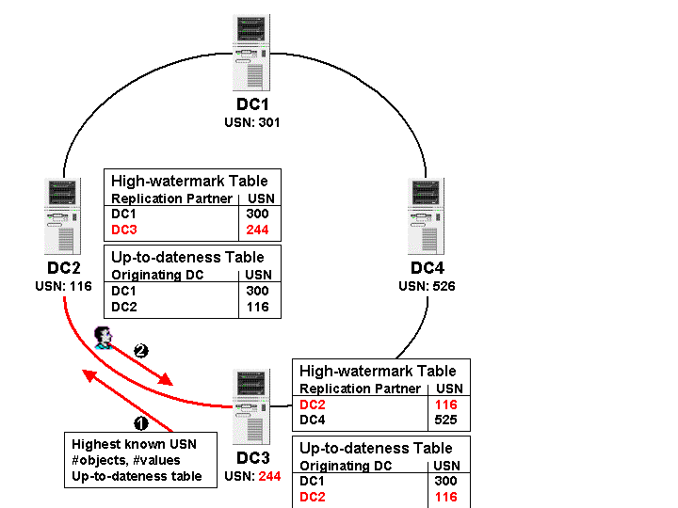
Figure 7: Replicating from DC2 to DC3

Step 4: Propagation dampening
Figure 7: Replicating the user to DC3

This step is key in understanding how propagation dampening works and brings the whole concept together.
DC3 has two replication partners, DC2 and DC4. The user object has been replicated from DC2 to DC3. DC3 will now want to replicate it to DC4 since DC4 is a replication partner. However DC4 has already replicated data for the new user object from DC1 and is now up to date. However, DC3 is not aware that DC4 is up to date and will attempt to replicate the data again unless the propagation process is dampened.
As part of the replication process, DC4 sends a number of parameters that will allow DC3 to determine the exact data to be replicated. One of those parameters is the Up-to-dateness vector table, which contains the originating writes in the domain.
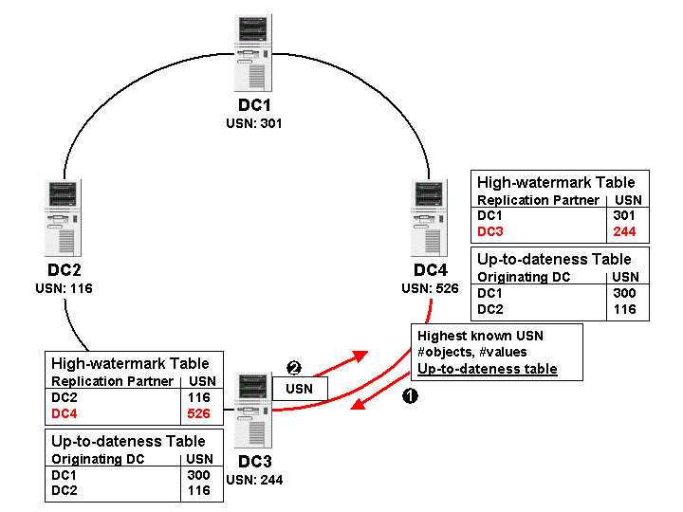
The Up-to-dateness vector table controls propagation dampening as it enables DC3 to realize that DC4 is already up to date. The Up-to-dateness vector contains the originating write DC GUID and the USN for that operation and allows DC3 to detect that the user that was originally created on DC2 has already been replicated to DC4 using an alternate path. When DC3 receives the up-to-dateness vector, it finds that DC4 knows about all changes made on DC2 up to USN 116. The highest USN for DC2 known to DC3 is also 116, so the two values match, meaning that DC3 does not need to replicate the user to DC4, dampening propagation. It will instead only send its own highest USN number so that DC4 will be able to update the High-Watermark vector table and be up to date with this replication partner.
Figure 8: Propagation dampening.
This is a small example with just a few DCs. Imagine a network with an enterprise Windows 2000 infrastructure and hundreds of DCs. Propagation dampening is key in a model where a DC may have multiple replication partners because it avoids the same information replicating multiple times, thus saving network bandwidth and time.
Sites
Figure 8: Propagation Dampening

A Windows 2000 site is a collection of IP subnets with good connectivity. In fact, the best way to think of a site is to compare it to a LAN. Sites reflect locality, insofar as all the systems belonging to the same site can be considered to be physically close to each other and benefit, ideally, from LAN-quality network connectivity. In other words, each of the servers within a Windows 2000 site should be connected with links of 512 Kb/s or greater of net available bandwidth. True LAN-type bandwidth (10 Mb/s or greater) is preferable and recommended. The LAN-quality connectivity requirement for the subnets within a site is largely due to how intra-site replication is performed (this is covered in details in a later section).
The concept of locality is extended to workstations, as workstations always attempt to connect to a domain controller in the same site. The Active Directory contains information about sites and their underlying IP subnets and is able to associate a workstation with a site by comparing the workstation’s IP address with the site definitions. As servers are added to a domain, the Active Directory also examines their IP address and attempts to place them in the most appropriate site.
When a Windows 2000 server creates a new domain, the Active Directory creates the site Default-First-Site-Name and places the DC there. All the DCs joining the domain are added to the default site. Systems continue to be added to the default site until a new site is explicitly created.
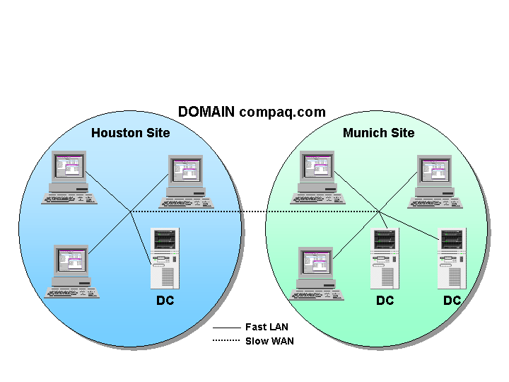
A domain may span multiple sites, as seen in Figure 9. Multiple domains may also belong to a single site because sites are independent from the domains they belong to. Sites are objects stored in the Configuration Naming Context and therefore site information is replicated to all DCs in the forest.
Figure 9: Illustrating Sites

Sites are used for two roles:
- During Workstation logon to determine the closest DC. We will review how workstations discover the closest DC in the next section
- During Active Directory replication to optimize the route and transport of replicated data between sites. This topic is also discussed later in this paper.
In order to achieve these two roles, all DCs in a domain know about all the sites.

Replication transports
Replication occurs between DCs in the same site and between DCs located at different sites. Intra-site replication is performed through standard Windows 2000 Remote Procedure Calls (RPCs).. However, different transports can be used to replicate data between domain controllers in different sites. The Active Directory holds information about the domain controllers in each site, the connectivity that exists between each site, and the best route to take to replicate information. Network links between sites vary greatly. To support varying types of connections the Active Directory supports two major replication transports:
- DS-RPC (Directory Services RPC)
- ISM- SMTP (Inter-Site Messaging - Simple Mail Transport Protocol)
A general assumption is made that replication must occur quickly within a site and that there is a low tolerance for inconsistencies within the directory across all controllers in a site. For this reason, intra-site replication is always RPC-based. Inter-site replication can be performed through RPCs or via special forms of SMTP messages sent between domain controllers. RPC replication is always synchronous whereas message-based replication is asynchronous. Intra-site replication cannot be scheduled. Each domain controller sends update notifications to its replication partners after updates have occurred. Normally this happens every 5 minutes. This interval is configurable through the system registry (see Appendix). Even if no changes have occurred and replication has not taken place, domain controllers “ping” each other every hour by exchanging details of the latest USN value held on the controller to ensure that an update has not been missed. After a DC receives a notification that an update is available, it makes a connection to the DC where the change has occurred to initiate replication. Data is not compressed during intra-site replication.
Inter-site replication uses compressed data when the data is bigger than 50 KB regardless of the replication transport. The data is compressed to 10-15% of its original volume before it is sent. This means that the compression is very efficient. CPU cycles are required to compress and expand the replication data, but the overhead required in CPU cycles is more than compensated by the reduction in data that passes across the network. Inter-site replication can also be scheduled to occur at a particular time.
Connectivity between sites is usually not as good as intra-site, and replication can take advantage of compression and scheduling. Scheduling can be defined to force replication to take place at specific times. Replication topologies are normally automatically generated.
Intra-site vs Inter-site replication
 | Intra-site | Inter-site
Transport | RPC | RPC or SMTP(1)
Topology | Ring | Spanning Tree
Schedule | Pull Schedule | Availability and Frequency Schedule
Replication Model | Notify and Pull | Pull
Compression | None | Full beyond 50 KB
A number of important differences exist between Inter-site replication and Intra-site replication.
The Intra-Site replication model has the following characteristics:
- Transport can only be RPC over IP
- The generated replication topology is a ring between domain controllers with additional connections between DCs depending on the number of replication partners in the site and the presence of GC servers in the site (GC replication is discussed later). If a DC cannot reach another DC in the same site within three hops, then it will generate additional connection objects. This means that if there are 7 DCs in a site then a simple ring connecting all DCs will be generated because all DCs can reach all the other DCs within the three hops limit. If there are more than 7 DCs, additional connection objects will be created and the topology will look like a ring containing a star.
- The replication period uses a default interval of every 5 minutes configurable in the registry.
- Replication is based on a notify and pull model
- Data is never compressed. This is because in a site bandwidth is by definition available.
The Inter-Site replication model has the following characteristics:
- The transport can be either RPC or SMTP. Note however that SMTP transport can only be used when replicating the Configuration and Schema naming contexts, or when replicating from a DC to a GC that belongs to a different domain.
- The topology generated will be a Spanning Tree, which by definition avoids creating any loop.
- Replication is based on a scheduled pull.
- The Availability schedule controls when data is replicated between sites. By default inter-site replication occurs every three hours, the minimum is every 15 minutes and the maximum is 10080 minutes (or one week).
- Compression is enabled when data is bigger than 50 KB.
Replication Topologies
The replication topology is a map of how information replicates between Domain Controllers. The topology is generated and maintained by a service running on every DC.
The replication topology allows DCs to find other replication partners. If a DC becomes unavailable for example because it is shut down, its replication partners will change the topology to allow replication to happen using an alternate route.
There is a replication topology per Naming Context scope: forest-wide or domain-wide. This means that the Schema and Configuration NC, which have a forest-wide scope, share the same topology. Each domain in a forest creates its own topology as they have a domain-wide scope.
For example if we assume we have three domains in a forest, 4 replication topologies will be created:
- One per domain NC
- One for the Configuration and Schema NCs
Knowledge Consistency Checker
The Knowledge Consistency Checker (KCC) is a service running on every DC. The role of the KCC is to
generate and optimize the replication topology by creating Connection Objects between DCs.

By default, the KCC runs every 15 minutes. Administrators can trigger the KCC manually via the Active Directory Sites and Services snap-in. The following registry setting can be used to set a different check interval for the topology:
HKLM\System\CurrentControlSet\Services\NTDS\Parameters\Repl topology update period (secs)

Connection objects
A Connection Object is an authenticated communication channel used to replicate information from a DC to another DC. The properties of a connection object include the replication partner and the site in which it belongs to. The properties also define the transport that the Connection Object will use (RPC or SMTP), and a schedule that will be used for replication if the notification message is not received (we discuss replication schedules in more details later).
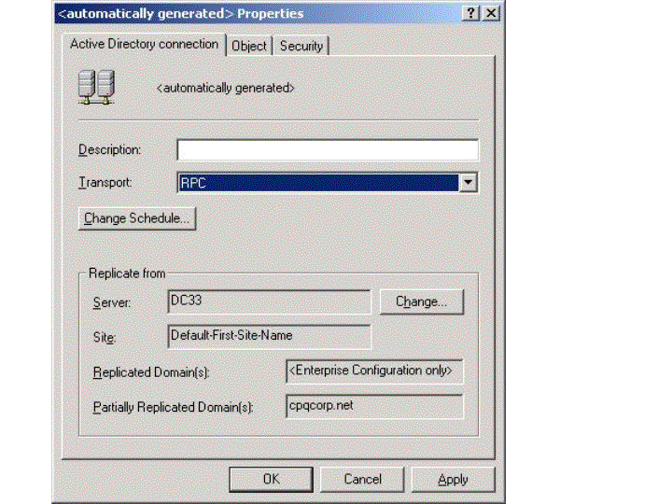
A Connection Object is a uni-directional connection from a replication partner. This means that there are always two connection objects between DCs in a site. Connection Objects are normally created by the KCC, but an Administrator can also create them manually. If necessary, administrators can force replication to occur immediately over a specific Connection Object.
Figure 10: Connection Object properties
Replication can be forced by right-clicking a connection object in the Active Directory Sites and Services snap-in and clicking on the Replicate Now button.
Another way to force replication is to use the resource kit tool called Replication Monitor. Using this tool, it is possible to synchronize and entire naming context. By doing this, Replication Monitor will trigger replication between all DCs containing the selected naming context.

The Connection Object shown in Figure 10 was generated by the KCC. We can also see that DC is a GC and that it replicates the Configuration and Schema NC as well as the partial domain cpqcorp.net.
If you create a connection object, the KCC will not manage it, you will need to destroy it. This connection object is said to be explicit. The KCC only manages connection objects that it has generated.
The process of replication within a site involves a notification from the source DC to its replication partners. This triggers the replication process. In the event of a missing notification, DCs will use a schedule to trigger replication by themselves. This schedule is defined at the level of the site and can be set to specify any hour in a week to replicate once per hour, twice per hour or four times per hour or can be turned off. All the connection objects within a site will reflect the schedule defined for the site. This means that if you modify the site schedule, you are affecting all the schedule of connection objects managed by the KCC in the site. If you modify the schedule for a connection object that was generated by the KCC, then the KCC will no longer manage the connection object and you will need to manage it. If that is the case the schedule of connection object will take precedence over the site schedule.
Connection objects are the most important components in a replication topology because they enable information transfer from a DC to its replication partners. Connection objects show when replication happens (storing this information in the replication schedule) and they regulate the consistency of the Active Directory.

Intra-Site Replication Topology Generation
When a new Windows 2000 domain is created and there is only one DC in the domain, no replication is necessary and none occurs. As soon as a second DC joins the network, the KCC generates the replication topology between the two DCs.
If the two DCs are in the same site, two uni-directional connection objects are created, as shown in Figure 11. These connection objects are mutually authenticated channels between the two DCs that allow them to replicate information. The replicated objects depend on the Naming Context in which they belong. When two DCs connect for the first time, all NCs are replicated: the configuration, the schema and the domain to which the DCs belong. Between DCs of different domains, only the configuration and schema NCs are replicated. In the case of a DC that is also a Global Catalog, the three NCs will be replicated. However only a subset of the domain NC is replicated to a Global Catalog (GC replication is further detailed later).
When additional DCs join the domain in the same site, the KCC service running on every DC will automatically create the required connection objects and avoid duplicate replication paths. In order to optimize the number of connections created, the KCC on each DC attempts to compute the required number of connections required for every DC in the site so that the number of hops between itself and any other DC in the site is three at the most.
Rings of Replication
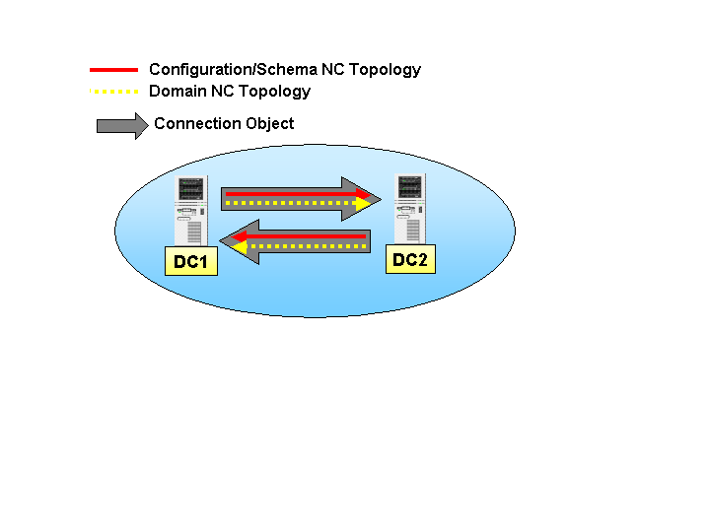
Let’s assume we have a domain, compaq.com and a site with one DC called DC1.
Figure 11: Connection Objects between two DCs

We run DCPROMO on a second server, DC2. DCPROMO is a wizard-based application that allows the promotion of the standalone server to a Domain Controller. Using DCPROMO we configure DC2 as a replica of the compaq.com domain.
During the DCPROMO process, the KCC on DC2 creates a connection object and generates two replication topologies, one per scope (forest-wide and domain-wide). In Figure 12, the top line shows the Configuration NC and Schema NC replication topology while the bottom dotted line shows the Domain NC replication topology. DC2 replicates the configuration, schema and domain objects from DC1. Once the DCPROMO process is completed DC1 then generates connection objects from DC2 to replicate any operation performed on that DC.
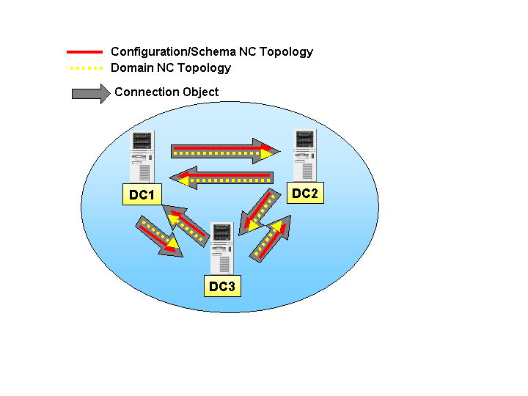
We then boot a third server, DC3, and run DCPROMO to allow it to join the compaq.com domain as a replica.
Figure 12: Topology generated between three DCs

As shown in Figure 12, DC3 then joins the domain after connecting to DC2. A question we may ask ourselves is why the initial connection for a new controller is not automatically made with the first controller in the domain? The DCPROMO utility is used to promote a server to be a domain controller. It is during the promotion process that the decision is made to contact a particular controller to retrieve information about the domain.
When DCPROMO runs on DC3, a query against DNS returns a list of all the domain controllers that belong to the compaq.com domain. After reviewing the SRV records for the compaq.com domain, DNS returns DC1 and DC2. DC3 will then contact the two DCs to find out which one is currently available. In our example we assume that DC2 is faster to respond.
DC3 then contacts DC2 and creates the connection object for the two topologies required for the schema/configuration and domain naming contexts. Replication is then performed and DC3 joins the domain.
DC2 will then create its own replication topologies using the updated information from DC3 and will notify DC1 that a new DC has joined the domain. DC1learns about the new DC in the site (DC3) by replicating the configuration NC from DC2. DC1 and DC3 then create the connection objects necessary for replication to happen between each other.
Figure 13 illustrates what happens when a fourth DC is added to the domain. Essentially DC2 and DC3 now create connection objects to DC4.
The KCC service running on each DC constantly tries to optimize replication topologies. One rule is that if a DC cannot be accessed within 3 hops, an, additional connection object will be created to reach that DC. This means that Active Directory replication uses a store and forward mechanism to disseminate information from DCs to other DCs. Replication partners will pull information from a particular DC and treat it locally and then another DC (or hop) will replicate the same information and will be ready to disseminate it further. If for example, we have 8 DCs belonging to the same site, a DC in that configuration will not be able to reach all the other DCs within 3 hops and must create an additional connection object to each controller that it cannot reach.
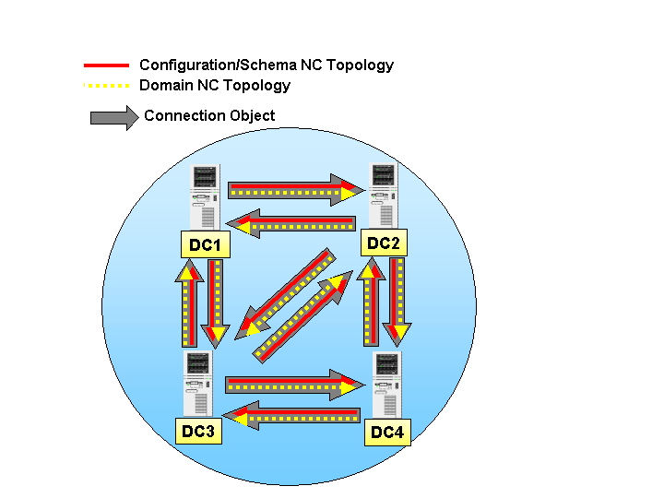
In our example (Figure 13), we have only 4 DCs, which means that any DC can reach any other DC within 3 hops. Therefore, when the KCC reviews the replication topology, it will conclude that the connection objects between DC3 and DC2 are not necessary because sufficient replication paths exist without these connections. The KCC always attempts to create a ring of replication paths within a site. This implies that the KCCs on DC3 and DC2 will remove the connection objects pointing at each other, as there are other valid replication routes. This leaves us with two replication topologies forming a ring.
Figure 13: Four DCs in a Site. Redundant connections

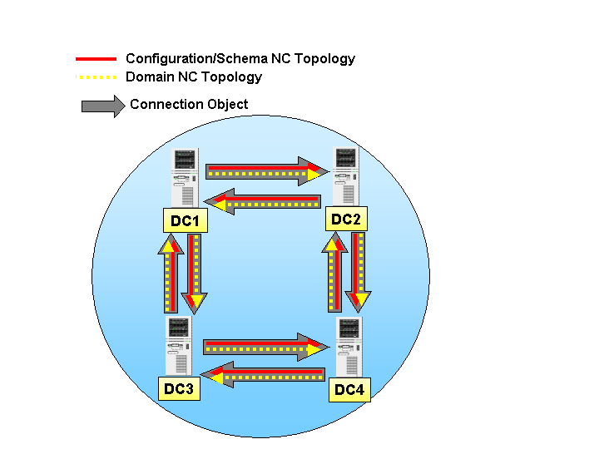
There will always be a maximum of two generated connection objects between two DCs, one per direction, additional connection objects could, however be manually created by administrators. Multiple replication topologies will share the connection objects for replication purposes.
Figure 14: Optimization of connection objects

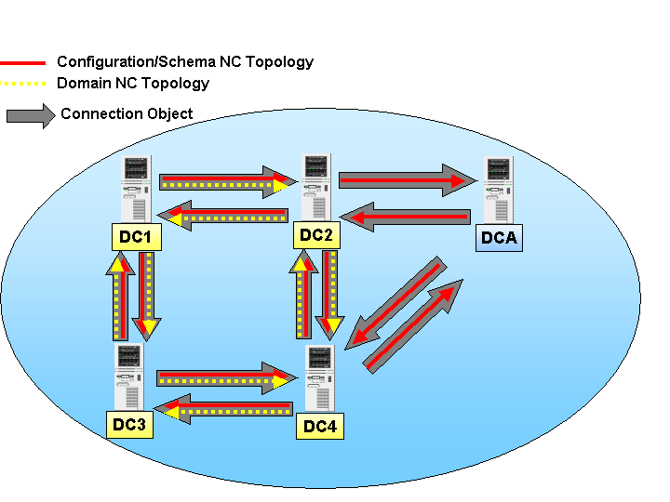
We now create a child domain for the compaq.com domain, called sales.compaq.com, shown in Figure 15. We install a DC (DCA) of the child domain in the same sites as the other DCs belonging to the compaq.com domain. Once again, during the DCPROMO process, the new controller (DCA) queries DNS to find all the DCs belonging to the compaq.com domain and then contacts them to discover which one is available. Let’s assume that DC2 from the compaq.com domain responds faster again.
Figure 15: Adding a second domain to the topology

During the DCPROMO process, DCA creates a connection object for both the Configuration and Schema NCs. Note that the compaq.com Domain NC connection is not created (Figure 15). This is due to the fact that a domain NC is only replicated within its own domain. DCA does not belong to the compaq.com domain, therefore only a connection object for the forest-wide topology is created. DCA joins the forest and DC2 informs all the other DCs that a new child domain exists with a DC in the same site. The other DCs, or more accurately, the KCCs running on the DCs, evaluate the situation and DC4 closes the loop by creating a connection object with DCA. DCA will do the same and create a connection object with DC4.
To complicate matters even further we add a second DC in the sales.compaq.com child domain, DCB (Figure 16). During the DCPROMO process, DCB communicates with DCA and replicates the sales.compaq.com domain NC as well as the Configuration and Schema NC. DCA informs the rest of the forest that a new DC (DCB) has joined its domain. The KCCs once again evaluate the situation and optimize the topologies. Connection objects are created from and to DC4 and DCB.
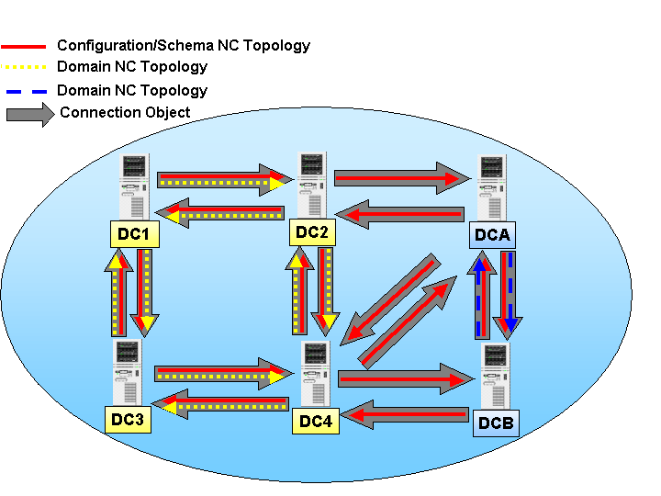
Figure 16: Adding a second replica

During the optimization process, DCA and DC4 remove the connection objects between them. This is because the rings are available on an alternate route. As a result, we have created two domains, with three rings of replication:
- 1 domain NC for compaq.com
- 1 domain NC for sales.compaq.com
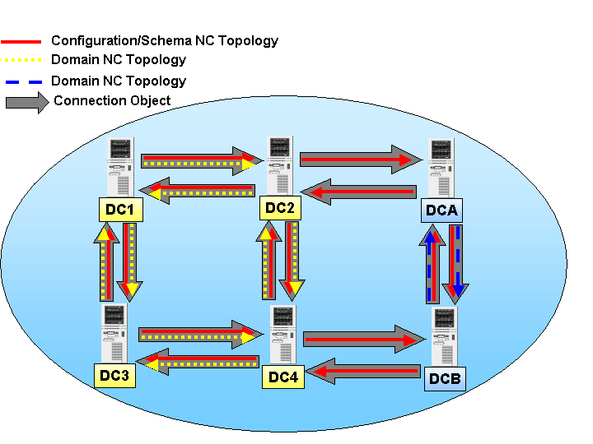
- 1 schema/configuration NC for the entire forest
Figure 17: Optimization of connection objects between domains

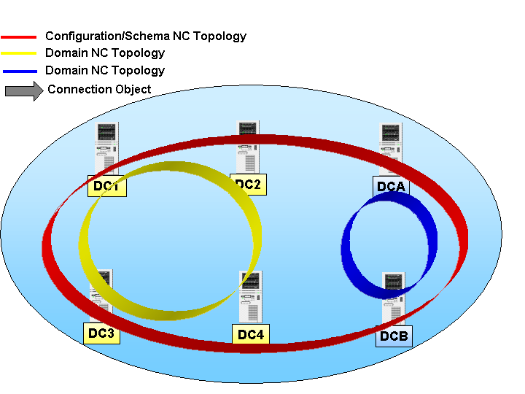
Figure 17 illustrates the three rings of replication that are built after all the domain controllers have joined in the forest. The solid arrows show the Configuration and Schema NC topology ring. The dotted and dashed arrows show the two domain NCs topology rings.
Figure 18: Rings of replication

Global Catalog Replication
A Global Catalog (GC) is a special form of domain controller that holds read-only subsets of information about objects from all domains in the forest. Replication to form Global Catalogs implies that the domain NC is replicated within the forest, this is because GCs may belong to different domains. If we take the example we have just been reviewing and assume that DC4 and DCA are GCs in their respective domains, then we can see that the KCCs will extend the compaq.com and sales.compaq.com domain NC replication topologies to reach those GCs, and replicate domain information across the domain boundaries. Domain NC information replication to GCs in the forest occurs in the same manner as between DCs of the same domain, except that the domain NCs are outbound to GCs in other domains and never inbound. This means that a DC can replicate information from the domain NC to a GC belonging to another domain, however it cannot replicate from that GC for the same information. In our example, the result of the replication topology shows additional connection objects, these are created to be able to close the ring. Figure 18 shows the result of the generated topology. It’s important to note in the figure the inbound connection objects created towards GCs and the replication topologies that they contain. As shown in the figure, domain NCs reach GCs but if the GCs has multiple replication partners, then other DCs belong to a different domain than the GC (for example DC2) will not replicate their own domain NC from that GC.

For replication, the relationship between a DC and a GC is the following:
- A domain controller replicates three naming contexts (the domain NC in which it belongs, the schema and the configuration NCs), therefore replication for a DC is the sum of the three naming contexts. The following shows that the replication involving a domain controller is affected by changes in any of its three naming contexts:
R_{dc} = NC_{domain} + NC_{schema +} NC_{config}
- Global Catalog replication is equal to the replication of a normal DC if the two servers belong to the same domain and if there is only one domain in the forest. This is because a GC is also a DC in its own domain and as such has read/write access to the forest-wide naming contexts as well as the domain NC of its own domain. However if the forest contains multiple domains, then each GC also replicates partial domain NCs from all other domains in the forest. A partial domain NC contains all the objects in the domain NC but only covers a subset of the attributes for each object. The decision whether to replicate an attribute to a GC is governed by the isMemberOfPartialAttributeSet property, which is set in the schema. If the property is set, the attribute is published to all GCs. Therefore the difference between GC replication and DC replication can be represented as follows:
R_{gc} = R_{dc} + NC_{partial domain} * (n – 1)
Where n = the number of domains in the forest
In the case of a forest with simply one domain, there is no increased traffic generated by setting all DCs as GCs because each controller in a domain replicates the full set of attributes for all objects anyway and is demonstrated by the GC formula above which would equate to R_{gc} = R_{dc} when n equals 1.
If a site contains a GC, then it is most likely that it will be used for inter-site replication (and become the bridgehead server, BHS are discussed later) If that is the case, then all the DCs belonging to the same domain as the GC in that site can also be GCs. This is because there will always be one bridgehead server replicating information for one domain NC from a server at a different site, meaning that only one GC will perform inter-site replication. The other controllers in the same site will use intra-site replication. GC replication with all GCs in the same site is always performed over RPCs because a site is composed by a well-connected subset.
DCs cannot replicate domain NC data from GCs belonging to other domains. This is because GCs contain read-only replicas from all domains and are not authoritative on these objects. Administrators cannot use GCs to modify the read-only replicas and therefore DCs cannot use GCs in the replication topology generation to replicate data from them.

Site Topology
Fundamentals of Site Topology Design
For Windows 2000, a Site Topology is a logical model layered on top of a physical network. Windows 2000 does not communicate with network routers to retrieve information from the OSFP tables about the network and its characteristics. This means that Windows 2000 does not attempt to detect the physical network and relies on the Site Topology for information about network availability and the cost of replication. The Site Topology is used by the KCC to generate the best optimum path for information to replicate between DCs.
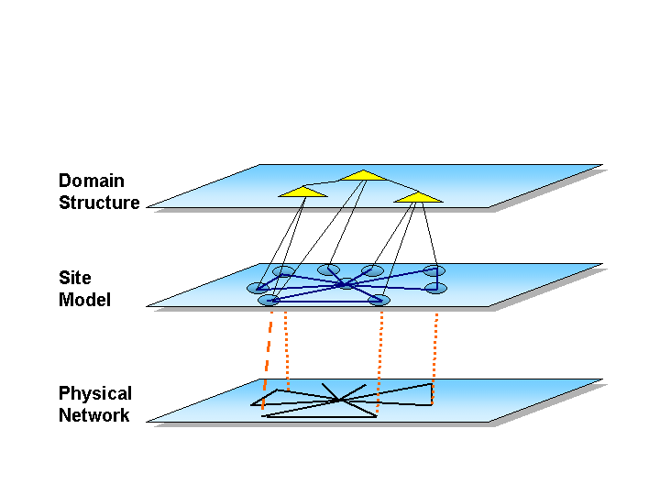
Figure 189: Site Topology

The role of the Windows 2000 infrastructure architect is to model the Site Topology to accurately reflect the underlying network topology. As shown in Figure 18, there are three layers that must be considered when you design Windows 2000 sites.
- The Physical Network forms the bottom layer.
- The middle layer is the Windows 2000 Site Topology, which reflects the Physical Network.
- The Windows 2000 Domain Structure forms the top layer. Domains rely on the Site Topology for replication, and should be designed to conform to that model. Replication restrictions may be a reason for splitting domains. In turn, the physical network may be responsible for imposing some restrictions on how replication is possible.
It’s important to make a distinction between Domain structure design and Site Topology design. Sites reflect the location of user communities whereas domains contain objects. A domain is mapped to a site by placing a replica of the domain into the site. A site does not contain a portion of a domain. It contains the entire domain. Sites contain DCs and these are entire replicas of a domain. If a GC is placed in a site, then the entire Active Directory becomes available to the site. From a different perspective, if a site does not contain a DC or a GC it is essentially useless as no objects are available within the site.
The Site Topology may affect the Domain structure due to the available bandwidth required to perform replication. Ideally, given the scalability of the Active Directory, most companies could deploy just one domain in their enterprise. However, there are usually a number of reasons for a company to split domains. The network bandwidth used for Active Directory replication is one such reason. This could be the case if number of objects in the Active Directory and the rate at which these objects change generates a lot of traffic. A fine tuned Site Topology can help reduce the network traffic required for performing replication.
Site Links
Inter-site replication requires an explicit Site link to be created. As the name indicates, a site link links two sites together. A site link represents a network connection between two sites.
A site link has a cost associated to it. The cost is used to determine how easily data can be replicated between sites. When multiple sites are linked together using site links the KCC will use the cost and the site link availability schedule to determine which connection objects must be created between DCs to enable replication.
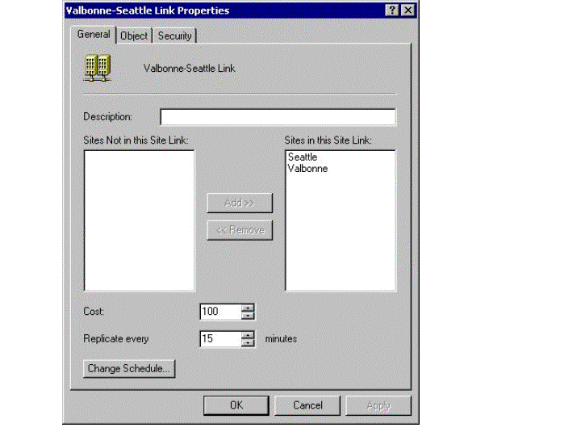
The KCC creates a spanning tree of connection objects between DC at different sites. Spanning trees avoid loop being created between the sites.
Figure 2019: Site Link properties

A site is a collection of IP subnets with good connectivity and a Site Link is a logical connection between sites. Site Links must mimic the network and should be viewed as possessing similar characteristics to the underlying connection between the sites. In other words, a Site Link represents a WAN link.
It’s important to make the distinction between Connection Objects and Site Links. Connection Objects connect Domain Controllers, and are generated by the KCC, or can be manually created by administrators. Site Links must be created by administrators and are used by the KCC to determine the cost and availability of a network for performing replication between two sites.
Figure 20 illustrates the properties of a site link. The complete list of available sites appears on the left hand side. Administrators can select which sites are connected using this site link. In the illustration, the two available sites are selected.
A Site Link has an associated cost and an availability schedule, which are used as inputs for the KCC to generate or optimize the replication topology. Figure 21 shows the Site Link replication availability schedule.
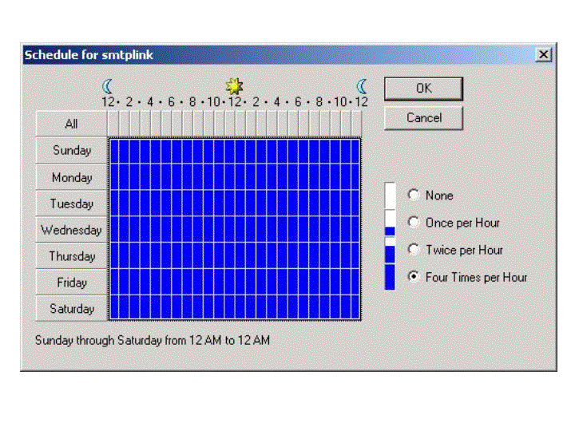
The Cost Factor is a number between 1 and 32767 that indicates the cost of replicating data from one site to another. The default value is 100 and the smaller the value, the better the network connectivity and easier it is to replicate information across the link. The KCC uses the Cost Factor to generate and optimize replication topologies. Going back to Figure 20, it shows that there are two sites, Valbonne and Seattle. The cost of replication is 100 and the link is scheduled to replicate every 15 minutes. The default replication frequency for a site link is 180 minutes, the minimum is 15 minutes and the maximum is 10080 minutes (or one week).
Figure 210: Replication Availability Schedule
Figure 22 shows how the KCC computes the replication costs between sites. Basically the cost of every Site Link is added between two distant sites and the total cost is used to determine the best (cheapest) route.
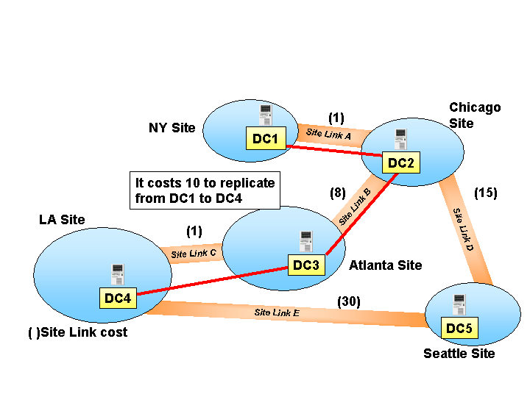
In this example, given that it costs 1 for replication to go from the NY site to the Chicago site and it costs 8 from the Chicago site to Atlanta, replication from DC1 to DC3 costs 9 whereas replication between DC1 to DC4 has a cost of 10.
Figure 212: Replicating costs
Using the store and forward mechanism, data is replicated from DC1 to DC2. However on DC2 there are two possible paths to reach DC4: DC3 and DC5. The KCC on DC2 will opt for DC3 because the cost value is smaller. If DC3 becomes unavailable, then the KCC on DC2 will generate a connection object directly to DC4, this is because the sum of the cost of Site Link B and Site Link C is still cheaper than the sum of the cost of Site Link D and E. Cost should be used to provide hints to the KCC as to the state of a network link. Bandwidth could be a factor however given that Windows 2000 doesn’t see the underlying network and will not see firewall for example, cost can be used to avoid paths or to prefer a particular path versus another one.
It is possible to add multiple sites in a Site Link. What this means is that multiple sites that share the same cost and same availability schedule can belong to the same Site Link. The KCC will then treat these sites equally and create/manage the resource objects consequently. This could be the case for example between sites that are connected to the same backbone. The bandwidth will be the same between all sites and so will be the connectivity. If the backbone becomes unavailable then all sites will be affected anyway. At Compaq, two distinct companies are providing the network forming the main ATM backbone, which means that if one network becomes unavailable, replication is still possible via the second one. In order to simplify management of replication between all the sites connected to the same backbone, it’s simpler to put them in the same site link. The replication schedule will then be the same and any changes will affect all sites in the site link.
Bridgehead server
A Bridgehead Server (BHS) is a DC that performs replication operations with DCs in another site. Not every DC in a site is a BHS. Each site has a DC that takes the Inter-Site Topology Generator (ISTG) role. The ISTG role reviews the list of available DCs in the site and determines the BHS. The ISTG role cannot be transferred like other Operation Master roles. Administrators cannot select which DC owns that role. All DCs in a site are eligible for this role.
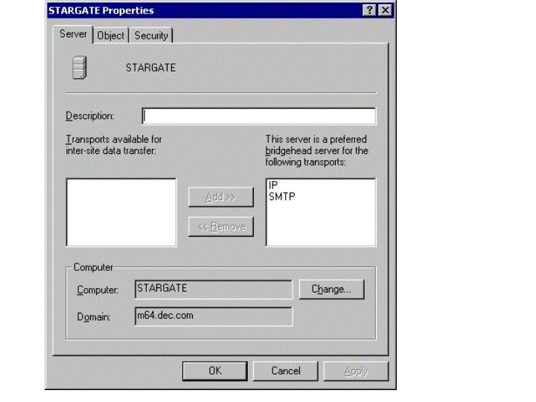
The algorithm used by the DCs to determine which DC will be the ISTG role owner is that every DC evaluates the list of domain controllers present in the Site as defined in the Configuration NC, removes any domain controllers that are not currently available and orders the remaining domain controllers in the list by GUID. The DCs then select the first domain controller in ascending order of that list. In other words the oldest DC in a site becomes the ISTG. Because every domain controller follows the same algorithm, all will agree on which machine is the ISTG role owner.
Figure 232: Preferred Bridgehead server
The ISTG will assign one BHS per transport per site and per domain NC. You can, however, create explicit connection objects between DCs located at different sites. By doing this you are implicitly adding more BHSs to the site. If a site contains two DCs belonging to two domains, the ISTG will designate both of them as BHSs. A DC cannot replicate information belonging to another domain, so the two DCs will be assigned to replicate information to DCs in other sites belonging to their respective domains.
You can only have one bridgehead server per transport per site. Therefore, you could designate one bridgehead server for IP and/or one bridgehead server for SMTP. Figure 22 shows the properties of a Domain controller in a domain. These can be found by right clicking on a DC in the Active Directory Sites and Services snap-in, under the default site and servers folder.
Selecting RPC over IP and/or SMTP as transport for this DC means that it is enabled as a preferred bridgehead server.
If you designate a set of DCs as preferred BHSs, the ISTG will not assign DCs that are not part of the preferred list. If for example a site has five DCs, and two of them are designated as preferred BHSs, the ISTG will use only these two DCs. If both of them are shut down, the ISTG will not use any of the remaining DCs because they are not part of the preferred list. In other words, by defining a preferred list of DCs, you are informing the ISTG that you want inter-site replication to occur only using the DCs in that list.
Figure 24 is an illustration of bridgehead servers. We have three sites, Valbonne, Seattle and Houston. In the Valbonne site we have two DCs: DC1 and DC2. These two DC2 have created a ring of replication between them. DC2 is the bridgehead server for the site. This means that an Administrator has defined the transport on this server for inter-site replication.
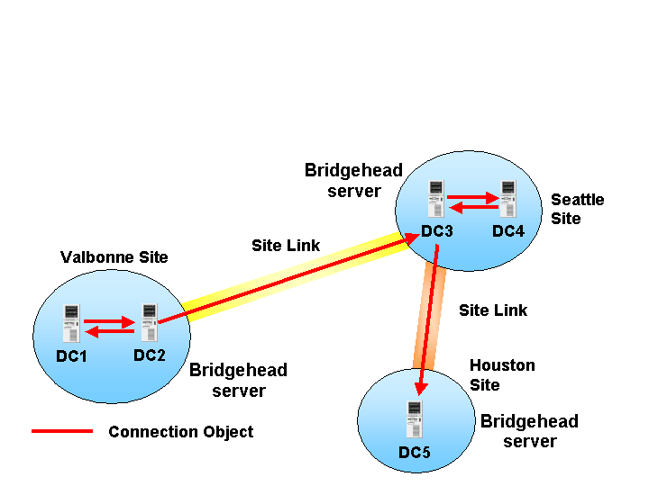
Figure 243: Bridgehead servers

In the Seattle site we have a similar configuration with two controllers, DC3 and DC4. DC3 is the bridgehead server. Note that there is a connection object between DC2 and DC3 only. If one of these two servers happens to be unavailable, then replication to the Seattle site would fallback to use the remaining DC as a bridgehead server. If the remaining server (DC4) is shutdown replication could still be working to the Houston site, as by default Site Links are transitive. This means that a connection object between DC2 and DC5 could be generated automatically if these bridgehead servers couldn’t find a suitable DC running in the Seattle site. Let’s examine how this happens in more detail.
Site Links implementation
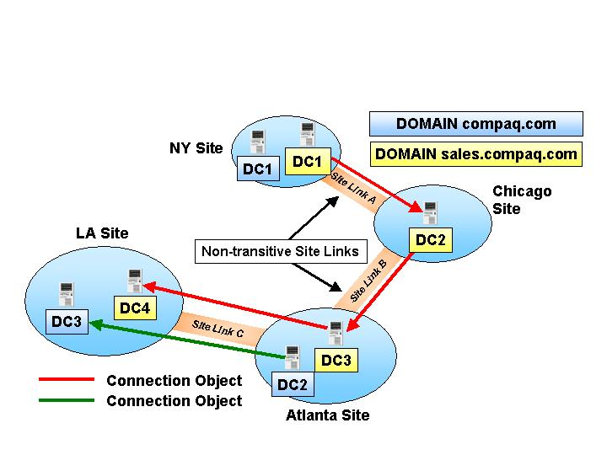
Figure 25 illustrates four sites containing two domains. The controllers that belong to the compaq.com domain are indicated with a darker (blue) color, while those belonging to the sales.compaq.com domain are shown in a lighter color (yellow).
Figure 245: Site Link implementation

Connection objects are created by the various KCCs as Site Links become available between sites. Replication is working for the sales.compaq.com domain .A DC is available on every site, and a spanning tree replication topology is generated. If we focus on the compaq.com domain, we can see that replication is only working between DC2 and DC3. There are a number of reasons for this:
- The DC2 server in compaq.com cannot transport replication information for another domain other than its own.
- There are no direct site links between the NY and LA sites. The Site Links between NY and Chicago and Chicago and Atlanta are not transitive. In this case DC1 from the compaq.com domain cannot communicate to DC2 in the same domain.
There are three ways to fix the replication topology:
- Place a domain controller for the compaq.com domain in the Chicago site. However if there aren’t any users for this domain, then this would be an expensive operation and it wouldn’t be worth it.
- Change the setting of the Site Links to make them transitive.

- Create an explicit Site Link Bridge between Site Link A and Site Link B.
Let’s see in more details what is a Site Link Bridge.
Site Link Bridges
A Site Link Bridge connects two site links to form a bridge. Think of Site Link Bridges as routers that connect two networks together. In replication terms, these networks are Site Links. A Site Link Bridge connects site links together and creates a transitive and logical link between two sites that don’t have an explicit site link between them.
Figure 26: Site Link Bridge

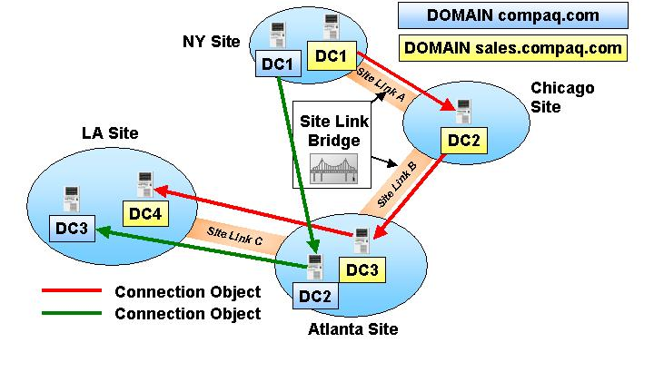
In the example in the previous section, we have four sites. The NY site does not have an explicit Site Link to the Atlanta site. Using a site link bridge to connect those two site links enables the DC in the Atlanta site to generate the connection objects from the DC in the NY site and replication can be performed.
In Windows 2000 site links transitivity is enabled by default, which means that site link bridges are not necessary in most cases. Site link transitivity can be disabled by selecting the properties of a replication transport. Transitivity affects all site links, which means that when it is turned off none of them a transitive and explicit site link bridges must created.
Site Link transitivity is turned on by default in Windows 2000 because for most small to medium deployments of Windows 2000, it is acceptable and recommended to allow the KCC to find alternate DC on any available site. On larger deployments on the other hand, it is recommended to turn transitivity off. This may be the case when for example there is a firewall in the network and the generation of the replication topology must be controlled to avoid it. The replication topology, in this case must be fine tuned by creating explicit site link bridges to control the creation of the connection objects between sites. We will see a few examples in a later section.
Figure 26 shows the properties of the IP replication transport. Administrators can turn on site link transitivity by clicking on the Bridge all site links check box. This operation can also be performed for other transports.

Creating replication topologies
The following approaches can be used to create a replication topology:
- An option is to turn off the KCC entirely or partially (between sites for example) and manually create the connection objects between the various DCs. You can certainly attain total control, but if a server goes down, the KCC will not try to find an alternate route and an administrator would have to create a replacement connection object. In a large implementation the cost of managing the explicit connection objects and monitoring all of the domain controllers would be too high, so this solution is not practical.

- Another option is to give the KCC information about the underlying network by creating a set of sites, site links with associated costs and availability schedule. The goal here is to reflect the constraints of the physical network, and avoid replication during peak working hours. This is the most flexible and powerful scenario because it allows administrators to fine tune and optimize replication. Further tuning in this scenario could be achieved by turning off site link transitivity and create specific site link bridges to allow transitivity and create redundant site links in specific cases. This scenario involves a careful design of the site topology.
Network Topologies and Site Design
In this section we will review different network topologies and analyze the consequences of different Site designs. We will also look at redundant topologies and see how Site Link Bridges may contribute to site designs.
Hub and Spoke Topology
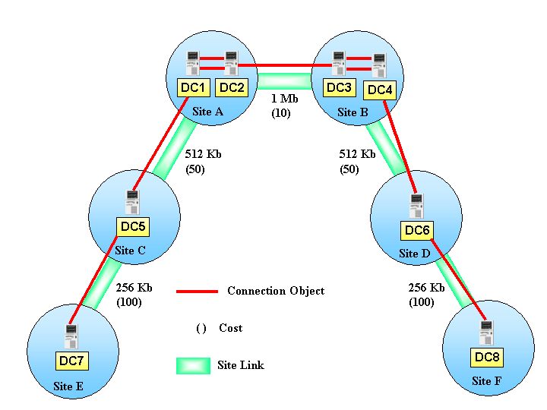
A Hub and Spoke topology is composed of sites organized in multiple tiers like a tree of sites. Figure 28 illustrates a typical Hub and Spoke topology where the first tier contains one or more central sites connected to the sites in the second tier. The second tier sites may be connected to a third tier and so on. Generally bandwidth becomes smaller as we descend to lower tiers. The goal of a Hub and Spoke topology is to centralize management. Replicated information should flow from one tier to another but not between tiers on the same level, except at the first level because this is where most bandwidth is available.
Figure 287: Hub and Tree Spoke topology

To achieve this, site links can be created between sites of different tiers. Site link transitivity can be turned on, however the cost of every site link will dictate the generation of the connection objects. The cost is low between the site links of the top-level sites. The cost will then gradually become more important between the sites of the lower tiers. The result is that the KCC will always generate a connection object with the adjacent sites in the above tier. If for example, the DC5 in the middle tier becomes unavailable, then the KCC on DC1 will generate a connection object directly from DC7, this is because the sum of the site links will always be lower between these two DCs.
Replication will always flow from the lower tiers towards the top tiers and from there down again to other tiers. This configuration will work best when there is a central backbone with high bandwidth and multiple sites connected to it through slower links.
If, instead of creating a cost structure, we leave the costs to their defaults (100), then we could achieve the same results using site link bridges. This is not the best solution, however it help in understanding the role of site link bridges. In that case a site link bridge should be created between sites links at different levels. This will ensure that if a site in a middle tier doesn’t have a DC capable of storing and forwarding the replicated information, the KCC will attempt to contact a site at the next level. Because the site link bridges will limit the visibility from the lower tier to the top tier, connection objects will never be generated between two sites of the same tier (except the first tier).
Ring Topology
In the case of a Ring topology, each site is connected to other sites forming a loop or ring as shows the illustration. The advantage of a ring topology is that DCs in different sites are allowed to store and forward replicated information to the adjacent site. The information is routed around the ring simultaneously.
Generally a ring topology can be found when multiple sites are connected to the same backbone. The cost will be a constant since the connectivity is the same for all sites. Site Link transitivity should be in this case turned off. If the DCs in one site become unavailable, then site link transitivity will allow the KCC to find an alternate DC in a different site. Over the longer term, the KCC will create a mesh topology and this will not be easy to control.
Disallowing Site Link transitivity and creating explicit site link bridges every three sites is the recommended approach. If one of the sites becomes unavailable, then the KCC will use the site link bridge to connect to a DC in the following site. This is a more powerful approach because it preserves the Ring topology.
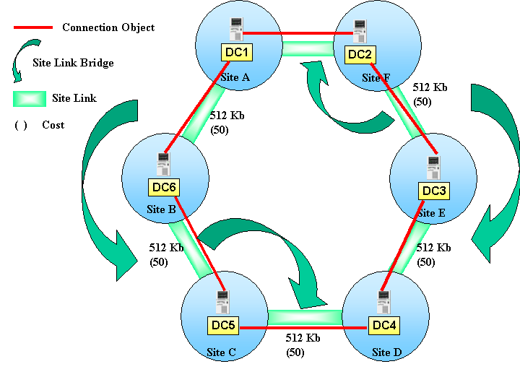
Another technique to maintain full redundancy between the site links and maintain a Ring topology, every trio of sites should have a site link in common. This will allow the KCC to generate connection objects within sites in the site link and a mesh topology will be avoided.
Figure 289: Ring Topology

Mesh Topology
A mesh topology allows every site to connect to all other sites. For example, if we take four sites, each site has an explicit site link to all other sites. In this case every site is a member of three site links. The number of required site links is equal to N*(N-1), where n is the number of sites to connect. Such an implementation is not really scalable or manageable. By allowing site link transitivity, we can reduce the number of site links that are required to connect sites in a satisfactory manner. Transitivity will allow the KCC to create connection objects to any DC in any site.

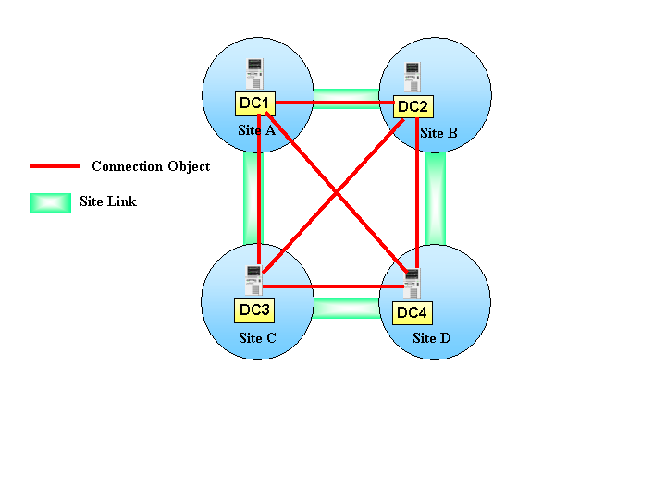
Figure 3029: Mesh Topology

Replication challenges
Urgent Replication
Even though priority cannot be assigned to the replication of different Active Directory objects, some objects replicate without considering the schedule. For example, when an account is disabled or locked out, this change must be replicated as quickly as possible to all DCs for obvious security reasons.
Another case of Urgent Replication is the assignment of RID pools, without which a DC cannot assign a SID when a new Security Principal is created.
LSA secrets such as computer passwords will also take advantage of urgent replication.
Urgent replication is available by default only between the DCs running in the same site. Urgent replication relies on notification to initialize replication. Between sites, this mechanism can be enabled.
Password uniqueness
A management operation involving a password modification does not take advantage of urgent replication however uses its own mechanism to ensure that password remains unique within a domain.
Windows 2000 DCs replicate password changes preferably to the Operation Master owning the PDC emulator. Each time a DC fails to authenticate a password it contacts the PDC emulator to see whether the password can be authenticated there, perhaps as a result of a change that has not yet been replicated down to the particular DC.

Collisions
In a multi-master replication model, there is a possibility that a concurrent attempt might be made to update the same attribute at two different DCs. Such an update will result in the USN advancing on both DCs. When replication occurs, the changed data is sent to replication partners, which then have to deal with a replication collision. The attribute has been updated multiple times, but which update is most valid and what should the attribute contain after the collision is resolved?
The Active Directory resolves the conflict by comparing the version numbers for the two replication operations and the greatest one wins. In case the version numbers are the same, the timestamps for the operation are evaluated and the latest timestamp found is used to determine the update that will be applied, and any update with an earlier timestamp is discarded. All DCs in a domain have their times synchronized. In the unlikely event that the operation happened at two DCs at the exact same time, the GUIDs of the DCs are evaluated and the latest generated GUID wins. This is, however, very unlikely. Generally, the last writer wins.
Another possible collision is the creation of an object in a particular OU on one DC. On a different DC an administrator could delete the very same object. In this case the object is created under a deleted OU. How is the collision handled? The delete operation on the OU is replicated throughout the domain and the object is moved the Lost & Found container. Enabling the Advanced features of the Active Directory Users and Computers snap-in will make this special container visible.
Another conflict case is the creation of an object in a container that is deleted on another DC. In the example we have a user created in an Organizational Unit on DC1, and at the same time, the OU is deleted on DC2. An object creation name conflict resolution occurs when two administrators create two different user objects that have the same relative distinguished name (RDN) on two different Domain Controllers at the same time. Again, the timestamps and DC GUIDs are evaluated to resolve the conflict. However in the case of a user, instead of deleting the oldest object, the RID associated with the user’s SID is appended to the name of the object and both objects causing the conflict are kept.
When a collision happens in a network with a large number of DCs the two originating DCs will replicate their conflicting changes to every DC. Every DC will receive the conflicting replication request and they will need to resolve it individually by evaluating the data of the originating DCs. All the DCs will follow the same resolution algorithm and will store in the event log the result of the conflict.

SMTP Replication Process
Basic SMTP functionality is included in Windows 2000 to allow servers to send information to each other across this transport. In terms of replication, SMTP can be used as a transport for replicating the Schema and Configuration NCs and for replicating a Domain NC to global catalogs. A layer called Inter-Site Messaging (ISM) is used to load the asynchronous transport. The transport is defined as a property of the Connection Object between two replication partners. The Connection Object is created by either the KCC or by an administrator, and relies on the transport defined in the Site Link. A Connection Object cannot use a different transport than the one defined in the Site Link.
Transports are provided to Windows 2000 in the form of loadable DLLs. The only asynchronous transport shipping in Windows 2000 is SMTP, but vendors could write their own transport DLL and provide it in the following location in the Active Directory:
CN=Inter-Site Transports,CN=Sites,CN=Configuration,DC=domain-name
The SMTP Transport DLL uses Collaborative Data Objects (CDO), a collection of COM interfaces used to create and send SMTP messages. When Exchange “Platinum” is installed on a Windows 2000 server, the CDO library is updated to allow SMTP transport between mailboxes as well as servers, and interpersonal messaging is enabled. Any DC that wishes to use the SMTP transport must have IIS installed in order to activate the CDO library.
The SMTP transport requires that a certificate be issued to all DCs using SMTP. This is because SMTP uses certificates to mutually authenticate two replication partners. Certificates contain the public key assigned to the DC. A Certificate Server issues keys in pairs: the private and the public key.
The private key is used by its owner to sign a message. The recipient of the message can then use the public key stored in the certificate to authenticate the message. The mathematical relationship between the key pair ensures that only one private key can be associated to a public key. The recipient of the message must rely on a trusted Certificate Server to validate the public key as a key belonging to the owner. To gather further information on Public Key Infrastructures, please read the white paper titled Security Fundamentals as implemented in Windows 2000 by Jan De Clercq.
Once two DCs decide that they must replicate information, they perform a mutual authentication using certificates. Certificates are stored in Global Catalogs, and this allows DCs in different domains to locate the necessary certificates.
The sender DC prepares the data that must be sent to the target DC. It compresses the data if it is bigger than 50KB and requests the ISM layer to load the SMTP Transport DLL. This DLL will sign the compressed data using the public key of the DC and will then use CDO to create and send the message to the target DC.
The target DC receives the message and uses the Certificate Server to verify the validity of the signature. This is done by checking with the Certificate Server that the public key in the Certificate is really the one issued to the sender DC. If this is the case, the target DC will process the message and the data will be replicated locally.
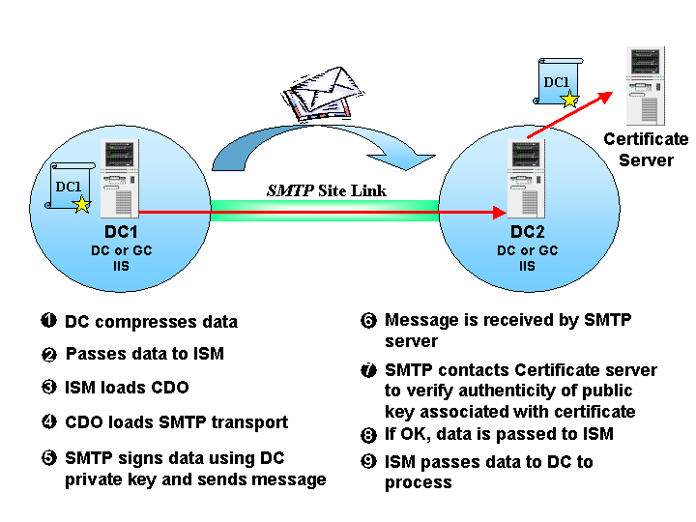
SMTP is designed to operate over extended and slow network links if required, which means that this transport can be used to replicate over slow and unpredictable network links. In fact, implementations could use public Internet links to transport messages from an intranet to another intranet.
Figure 310: SMTP Site Link

Figure 31 shows the steps performed by the DCs using SMTP replication.
RPC versus SMTP Replication
In a configuration where both the SMTP and RPC site links are available, the KCC will always prefer RPC replication to SMTP. For example lets assume that we have two sites, each containing a GC. The two GCs belong to two distinct domains within the same forest. Replication between these GCs can use the SMTP transport for the schema/configuration NC as well as the partial domain NC.
If we create two site links, one using SMTP and one using the RPC transport, then the KCC will generate a connection object for the RPC transport. This is the case even if the cost defined in the SMTP site is lower than the one defined in RPC link. This is because the KCC will always attempt to use RPC if available.
To create an SMTP site link, explicit connection objects must be created between sites that are not connected with an RPC site link. If an RPC link is added between two sites that are already replicating using the SMTP transport, then the DC will stop using the SMTP connection and generate an RPC connection.
SMTP replication should be used only in specific environments where bandwidth is scarce or connectivity is unpredictable.
Conclusion
The design of a fine-tuned replication topology is key when architecting a Windows 2000 based infrastructure aimed at large enterprises. The Active Directory is already used by a number of applications, including
- The version of DNS provided with Windows 2000 uses the Active Directory to store its data and uses the replication mechanism to ensure that other DNS servers receive updates.
- The “Platinum” version of Microsoft Exchange Server uses the Active Directory to store information about mailboxes and servers.
- All other Microsoft BackOffice applications are likely to use the Active Directory after they have been upgraded for Windows 2000.
Customer solutions can also integrate their data with the Active Directory. Active Directory enabled applications can modify the schema to add their own object classes. Instances of these classes will replicate using the same replication topology already in place.
Because Windows 2000 and many applications depend on the Active Directory, the replication topology must be carefully planned to provide the foundations for disseminating potentially large amounts of information. Planning for the deployment of the Active Directory is a critical part of any Windows 2000 implementation project.

Appendix - Registry Settings
Replication Priority
Replication can be tuned using registry settings. By default the registry settings are set for an optimum replication
HKEY_LOCAL_MACHINE\SYSTEM\CurrentControlSet\Services\NTDS\Parameters
The following keys can be used to modify the default behavior of Active Directory replication:
Control the priority used by the replication thread. This is more interesting in a multi-CPU environment where a CPU could be dedicated to processing replication data:
- Replication thread priority high set to 1. If not set or set to 0, this gives the replication thread a low priority.
- Replication thread priority low set to 0. By default this value is set to –1 which simply means that the key should be ignored.
Replication Packet Size
Tune packet sizes and number of objects per packet for each type of replication: intra-site RPC, inter-site RPC, and inter-site SMTP. The values are:
- Replicator intra site packet size (objects)
- Replicator intra site packet size (bytes)
- Replicator inter site packet size (objects)
- Replicator inter site packet size (bytes)
- Replicator async inter site packet size (objects)
- Replicator async inter site packet size (bytes)
Synchronous replication computes packet size dynamically, to best use of available system memory. Objects/packet starts at 100 for a 100 MB or smaller server and increases to 1000 for servers of a 1 GB or more.
In term of bytes sent, 100 MB or smaller servers send 1 MB; 1 GB or larger servers send 10 MB. Asynchronous packets are fixed at 100 objects and 1 MB.
Replication Latency
Replication latency can be adjusted by setting following values:
- Replicator notify pause after modify (secs) to control the number of seconds to wait after a modification occurs on a DC before notifying the first replication partner.
- Replicator notify pause between DSAs (secs) to control how much time the replication partner will wait to notify the next replication partners in the replication topology.

Replication TCP/IP Port number
Directory Replication uses dynamically mapped ports. However the port number can be statically assigned by editing the following registry key:
- TCP/IP Port

In some large site configurations the inter-site KCC (step 1b) runs too slowly, consuming too much CPU and memory. A large site configuration is one containing many sites, many domains, and/or many routes betweens sites.
Logging when KCC is running
It is possible to log in the Event Log when the KCC is started and when it has completed the generation or evaluation of the replication topology. The registry key is HKEY_LOCAL_MACHINE\System\CurrentControlSet\Services\NTDS\Diagnostics
The key value to set is 1 Knowledge Consistency Checker with a value of 3. If this value is set, then the KCC will log two events:
- Event 1009 which will be logged when the KCC is started.
- Event 1013 which is logged when the KCC is terminating.

