

WHITE PAPER

Protecting the Microsoft Exchange 2000 Environment with Trend Micro ScanMail® for Microsoft Exchange 2000
...

your Internet VirusWall®

Trend Micro Inc.
10101 N. De Anza Blvd., 2nd Floor

Cupertino, CA 95014

Phone: 800-228-5651 / 408-257-1500
Fax: 408-257-2003
Web: www.antivirus.com

Copyright © 2001 by Trend Micro Inc. All rights reserved.
ScanMail® is a registered trademark of Trend Micro Inc.

Table of Contents
Abstract 3
The Microsoft Exchange 2000 Server 4
Microsoft Exchange 2000 Architecture 5
How does the ScanMail Virus Scan API Work? 7
Viruses and the Microsoft Exchange 2000 Server 8
Viruses in the Microsoft Exchange 2000 Environment 9
Detecting and Cleaning Viruses 9
Basic Requirement for Antivirus Products for Microsoft Exchange 2000 10
Trend Micro ScanMail for Microsoft Exchange 2000 11
Comparing Virus Threats 11
The Trend Micro Response to Viruses in Email Environments 11
How ScanMail for Microsoft Exchange 2000 Works 11
Handling Scan Engine and Pattern 15
How ScanMail for Microsoft Exchange 2000 Works in Conjunction with Windows 2000 Advanced Server clustering 16
The Benefits of Using Centralized Control Error! Bookmark not defined.
Advantages of Trend Micro ScanMail for Microsoft Exchange 2000 19
Bibliography 20
Appendix A: :Trend Micro ScanMail for Microsoft Exchange 2000 21
About Trend Micro 22

All rights reserved. No part of this publication may be reproduced, photocopied, stored on a retrieval system, or transmitted without the prior written consent of the publisher.InterScan, eManager, Trend Virus Control System, ScanMail, ServerProtect, and OfficeScan are trademarks or registered trademarks of Trend Micro, Inc. All other company and product names are trademarks or registered trademarks of their respective owners.

Abstract

Email and groupware systems require specialized antivirus software to prevent virus infections from spreading via attachments, data files and executable programs shared through their server databases. While the proprietary formats of these databases ensure the security of the information they process, they also defy antivirus software’s traditional scanning techniques.

Proprietary email and groupware formats render traditional virus protection ineffective because they lack the standardized formats and API functions relied on by traditional virus scanning products. Hence, traditional antivirus software either bypasses scanning or is unable to scan the email attachments and information shared within these proprietary databases. Network administrators seeking email and groupware antivirus solutions often are forced to rely on desktop applications to combat viruses.

Unfortunately, desktop or server antivirus software only disinfects the local copies of attachments users save to their hard drives. This leaves the original transmitted file attachments, along with any viruses they are carrying, where users may forward them, thereby spreading viruses. Since email file attachments are the single most common way that viruses spread today, effective email/groupware virus protection must address this primary threat to prevent viruses from spreading through information-sharing functions.

Email/groupware server-level virus protection is preferred to desktop-only protection for several reasons:

- Effectiveness: Email applications retain original attachments at the email server, while delivering copies of attachments to users. Without email server virus protection, attachments remain infected on the server databases and spread to other client computers whenever users forward infected email attachments.
- Costs: Virus infection clean-up costs are greatly reduced when detected at the server-level before they proliferate to numerous client machines.
- Management: It is easier to manage and configure virus protection software centrally at the server rather than at multiple desktops.
- Security: The virus breach point at the email/groupware server is closed, preventing virus propagation and transferring responsibility for updating antivirus software and removing viruses.
- Performance: The LAN administrator is empowered to balance issues of performance, selecting when and what to scan, with overall network security and at the same time balancing the computing power for their servers.

In October 2000, Microsoft introduced the next generation of its messaging and collaboration platforms, Microsoft Exchange 2000. The new version includes advancements in reliability, performance while delivering the openness of the web to help business to use and share information more effectively.

The new web store technology built into Microsoft Exchange 2000 enables organization to store and access e-mail, documents, web content and application in one location. It also includes technology allowing new ways to collaborate and communicate through real-time conferencing services, video teleconferencing and instant messaging. While adding new capabilities to access e-mail, documents and streaming media from any device such as a hand held computer, cellular phone or web browser.

With these new capabilities, Microsoft Exchange 2000 Server has increased the risk of virus infections and malicious code infiltrating the Microsoft Exchange 2000 environment. The open architecture of the new Microsoft Exchange 2000 Web Store technology makes this possible. Because of this open architecture, content security will become even more important.

This paper outlines Microsoft Exchange 2000 Server’s architecture, its vulnerability to viruses, reviews how ScanMail for Microsoft Exchange 2000 works and outlines the benefits for businesses.

The Microsoft Exchange 2000 Server

A growing number of organizations are moving quickly to the new messaging and collaborations platforms. Integrated email, group scheduling, electronic forms, collaboration, groupware and Internet capabilities allow users to coordinate, discuss and collaborate on vital projects. Microsoft Exchange 2000 supports this wide range of communication on a single platform making it one of today’s fastest growing email/groupware systems.

Microsoft Exchange 2000 Servers provides:

Enhanced Messaging and Collaboration

- Attachment capability to accompany Exchange email messages allowing individuals to attach any type of file to email. Typical extensions include: EXE, VBS, SHS, COM, XLS, XLA, DOC, DOT, BMP, JPG and ZIP.
- Allows for many clients, such as POP3, IMAP4, SMTP, HTTP, to directly access attachments and collaboration content from the web store databases.
- Public folders replication and database replication between servers or organization. Public mailboxes where users can post, access and modify shared files.
- Messages, forms and documents stored in public folders are replicated across all Exchange 2000 servers to make this information available to all network users.
- Exchange 2000 servers provide support for tens and thousand of users including single or multiple databases and single or multiple storage groups.
- Storage Groups allow for managing of multiple storage groups from single administration.
- Native Internet Mail provide direct access to stream data in and out of the database without content conversion.

Web Storage System Collaboration and Application

- One database can store everything, documents, messaging, and web applications.
- Allow seamless integration between Exchange 2000 and Windows 2000 file system
- Directly integration with Microsoft Office and Front Page, which allows for saving and retrieve of contents directly to the Web Storage databases.
- Workflow applications make it simple and close integration on the Web Storage system

Anywhere and Anytime Communication

- Enhanced mail client like Outlook Web Access and WEBDAV to directly access message, contents, scheduling and any collaboration information via the remote HTTP client
- Provide single unifying messaging area for retrieve or storing of email, fax, voice mail and page messages
- Provide instant messing for enterprise use and business to business communication
- Provide support for multiple clients and allow for conferencing technology and other third party conferring to be plug-in—including video conferencing.

Microsoft Exchange 2000 Architecture

In Microsoft Exchange 5.5, the Mail Transport Agent (MTA) is the heart of all information delivery (see Figure 1 below). It is a logical place to intercept and scan email and shared information for viruses and malicious code. Doing so not only prevents infected files from reaching these systems’ proprietary databases where they can spread, but also prevents infected information from being sent outside these environments where it can infect other users.

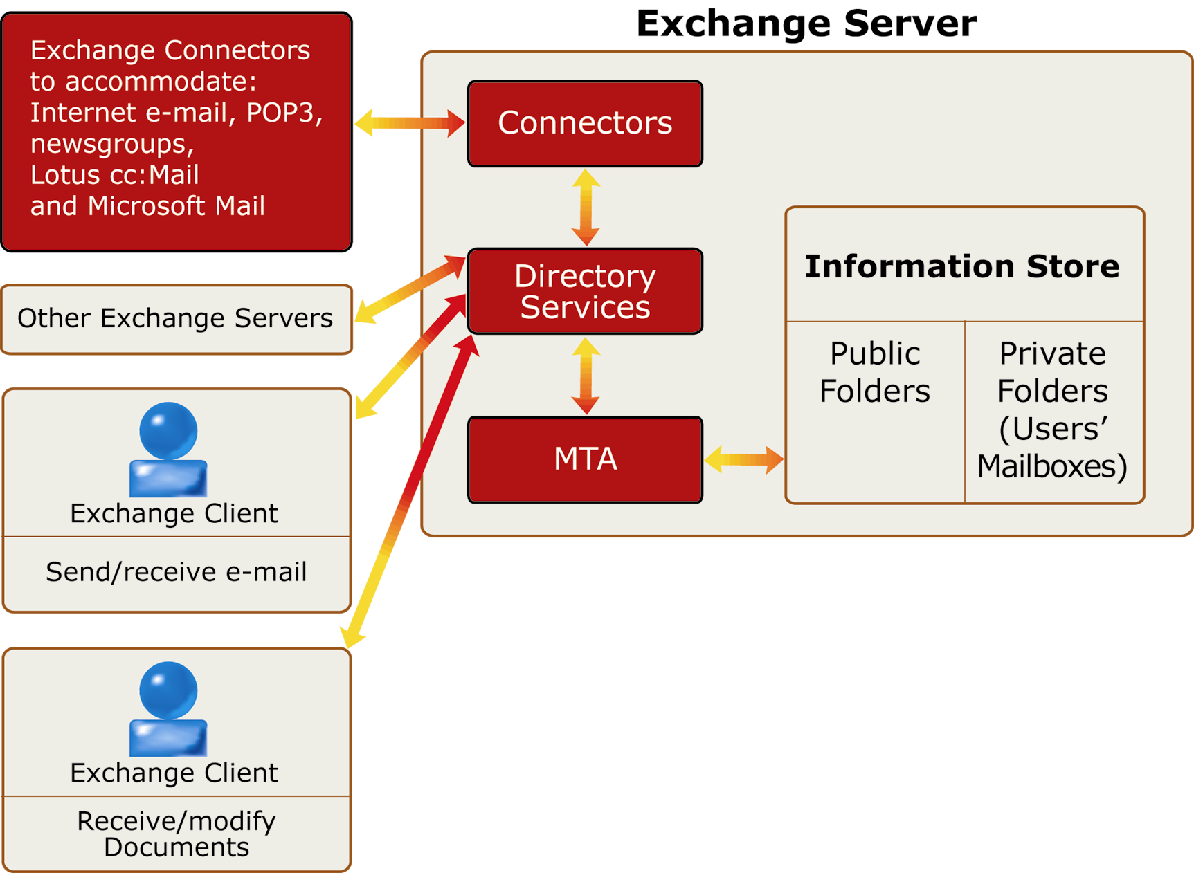
Figure 1. The Microsoft Exchange 5.5 Server, its Information Store, where all information is scanned, and Exchange “connectors” — bridges for information to flow from and into the Exchange environment.

Most messaging systems enable antivirus software to scan information at the MTA level with the exception of the Exchange Server. Microsoft has not published an MTA protocol to enable scanning information in Exchange at the MTA level and probably will not in the near future. But due to several virus incidents, Microsoft has provided an Antivirus Scan API hook on Microsoft Exchange Server 5.5, Service Pack 3 (SP3) for antivirus vendors. The virus scan API hook, allows antivirus vendors to provide a virus protection hook at a very low-level at the Information Store. (See figure 3).
In Microsoft Exchange 2000 Server, the architecture provides users with a scalable messaging, data retrieval and sharing system. It allows for greater flexibility for the administrator to design the network environment, because it integrates with Windows 2000 Active Directory, Microsoft Internet Information Service (IIS), and Web Storage System. Protocols such as Network News Transport Protocol (NNTP), Post Office Protocol version 3 (POP3), and Internet Message Access Protocol version 4 (IMAP4) run as part of the IIS process. The use of multiple databases and protocols expands the server’s capabilities to reduce network traffic, expedite and broaden data retrieval and usage, provide scalability, security, rapid recovery and failover.
Microsoft Exchange 2000 also supports multimedia formats, making information storage and retrieval fast and efficient. It stores native content, including Multipurpose Internet Mail Extensions (MIME) content, directly in a .STM file. Additionally, with the installable file system (IFS), you can use Exchange as a file repository for any application. IFS makes it possible to map Exchange folders and mailboxes as shared network drives. Finally, Exchange supports multiple public folder hierarchies. Each hierarchy, or tree, is stored in a public folder store. The default server installation includes one public folder store containing one public folder hierarchy. Figure 2 shows a graphical representation of the Exchange 2000 architecture, including the Extensible Storage Engine, Web Storage System, Exchange Interprocess Communication Layer (ExIPC), IIS, and their underlying components.
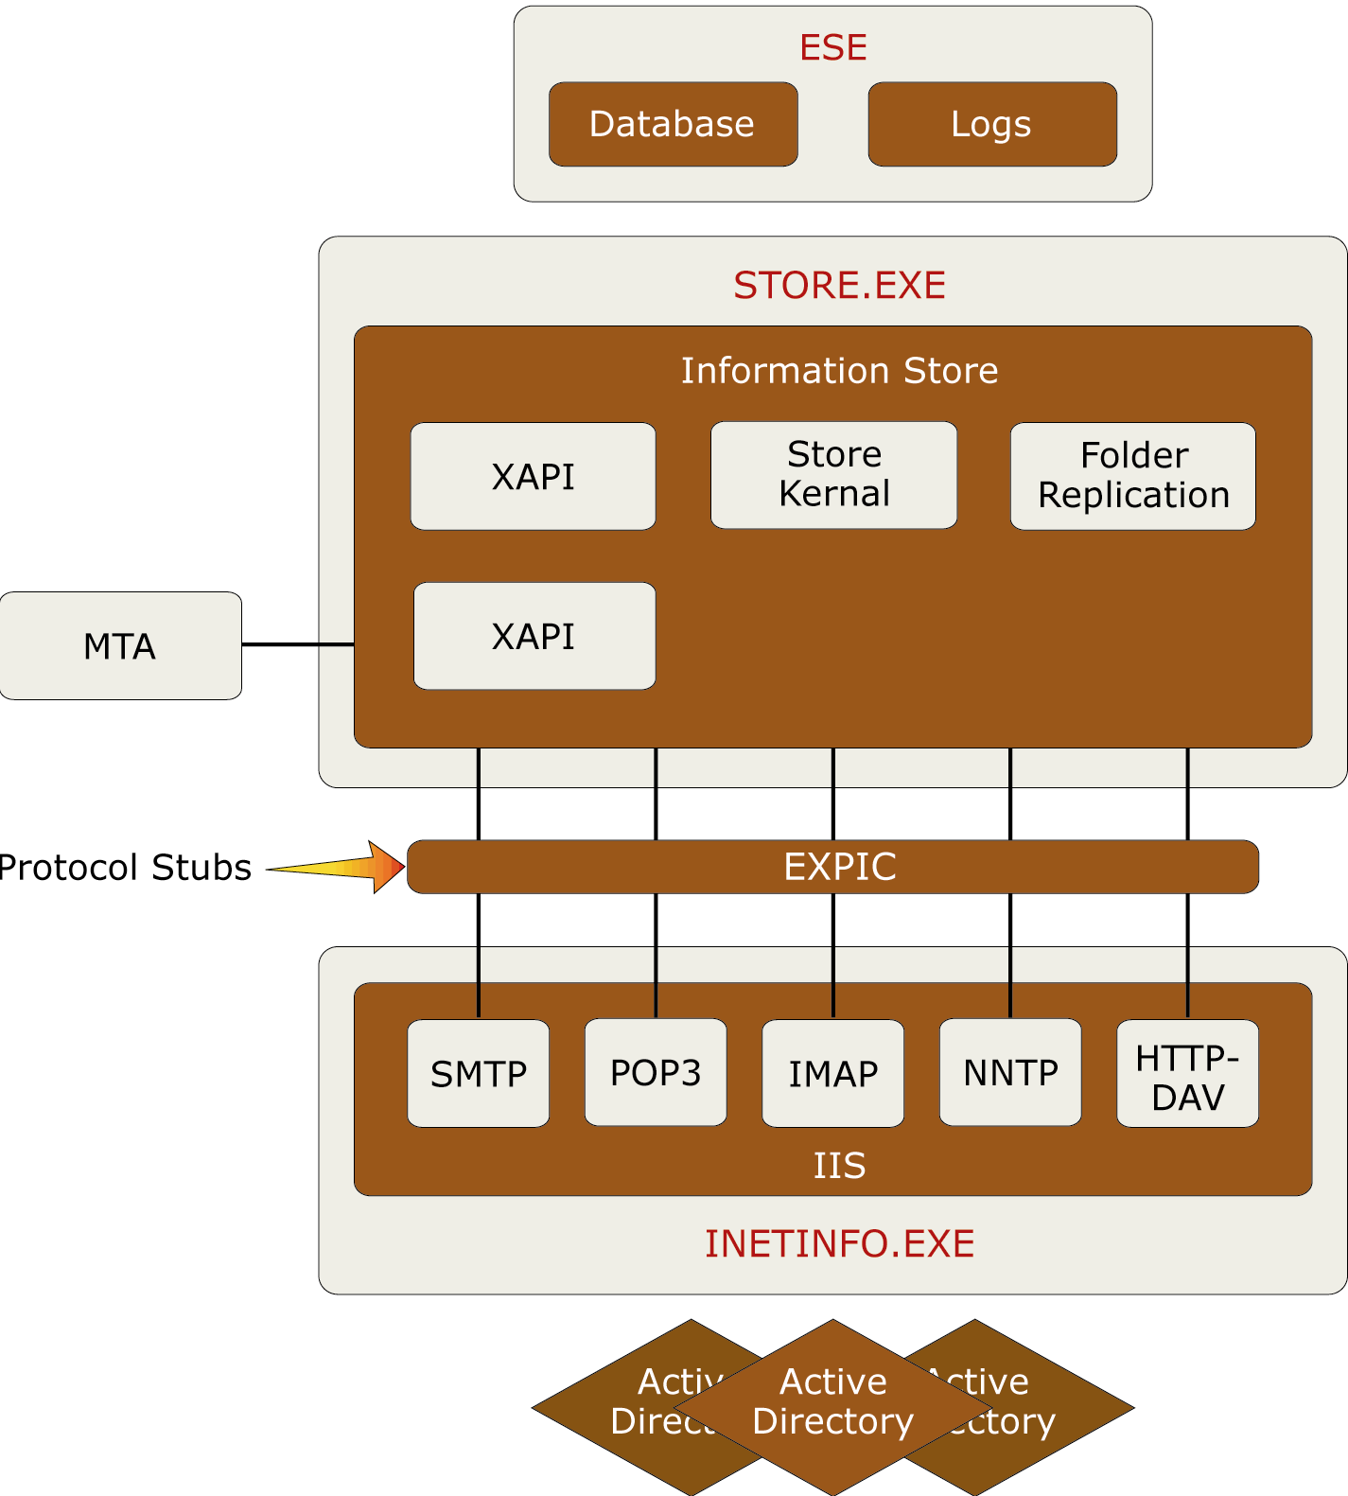

Figure 2. Microsoft Exchange 2000 Server Architecture

With the new architecture and capabilities comes concerns over security issues such as viruses penetrating and damaging the Exchange 2000 database. For this reason, Microsoft included the new Microsoft Exchange Anti-Virus Scan API which allows antivirus vendors to hook and do virus scanning before attachments and contents are saved or retrieved from the storage systems.

With this new Exchange Anti-Virus Scan API becoming available for antivirus vendors, products such as ScanMail for Microsoft Exchange 2000 can be constructed to provide high speed scanning, higher performance and scalable antivirus protection while ensuring the integrity of the information store, web store database and its contents.

How does the ScanMail Virus Scan API Work?

Exchange Server 5.5, Service Pack 3 (SP3) provides a new virus scan interface implemented at a low-level in the Exchange Information Store. This allows a virus-scanning implementation with high performance and guarantees the scanning dynamic link library are loaded and run before any client can access a message or attachment.

The new ScanMail Virus Scan API interface reduces problems associated with recognizing when a new mailbox has been added to the system and addresses scalability issues arising when a particular server has a large number of users/mailboxes.

The new ScanMail Virus Scan API allows messages to be scanned once before delivery, rather than multiple times, determined by the number of mailboxes the message is delivered to. Single instance scanning helps prevent a message from being rescanned when it is copied or passed from server to server. To improve virus scanning and protect the Exchange Server 2000 from virus for customers, this same Exchange Virus Scan API will also be incorporate into Microsoft Exchange 2000 and includes some of the limitations describe in this white paper. For further information on this new Microsoft Exchange Virus Scan API, please contact Microsoft or refer to the Exchange/MSDN documentation at www.microsoft.com.

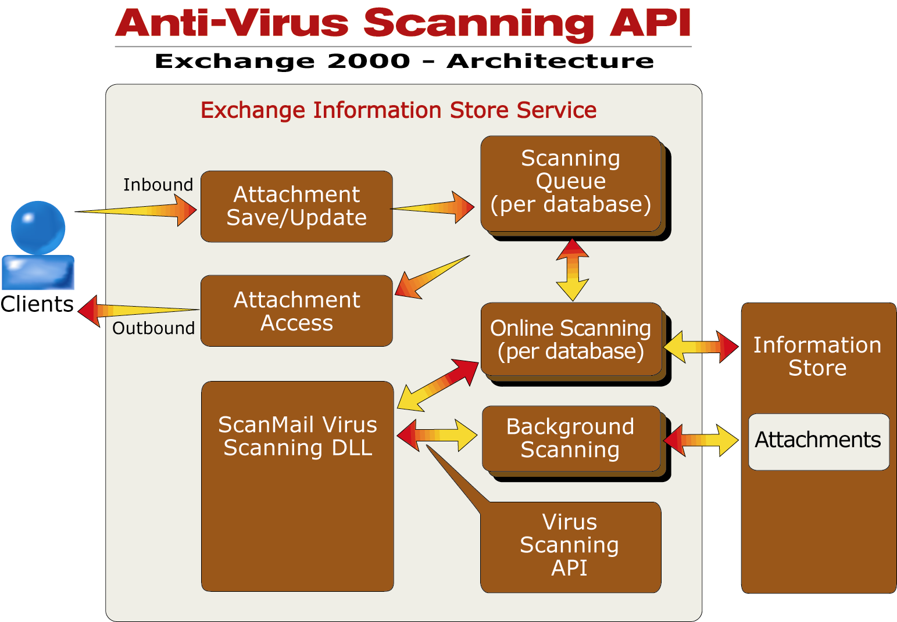
Figure 3. ScanMail for Microsoft Exchange 2000 Architecture

Advantages of the Trend Micro Implementation of the Microsoft AVAPI

- Enable the detection and elimination of viruses by scanning email attachments before users access mail
- Scans and blocks both inbound and outbound attachments
- Scan methodology, developed under close collaboration with Microsoft, guarantees the integrity of the Information Store, messages, and attachments, improving reliability and scalability on virus detection and cleaning
- Ensured that all attachments are scanned before entering or leaving the Exchange 2000 Server
- One hundred percent scanning of all attachments before user can open the attachments
- Improved real-time scanning performance and resource usage on the Exchange 2000 Server
- Email attachments are scanned only once regardless of how many servers, recipient or senders to which the message is sent

Viruses and the Microsoft Exchange 2000 Server

Virus Infection Background

All messaging systems, including Exchange 2000, are vulnerable to virus attacks. Viruses spread from computer to computer when infected programs or data files are duplicated through server replication or any other means by which files are shared or exchanged. Viruses are usually designed to carry a “payload” or an undesirable action generated by a virus. While some of these viruses are relatively harmless, like displaying an irreverent message on a user’s screen, they can also be damaging enough to wipe out all data on the infected PC’s hard drive or completely shutdown your mail server through some form of denial of services.

In Exchange 2000 servers, viruses spread along with the files users share: through email attachments, public folders replication, database replication, installable file system and other Exchange 2000 compliance applications using the web store to stored information and contents. With the additional connectors and new protocols for the Exchange 2000 server, they are open to a broader range of Internet information sources, greatly expanding the number of opportunities for virus infestation.

Virus Proliferation Through Shared Information and Electronic Mail

Only a few years ago, floppy-based viruses took weeks or months to spread around the world. With the exponential growth of the Internet and email, it now takes only a few seconds for a virus to travel across the world. The W97M_MELISSA virus was discovered the morning of March 26, 1999 in the United States and by noon of that same day it had traveled throughout the world and penetrated numerous enterprise networks.

Since plain text cannot carry the executable programs viruses require to propagate, text-only email messages are unable to spread viruses. The email virus threat stems from macro-enabled data files and from attachments containing active executable program files with extensions such as: VBS, CLASS, OCX, EXE, COM and DLL. Today Macro viruses are responsible for the majority of all virus infections.

Macro Viruses

The advent of the macro programming capability in applications created an effective, new way for viruses to spread. Prior to macro programming, Word and Excel files only contained data. Like text-only email messages, they were unable to harbor viruses because they did not carry executable code. Virus writers soon discovered macros for these applications could be used to create viruses.

A watershed year for virus proliferation, 1995 marked the discovery of the infamous Word Concept macro virus. Today’s widespread sharing of macro-enabled files is increasing exponentially along with the associated macro virus threat. Macro viruses like Concept, Cap, MELISSA, and ILOVEYOU are the most prevalent computer viruses in the wild and account for the vast majority of virus encounters in corporations.

Among the factors contributing to the dominance of macro viruses is the VBA (Visual BASIC for Applications) programming language making it as easy for virus writers to create time-robbing macro viruses as it does for users to create legitimate time-saving macro commands. Another factor spurring virus proliferation is the availability of macro virus construction kits that virus writers can easily download via the Internet.

At the time of this writing, hundreds of macro viruses exist and new ones are being created every day. Only a few viruses are harmful to data, but all require downtime plus the wasting of human, computer and monetary resources.

More information on macro viruses is available in Trend Micro’s white paper: “Trapping the World’s Most Prevalent Viruses" (http://www.antivirus.com/download/whitepapers/macrotrap.htm).

Viruses in the Microsoft Exchange 2000 Environment

Figure 4 diagrams how a virus in one client computer can proliferate throughout an organization via Microsoft Exchange server functions and then spread beyond that organization to users outside the network.

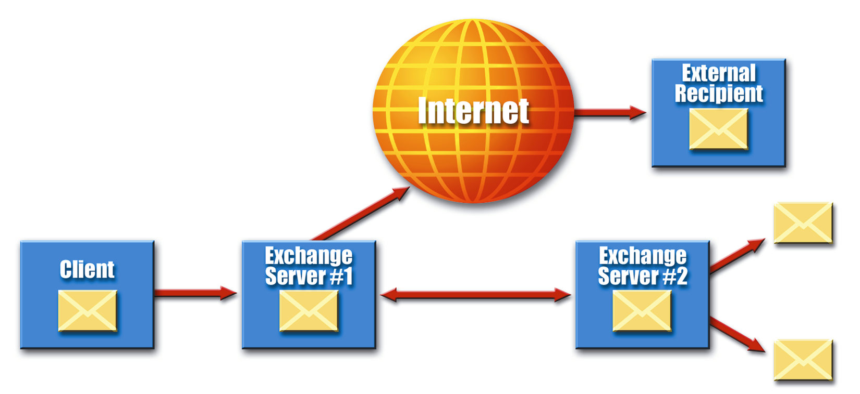
An Exchange client user attaches an infected file to an Exchange email and sends it to 10 other users. | Exchange server #1 stores the email in 10 recipients’ email boxes. One of the recipients posts the document to the public folder, broadly infecting the #1 server — while another user forwards the infected file to a user outside the company. | Exchange server #2 is infected by Exchange server #1 through the public folder file replication process. The file infects other users when they draw upon the public folder to access the infected file.

Figure 4. One virus-infected file can quickly infect an entire organization and external users
through Exchange servers’ email and information-sharing functions

The “old style” file and boot sector viruses remain a destructive threat which must be addressed by Exchange 2000 Servers and all other enterprise virus protection. However, since it is less common for users to share executable files than to share data files, the latter has eclipsed the former in terms of frequency of occurrence and has become the preferred method for virus writers to create “successful” viruses.

Detecting and Cleaning Viruses

An effective antivirus solution for the Microsoft Exchange 2000 environment is to provide real time protection scanning on all information store databases including both the EDB and STM database level using standard Microsoft Messaging API.

Products not using standard Microsoft messaging API to retrieve attachments and messages for scanning can cause corruption in the Information Store database, thereby rendering their messaging server useless. Because of the performance impact and delay of mail, such a delay could cause disruption to the company’s operation and productivity.

Once an antivirus application disinfects the Web Store database, it must then prevent infected files from entering the server. Network administrators must pinpoint and protect any possible virus entry points within the Exchange environment and enterprise network.
Exchange 2000’s external communication capabilities provide numerous network entry points that must be secured against viruses. These include:

- User mailboxes
- Internet email attachments from HTTP mail client such as IMAP4, POP3, Outlook Web Access or Outlook Express
- Newsgroup discussions including posted file attachments
- Public folders where clients may store and access files
- Both EDB and STM databases where other Exchange 2000 compliance applications may store and retrieve contents directly
- Moving folders from one server to another
- Database replication from server to server
- Systems that transmit messages through connectors such as: Lotus cc:Mail, Microsoft Mail, SMTP, x.400 and other external email systems
- Remote access where Exchange Servers are being accessed through a web browser

In addition to the virus entry points shown in Figure 2, Exchange 2000 Servers may be vulnerable to virus attacks due to uncoordinated virus protection elsewhere within the network.

Because many companies use an array of mismatched antivirus products, the “server leak factor” sometimes affects Exchange 2000 servers. The resulting overlap of functions, gaps in virus protection and different protocols used by competing antivirus packages prevents them from working together to effectively protect Exchange servers and their client users. In such an environment, conventional viruses, malicious Java and ActiveX code can “leak” past gateways and file-servers to infect Exchange servers and the enterprise at-large.

The “client leak factor” is created by the reverse situation with desktop antivirus products being unable to scan Exchange 2000 email attachments, mailboxes or public folders, thereby allowing users to post or download infected files to Exchange Servers.

Monitoring all potential points where viruses can enter enterprise-computing environments and leak into Exchange 2000 servers is CPU-resource intensive. Additionally, such monitoring is extremely cumbersome for network administrators to manage. Fortunately, Trend Micro’s family of integrated antivirus products includes an Exchange 2000-specific application that provides easy-to-manage, resource-efficient protection from viruses.

Basic Requirement for Antivirus Products for Microsoft Exchange 2000

An effective antivirus product functioning in Exchange 2000’s environment must be able to:

- Monitor the Web Store database in real-time, protecting all content traffic entering the .EDB and .STM databases
- Scan email and attachments entering and leaving the databases and then clean or eliminate infected files
- Provide manual and scheduled scanning of Exchange 2000 server, Web store and Web store databases
- Detect and clean existing infected email attachments in archive mailboxes
- Install, update and upgrade remotely from a central location, thereby minimizing deployment costs
- Provide easy automated web-access to virus pattern, scan engine and program file updates to minimize maintenance costs
- Provide a detailed virus activity log to secure and trace virus entry points
- Provide an alerting system for administrators in the event a new virus threat
- Provide centralized management through both web- and windows-based graphical user interfaces to minimize the time network administrators must devote to virus protection
- The ability of the vendor to provide engine or new pattern file in the situation where there’s a virus outbreak. Access to a new pattern file or engine is critical to real virus protection.

Trend Micro ScanMail for Microsoft Exchange 2000

Comparing Virus Threats

The International Computer Security Association’s (ICSA) 1999 Computer Virus Prevalence Survey found email attachments are the single largest source of virus infections. Their findings closely mirror the virus statistics compiled at the Trend Micro Virus Research Support Center during 1999. ICSA’s 1999 survey shows a continuing, long-term decline in the proportion of viruses spread by diskette.

The Virus Research Center knows many IT professionals working in small, medium and even large-sized organizations focusing their resources on desktop protection and floppy disk-based viruses, often to the exclusion of efforts directed against potentially more dangerous email attachments. Some antivirus products even today cannot detect viruses in email attachments before infected files are opened on client desktops.

The Trend Micro Response to Viruses in Email Environments

Trend Micro was the first antivirus company to develop and market effective technology to detect and eliminate viruses inside the Microsoft Exchange environment. ScanMail for Microsoft Exchange performs real-time monitoring of incoming and outgoing email attachments, thereby eliminating viruses from the Exchange server before users can make copies of infected files.

Since the advent of the Melissa macro virus, Trend Micro offers free web-based virus protection diagnostic service with HouseCall for Exchange and Lotus Notes. These services enable administrators to check the health of their Information Store database and users' personal folders.

ScanMail uses Trend Micro’s award-winning 32-bit multi-threaded VSAPI scanning engine with MacroTrap™ technology. Trend Micro’s patent-pending scanning engine minimizes the performance hits to Exchange servers during scanning. Furthermore, ScanMail cleans both known viruses “in the wild” as well as unknown macro viruses. This virus detection engine uses minimal server CPU resources while increasing its scanning speed and performance by more than 50 percent over Trend Micro’s previous scanning engine.

With the addition of the new ScanMail for Microsoft Exchange 2000, that hook into a very low level in Exchange 2000 Information Store, will provide fast real-time and on-demand scan of all attachments passing to and from the Exchange 2000 Server.

How ScanMail for Microsoft Exchange 2000 Works

The new Exchange 2000 Antivirus Scan API provides an interface implemented at a low-level in the Exchange 2000 Information Store and designed to integrate and load the ScanMail Virus Scan API program automatically when Exchange service starts. ScanMail for Microsoft Exchange 2000 gives the administrator flexibility to configure and provide real-time protection on the Exchange 2000 Server without stopping or restarting the Exchange services and while continuing virus protection in real-time.
As emails and attachments pass through the Information Store, the Information Store verifies if ScanMail is running. If ScanMail is running, the attachment will then be pass to ScanMail to for scanning. Afterward, ScanMail will pass the attachment back to the Information Store, which will then in turn combine with the clean attachment with original message and forward to the intended recipient. For detail, see Figure 3 &5.
Only an application following standard Microsoft messaging API can ensure that the Exchange Information Store database, messages and attachments remain both uncorrupted and clean. ScanMail does so without leaving traces of virus infestation or accidentally violating any API protocols that may result in corruption of the Information Store’s data structure or crashing the Exchange Server.
Figure 5 illustrates how ScanMail for Microsoft Exchange 2000 works with Exchange 2000 by hooking at the Information Store
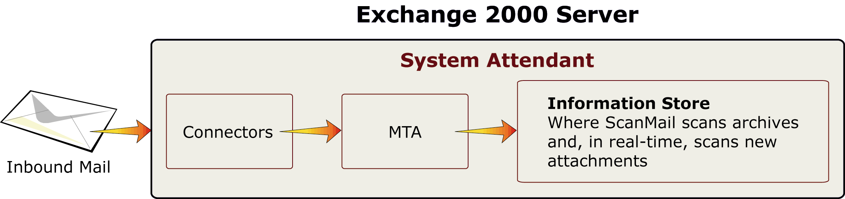

Figure 5. Email passes through the connectors and the MTA is delivered
to the Information Store for scanning by ScanMail.

Real-time Scanning and SmartScan™

ScanMail for Microsoft Exchange 2000 provides real-time scanning of all attachments from inbound and outbound the moment they reach the Information Store. In addition to real-time scanning for viruses, ScanMail constantly monitors all messages and content passing through Exchange 2000 Servers databases.

Performance Advantages of ScanMail for Microsoft Exchange 2000

- Scans and blocks both inbound and outbound email attachments at the Information Store level with a very low-level API hook .

- Scan methodology guarantees the integrity of the Information Store database, messages and attachments.

- Ensured that all attachments are scanned before delivery to or from the Exchange 2000 Server, even under heavy server load.

- One hundred percent scanning of all attachments before user can open them.

- Improved real-time performance and resource usage on Exchange servers with the new Exchange virus scan API.

- Single instance scanning with Smart Scanning scans messages and attachments once regardless of how many servers, recipients or senders receive the messages.

- ScanMail preserves the original email route to avoid information detours, preserve server performance and eliminate false delivery problems that can arise from additional routing.

- ScanMail’s incremental scanning scans email attachments only once, thus avoiding unnecessary repeat scanning of email archives to enhance overall scanning performance and shorten email delivery time.

- ScanMail’s Performance Monitor generates real-time reports of regular and infected email traffic passing through Exchange servers for easy analysis and reporting. The Performance Monitor enables administrators to balance IT resources by analyzing the Exchange server’s relative productivity

- ScanMail’s automatic, real-time protection for newly created, moved mailboxes, or database replication database prevents them from being infiltrated by virus-infected attachments while sparing administrators the trouble of performing a manual scan every time a new mailbox is created on the Exchange server.

- ScanMail provide real-time protection of contents being drag and drop to the database or mailbox folders.

- ScanMail provide real-time protection of contents when it is being published to public folders or databases.

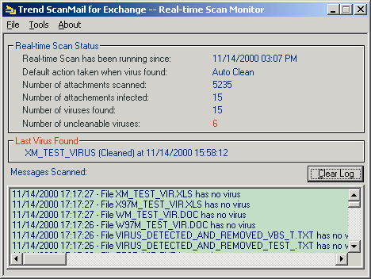
Figure 6 shows ScanMail’s real-time scan activities.

Figure 6. Real-time virus monitoring and antivirus activity on new ScanMail Virus Scan API mode

Establishing Protocol for Infected Files

Network administrators determine whether ScanMail will clean, delete, move or pass infected files found within the Information Store. Additionally, administrators have the options of configuring ScanMail to save and quarantine backup copies of infected files to a central repository, send a copy of infected files to network administrator.

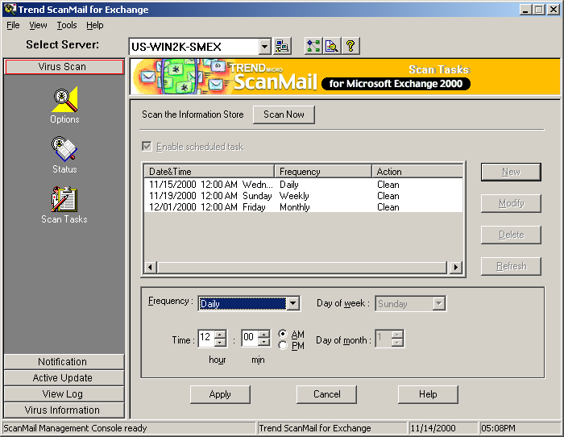
Figure 7. ScanMail’s manual and schedule scan option

ScanMail for Microsoft Exchange 2000 features:
- Easy navigation and configuration across the enterprise from a Windows or Web Interface.
- Easy options for performing a on-demand scanning of the information store databases or setting pre-schedule scan task to scan the information store database at a later date. Allowing it to scan and clean infected attachments in archive mailboxes.
- Flexible configuration with multiple entries to run prescheduled scanning and pattern update downloads.
- Generation of virus incident reports, update logs and virus information.
- Easy, automatic updating of scan engines, virus pattern files and patch files through the Internet.

Simple Remote Deployment and Management

ScanMail for Microsoft Exchange 2000 was the first antivirus product on the market that could be deployed and installed on single or multiple remote Exchange 2000 Servers across enterprise. This saves network administrators time and makes it unnecessary to travel to and from geographically isolated server locations.

ScanMail’s straightforward set-up procedures facilitate quick, easy installation across the entire Exchange 2000 environment. ScanMail prompts administrators through dialogue boxes to ensure that sufficient access rights are granted. The administrator are then free to set default actions and establish what notification message, if any, will be sent to network administrators.

On each Exchange 2000 installation server, ScanMail hosts a web-based list to deploy virus protection to other Exchange 2000 Servers. This list is automatically updated to reflect newly added or uninstalled Exchange servers. Each server entry on the list provides a link to ScanMail’s web-based control and configuration console for that server. Hence, administrators can now quickly and easily update ScanMail across the entire enterprise by downloading the latest virus pattern and engine files from Trend Micro’s website.

Furthermore, ScanMail’s web-based management console enables network administrators to configure and manage ScanMail throughout the enterprise via internet or intranet environment. There are many benefits using a web-base management console:

- Easy navigation and configuration across the Internet regardless of platform or physical location using a web browser, while supporting Microsoft Internet Explorer and Netscape Navigator.
- Updating of new engine, virus pattern and new patch files can be done remotely using a web browser.
- Secure data communication between your local workstation and the ScanMail server using SSL encryption.
- It gives administrators the flexibility to manage their antivirus product without physically being in the office or next to the Exchange Server(s).
- Reduce the overall cost of ownership for antivirus protection as well as to reduce management of human resources.
- Complete virus activities and notification of all Exchange Servers regardless where the administrator is for complete control of the antivirus policy.
- Can be centrally managed by Trend Virus Control System, which allows for total management of all Trend Micro products from the TVCS console.

Handling Scan Engine and Pattern

ScanMail includes ActiveUpdateTM technology allowing administrators to easily update the scan engine and pattern files across the enterprise with the options of on-demand or at pre-scheduled update times. Scheduled pattern and engine can be set base on an hourly, daily, week, or monthly configuration.
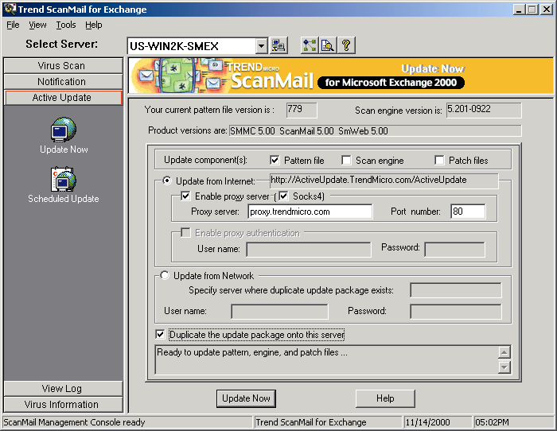

Figure 7. ScanMail’s Active Update

ScanMail in Microsoft Windows 2000 Cluster Environment

Microsoft has redesigned its clustering technology to best meet the needs of an organization independently setting up their clustering environment. Additionally, Microsoft has improved their clustering technology in Windows 2000 Advanced Server, offering a maturer product with added stability. The product now provides support for single and multiple database as well as support for up to 32 nodes. Microsoft clustering technology makes it possible for company to setup database center and deployed critical e-commerce business.

A cluster is a group of independent computers working together to run a common set of applications while providing the image of a single system to the client and application. The computers are physically connected by cables while being programmatically connected by cluster software. These connections allow computers to use failover and load balancing, which is not possible with a stand-alone computer.

Linking individual servers physically and programmatically and coordinating communication between them so they can perform common tasks is known as clustering. Should any one server stop functioning, a process called failover automatically shifts the failed unit's workload to another server to provide continuous service.

In addition to failover, Windows 2000 Advanced Server clustering also employs load balancing. This function enables the company server to load balancing the computing power from server to server thereby improve the performance of an organization speed in providing solution for their customer.

Combined with advanced symmetrical multiprocessing (SMP) and large memory support in both Windows 2000 Advanced Server and Datacenter Server operating systems, Windows clustering technologies enable organizations to ensure the availability of critical applications while being able to scale those applications both up and out to meet increased demand. On the Windows 2000 Advanced Server Microsoft introduces two clustering technologies that can be used independently or in combination, providing organizations with a complete set of clustered solutions that can be selected based on the requirements of a given application or service. Windows clustering technologies include:
- Cluster service. This function allows for supporting of failover for applications running on the Windows 2000 Advanced Server. For example: in company where they have to have mission critical email coming through without stopping or database that process and accepting order from the internet. Professional product such as ScanMail for Microsoft 2000 which require it to run all the time to prevent virus outbreak or virus from damaging any data inside the Exchange 2000 database.
- Network Load Balancing (NLB). This service allows for low balance of computing power across multiple servers thereby speed up performance and database process power.

Details on Windows 2000 Advanced Server Clustering technology and its architecture can be found on the Microsoft home page www.microsoft.com/exchange

How ScanMail for Microsoft Exchange 2000 Works in Conjunction with Windows 2000 Advanced Server clustering

ScanMail for Microsoft Exchange 2000 is the first antivirus product on the market fully compliant with Microsoft Exchange Cluster technology. It installs into all physical nodes of the cluster server and operates seamlessly to provide virus protection for clustered servers whiled preserving all fail-over and disaster recovery capabilities that can be initiated through cluster technology.

ScanMail must be installed on all nodes on the cluster server. During installation, the setup program automatically detects all cluster nodes and installs itself on to the appropriate drive as selected by the user, this is normally on the local drive of the physical node. After completing installation, it will automatically create service and program groups on the cluster server for easy management and configuration.

Once ScanMail is installed, it automatically initiates all ScanMail services and begins protecting the active server mailboxes. If there is information existing inside the information store databases, then ScanMail will provide a complete scanning of the store to ensure they are clean from viruses. ScanMail for Microsoft Exchange 2000 supports both Active/Active and Active/Non-Active node.
Notification and Logging

In a large enterprise environment it is important to receive notification when a virus is detected since it allows problem viruses to be effectively isolated and quarantined. ScanMail notifies network administrators of any newly detected viruses using email, SNMP trap notification, pager messaging, and Windows NT event log recording. Each of these notification methods can be configured to send a standard default message or a customized alert.

In addition to these standard notification methods, ScanMail can send Outbreak Alert notifications whenever a high number of viruses attempt to pass through the Exchange server or if a pre-selected number of viruses have not been cleaned within a few hours.

ScanMail creates logs of viruses attempting to pass through Exchange servers. These are logs later used to generate reports and analysis to better manage future virus threats. To prevent future virus outbreaks, ScanMail’s browser interface can remotely retrieve each server’s virus logs to trace the source of infected files and isolate infested sites. This function saves administrators hours of valuable time and cuts the potential costs of a virus outbreak.

Administrators are provided with services both on-site or remotely through ScanMail's use of a web browser. Depending upon the administrator's requirements, notification services can be configured to automatically alert administrators, recipients and selected Exchange users of infected email transmissions. The notification can be either by email, SNMP trap notification or pager. Administrators can elect to send a standard default notice or their own customized warning message.

Information contained in customized email alerts may include the following:

- The identity of the administrator(s) responsible for the infected Exchange Server(s)
- Date and time of infection
- The identity of the Exchange Server(s) infected with the virus
- The name of the infected file
- The scanning method used by ScanMail to detect the virus
- Any action taken by ScanMail against the virus and the name of the virus

A warning notification is sent to the recipient in the attachment message and includes the infected attachment renamed with customize message inserted inside. Administrators can customize the notification message or select not to send notification if the attachment is successfully cleaned.

All automatic actions are performed on infected files in accordance with the administrator’s configuration. Options include cleaning the file prior to sending it to original recipient, deleting the infected file, moving it into a quarantined folder, or letting it pass with a warning message to the user. In addition, ScanMail can be configured to backup infected attachments before any action is taken.

ScanMail for Microsoft Exchange 2000 can automatically forward copies of infected attachments to virus_doctor@trendmicro.com at the Trend Micro Virus Research Center for analysis and feedback. This allows Trend Micro to immediately diagnose new strains of viruses threatening customer sites. Trend Micro incorporates these new viruses into its weekly pattern files updates that are made available to all Trend Micro customers.

Note: Using the new Exchange 2000 Anti-Virus Scan API (AVAPI) the functions of notification, logs and reports are limited to virus information only. This limitation of the new Exchange 2000 Anti-Virus Scan API. Trend Micro is currently working with the Microsoft Exchange 2000 team to define these additional APIs for future releases of Exchange and service packs. Please contact Microsoft Professional Service Support for more information on the status of Microsoft Exchange 2000 Service Pack 1.

Summary

Traditional desktop antivirus software alone cannot provide complete virus protection for the enterprise. Table 1 outlines the primary benefits to organizations using Microsoft Exchange 2000 Server in conjunction with ScanMail.

Traditional desktop antivirus software is unable to detect viruses embedded in email attachments inside Exchange 2000 servers. Desktop protection must instead wait until users open attachments, and potentially allow infected files to be copied to their hard drives before scanning and cleaning take effect.

Desktop scanning alone leaves the original, infected files at the Exchange server where they can be forwarded infect other users. However, we do not completely eliminate desktop and server virus protection from this environment.

Functions | ScanMail for Microsoft Exchange 2000  (Email scanning Product) | Traditional Desktop/Server Antivirus Protection
Real-time scanning and cleaning of attachments transmitted through and from the Exchange 2000 Server | Yes | No
On-demand and prescheduled scanning of user email boxes and subfolders such as the Inbox, Outbox and Sent Items | Yes | No
Scanning and removal of infected email attachments from archived  user mailboxes | Yes | No
Detection and removal of viruses before they reach the desktop | Yes | No
Protecting Exchange 2000 during database replication or mailbox move | Yes | No
Monitoring of Public Folders and Exchange 2000 database using other HTTP client program | Yes | No

Table 1: ScanMail compared to traditional desktop virus software.

Since traditional desktop or server antivirus applications cannot provide full protection within Microsoft Exchange 2000’s proprietary email/groupware messaging format, enterprises must deploy email-specific scanning products like Trend Micro ScanMail for Microsoft Exchange 2000 for more complete virus protection.

Trend Micro recommends the deployment of four tiers of virus protection. This proactive approach includes complete SMTP scanning on the gateway, complete groupware virus protection on the intranet email server servers, and complete File Server protection on all application/file sharing server to ensure they are free of virus. If you are using your Exchange 2000 server as a file-sharing Trend also recommends installing a file server protection product.

Finally, Trend's approach to virus control provides complete desktop protection to ensure all files copied from floppy or local hard drives are scanned and cleaned. With these four layers of protection, ensure the best virus protection in for an organization.

Trend also recommends installing a management console, such as Trend Virus Control System(Trend VCS), with the ability to manage the different layer of products. The product provides the administrator with the ability to view logs, create reports, deploy engine, pattern and patches with the click on a mouse button from virtually anywhere.

Advantages of Trend Micro ScanMail for Microsoft Exchange 2000

- Reduces overall virus protection costs
ScanMail reduces the overall cost of virus protection by detecting and removing viruses at the Information Store before they can reach organizations' numerous desktops. Scanning and cleaning viruses at the Exchange server level halts viruses before they can be distributed throughout the network. This approach is more efficient in neutralizing virus threats, rather than after they spread among network users.

- Reduced overall deployment and management costs
ScanMail provides complete, remote deployment capabilities allowing a single administrator to deploy ScanMail from a central location within an enterprise to all remote Exchange sites across the network. ScanMail can be deployed to a single or multiple Exchange servers simultaneously. Cross platform support for Intel and Dec Alpha platforms, including Microsoft Exchange Cluster environments, makes ScanMail ideal for flexible deployment.
ScanMail is fully web-enabled and shipped with its own web server that supports the Trend Virus Control System (TVCS). TVCS allows administrators to operate and configure ScanMail from anywhere in the enterprise through a web browser. From a single TVCS console, Administrators can also remotely update virus pattern files, scan engines, consolidate and update virus activity logs throughout the Exchange enterprise.

- Virus detection and removal, including macro viruses, at the server
To protect the Exchange server, ScanMail removes known and unknown viruses including macro viruses during real-time, on-demand and scheduled scans. With Macro Trap technology, heuristic rule based scanning; administrators can configure different levels of heuristic protection for ScanMail to check for known and unknown macro viruses. This prevents newly created macro viruses from penetrating the Exchange server.

- Scans most compressed and encoded formats
ScanMail for Microsoft Exchange 2000 scans deep inside attachments to detect viruses buried in multiple levels of encryption and compression. ScanMail decodes BINHEX, UUENCODE, MIME, S/MIME and BASE64 attachments. Files compressed with PKZIP, ZIP2EXE, ARJ, ARJ2EXE, LHA, LHA2EXE, TAR, GZIP, LZEXE, PKLITE, DIET, MSCOMPRESS, CABINET, UNIX LZW, COMPRESS and UNIX PACK compression schemes are also effectively scanned. ScanMail even scans files with multiple compression levels; for example, a ZIP2EXE file that has also been compressed with LZEXE and ARJ, then zipped up to 20 layers deep.

- Centralized management
ScanMail for Microsoft Exchange 2000 centrally manages all ScanMail servers via a single web-based or Windows-based console. It is remote configurable and manageable through HTTP and RPC protocols. This web-browser based management capability allows network administrators to manage ScanMail servers throughout the world from their workstation. ScanMail also supports TVCS, provides comprehensive domain management of ScanMail and other Trend Micro antivirus software through the Internet.

- Content filtering and Anti-spam management
ScanMail for Microsoft Exchange 2000 empowers administrators to maximize the performance and output of their Exchange servers administrators by letting them define and configure the type of email and data allowed to pass through their Exchange servers.

Bibliography

International Computer Security Association (ICSA, formerly National Computer Security
Association), “1998 Virus Prevalence Survey,” September, 1998. Available on the web at:
http://www.icsa.net/services/consortia/antivirus/survey_request.shtml

Appendix A: :Trend Micro ScanMail for Microsoft Exchange 2000

System Requirements

- 200 MHz Pentium or faster processor
- 128 MB RAM minimum (256 MB recommended)
- 50 MB free disk space for the program files
- Microsoft Exchange 2000 Server
- Microsoft Windows 2000 Server or Advanced Server
- Microsoft Windows 2000 Server Service Pack 1
- A Java-enabled web browser that supports frames, such as Netscape
Navigator 3.0 (or above) and Microsoft Internet Explorer 3.0 (or above) for web-based management

ScanMail Certifications

- International Computer Security Association, ICSA Certified, Detect 100% virus in the wild
West Coast Lab, Check Mark Certified, Detect 100% virus in the wild

Recent Trend Micro awards

- Microsoft Exchange 2000 Conference, Best Tool or Utility
- 2000 Secure Computing, Best Buy Awards
- 2000, ScanMail for Microsoft Exchange, ICSA Certified, CheckMark Level 1 & 2 Level Certified
- 2000, Server Protect, OfficeScan, TVCS, Editor Choice, PC Professionell Germany
- 2000, ScanMail for Microsoft Exchange 2000, Product, Best Buy Award, Secure Computing Magazine
- 1999, ScanMail for Exchange, Solution of the Year, PC Expert Magazine (France)
- 1999 Total Solution, Editor’s Choice, PC Magazine
- 1999 Total Solution, Solution of the Year, InfoWorld
- 1999 InterScan VirusWall, Editor’s Choice, Network Computing
- 1998 OfficeScan for Microsoft Small Business Server: Recommended by Computer Reseller News/Spring COMDEX Test Center
- 1998 ServerProtect: Five Palm Award, Beverly Hills Software
- 1998 ScanMail for Lotus Notes: Gold Editors’ Choice Security Award, Lotus Notes and Domino Advisor
- 1997 ScanMail for Lotus Notes 1.0: Best of Test Center Award, InfoWorld
- 1997 HouseCall: Best of the Web, HomePC
- 1997 InterScan Email VirusWall, Editors’ Choice for Internet Email Gateway Antivirus, PC Magazine

About Trend Micro

Trend Micro provides centrally controlled server-based virus protection and content-filtering products and services. By protecting information that flows through Internet gateways, email servers, and file servers, Trend Micro allows companies and service providers worldwide to stop viruses and other malicious code from a central point before they ever reach the desktop. Trend Micro's corporate headquarters is located in Tokyo, Japan, with business units in North and South America, Europe, Asia, and Australia. Trend Micro's North American headquarters is located in Cupertino, CA. Trend Micro's products are sold directly and through a network of corporate, value-added resellers and service providers. Evaluation copies of all of Trend Micro's products may be downloaded from its award-winning web site, http://www.antivirus.com.

